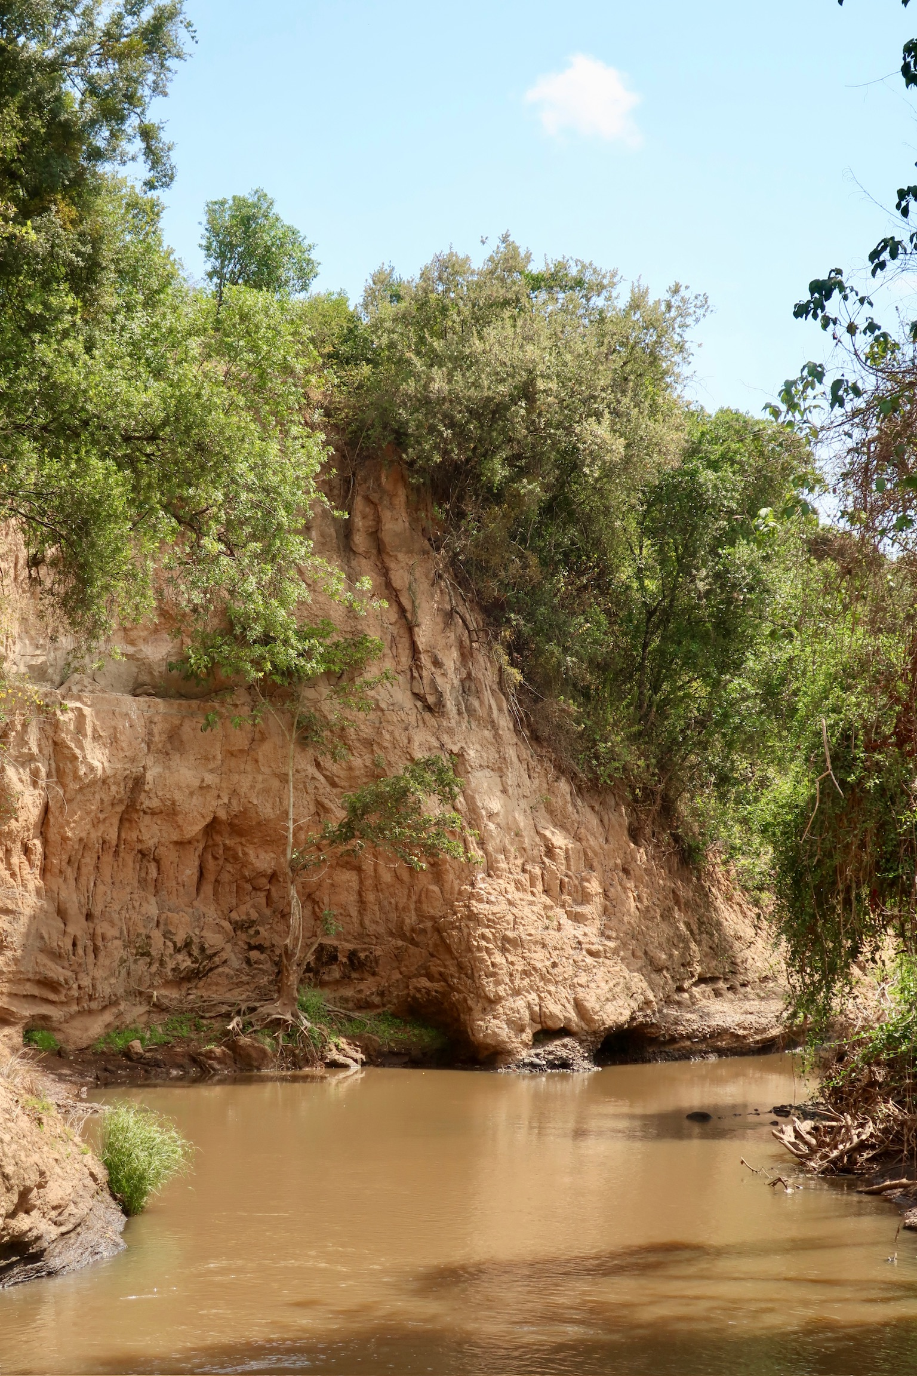Manual for the implementation of a Flood Early Warning System in small urban areas in Africa



Preface

This document, together with the “*Implementation of a Flood Early Warning System in Narok Town, Kenya*”, are written as part of the course CEGM3000 Multidisciplinary Project in the MSc programmes Civil Engineering and Environmental Engineering of TU Delft. We want to express our gratitude to our supervisors Prof. Dr. Ir. Nick van de Giesen and Frank Annor.

The main objective of this multi-disciplinary project is to "design a flood early warning system to reduce the impact and damage of flash floods in Narok town, Kenya”. The obtained methodology and findings are used to write a manual for the design and implementation of flood early warning systems in similar small urban areas in Africa. This manual aims to be easily readable and is written in a step-by-step manner. The target audience is anyone who is concerned about the impact of (flash) floods of rivers in small urban areas in Africa, for example municipalities, county governments, water authorities, or meteorological departments.

The first step of the manual describes an elaborate study of the flooding problem, by taking multiple sources into account. In this step, the value of a Flood Early Warning System will be assessed. Subsequently, the boundaries of the model will be determined and a further spatial analysis will be done in step 2. Step 3 describes the field measurements that need to be done to gather the necessary data of the river reach that will be modelled. In step 4, this data is processed, by help of a python package which is attached to this document. Step 5 includes multiple possible modelling methods to process the data further and conclude on a critical discharge that is reached upstream in case of a flood, as well as the time this water will take to flow down. In step 6, all aspects of the implementation and function of the Flood Early Warning System are discussed. In order to keep the manual concise and readable, some steps are accompanied by various appendices for further elaboration.

This project was carried out in collaboration with TEMBO, an organization focused on closing the environmental data gap in Africa. TEMBO aims to do this by creating affordable sensor networks that are supported by climate services built around them. Currently, their services include Flood Early Warning Systems, Water Reservoir Management, and Agricultural Information. TEMBO works closely with TAHMO and TU Delft. (TEMBO, 2024)

We had the pleasure of working with the Kenyan Meteorological Department (KMD), particularly Josiah Kahuthu; the Water Resources Authority of Kenya, with special thanks to Anne Wamuyu; and Maasai Mara University in Narok, Kenya, with appreciation to Dr. Samson Mabwoga and Simon Raphael. We’re very grateful to these individuals and organizations for their valuable contributions.

Tim van Binsbergen, Evira Eman, Lars Heijboer

Emmanuel Weizenbac & Lisette de Valk

October 2024, Narok town, Kenya

# Table of Contents

Introduction 6

1. Investigate the flooding problem 7

1.1 First environmental analysis 7

1.2 Local authorities 7

1.3 Local community 7

1.4 Literature study 8

1.5 Media sources 8

1.6 Conclusion 8

2. Boundaries of the river reach and spatial analysis 9

2.1 Identification of the flood point 9

2.2 Identification of the gauge placement 9

2.2.1 Warning time 10

2.2.2 Flow velocity of a (flash) flood 10

2.2.3 Conclusion 10

2.3 Spatial analysis of the river reach and corresponding catchment 11

3. Map the river 12

3.1 Exploration of cross-sections 12

3.2 Incorporation of Junctions 12

3.3 GPS System and background 13

3.4 Preparing a measurement day 14

3.5 Execution of a measurement 15

3.5.1 Determine a suitable cross section and its bankfull state 15

3.5.2 Cross section measurement 15

3.5.3 Water elevation measurement 15

3.5.4 Length profile 15

3.5.5 Velocity profile 15

3.5.6 Slope of the river 16

3.6 Conclusion 16

4. Process data 17

4.1 RTK software processing 17

4.1.1 File structure 17

4.1.2 RTK software processing 17

4.1.3 Save the data in the Excel Template 18

4.2 Python Processing 18

4.2.1 Opening python file 18

4.2.2 Using the Python file 19

4.3 Conclusion 19

5. Build model 20

5.1 Alternative manual computations 20

5.2 Modelling a flash flood 21

5.2.1 Geometry 21

5.2.2 Steady Flow 21

5.2.3 Unsteady flow 22

5.3 Models 22

5.3.1 Full model 22

5.3.2 Model Build-up 24

5.3.3 Conclusion 28

5.4 Conslusion based on complete line model 28

5.5 Conclusion 29

6. Implementation 30

6.1 Partners involved 30

6.1.1 Local authorities 30

6.1.2 Local community 30

6.1.3 Funding 30

6.2 Functioning of the system 31

6.2.1 Processing the warning 32

6.2.2 Communication of the warning 32

6.3 Selecting a sensor 33

6.3.1 Types of sensors 33

6.3.2 Selecting the sensor 34

6.4 Installation of the sensor 35

6.4.1 Location 35

6.4.2 Installation 36

6.4.3 Maintenance 36

Bibliography 37

Appendix A. Spatial analysis of the catchment using QGIS 38

Appendix B. Installation Manual GNSS Receiver 47

Appendix C. Fieldwork preparation 61

Appendix D. Fieldwork execution 66

Appendix E. RTK Software processing 70

Appendix F. Python processing 76

Appendix G. HEC-RAS 81

Appendix H. Theoretical background HEC-RAS 100

Appendix I. Alternative manual computations 107

Introduction

This document entails a manual for the implementation of a Flood Early Warning System (FEWS) for riverine floods. This manual is targeted at small towns in Africa, with populations of fewer than 700.000 inhabitants, that experience riverine floods in town. Specifically, the case of flash floods is considered. A flash flood is a sudden local flood, typically due to heavy rain, which begins within 3 to 6 hours, after the rain event. This restriction in time, gives little time for warning. Additionally, flash floods can have a really high wave celerity, and therefore can surprise flood prone areas. Flash floods are restricted to basins of a few hundred square kilometres or less. Steep terrain and high runoff coefficients of the land use are often contributing to the existence of flash floods. A flash flood can also be caused by dam or levee failure, or a sudden release of water in a previously stopped passage (i.e. by debris or ice). (United Nations Office for Disaster Risk Reduction, 2024)

Occurrence of floods have large impact on society. Reducing exposure to flash flood is considered to be key to any mitigation measure. Approximately 85% of all flooding cases worldwide are accounted for by flash floods, which also have the highest mortality rate among different classes of flooding. Yearly, on average more than 5000 lives are lost to flash flooding, which even ranks them among the world’s deadliest natural hazards. Besides the risk of lost life, floods also have significant social, environmental and economic impacts. (United Nations Office for Disaster Risk Reduction, 2024) These impacts can setback progression and development of the area significantly, e.g. economic growth, infrastructure, social stability. Besides reducing the risk of floods, flood early warning systems are considered crucial for the reduction of impact. A reliable warning system will make an area more resilient and will give a population the chance to reduce damage and save lives.

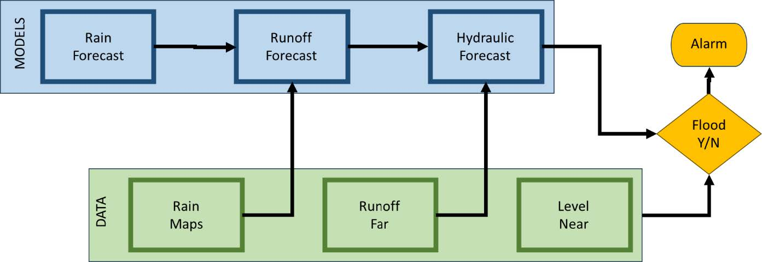As described in the preface, this manual is written for TEMBO. TEMBO develops different Flood Early Warning Systems, for different areas in Africa. The method of the system depends on the need for a warning system, possible damage, available data, and financial limits. An overview of the possible components of a FEWS, as designed by TEMBO, is given in Figure 1.

Figure 1: Proposed FEWS design by TEMBO (TEMBO Africa, 2024)

The Flood Early Warning System (FEWS) described in this manual relies on a gauge placed in the river (‘Level Near’ in Figure 1), located a certain distance upstream from the town. The idea is that a flood can be predicted by monitoring rapid changes in the river’s discharge upstream, until a specific discharge threshold is reached. Once this threshold is crossed, a warning is triggered. This type of FEWS provides a warning, though with only a few hours' notice.

This manual includes an investigation of the area, flooding problem and water system, a methodology to design a FEWS, and recommendations on the implementation of a Flood Early Warning System. The document will guide the reader through the process in a step-by-step manner.

1. Investigate the flooding problem

A comprehensive and effective design needs an inclusive and elaborate problem study. This should include what the flood prone area actually is, what the local water system looks like, what the main bottleneck of the water system is, what stakeholders are involved, and what research has already been done.

The initial study is divided into a couple of steps, that are described below. If a step entails an elaborate step-by-step instruction, this will be included as an appendix. For this chapter, the order is not important, the different studies can be done simultaneously, or in a different order. The chapter is concluded with a list of questions, that should be answered by the combination of all studies that are done.

# 1.1 First environmental analysis

The study begins by outlining the reasons for the need for a Flood Early Warning System. To assess the necessity of precautionary measures, it's important to document past flooding events, along with the associated damage and casualties. You might already be familiar with this information, or it can be gathered from old (online) newspapers or by speaking with local residents. Additionally, it's crucial to identify the possible causes of the floods. Is the river running through the town the main source of the flooding? What is the approximate extent of the flooded area? And is there an obvious bottleneck that can already be identified?

If you are not known in the area, it is strongly recommended to walk through town to get an idea on the order of size of the river, drainage channels in the streets, and the presence of structures in the water way such as bridges. The main water system can be further analysed by looking at Google Maps, Open Street Map, or other maps of the area.

# 1.2 Local authorities

Local authorities often have a lot of knowledge on past floods, and what precautional actions have already been undertaken. Local authorities can be municipalities, counties, police departments, meteorological departments, water authorities, disaster response authorities, or universities. Authorities could be in possession of reports on flood events, maps of the area, and information on (failed) measures already taken. However, take in mind the possibility of lacking documentation or a lack of willingness to share, so collect what is available. Connections with local authorities will be needed throughout the project, especially for the implementation of the system.

# 1.3 Local community

Ask local residents about their experience with floodings. Often residents already have a way of predicting and handling the flood, as the population has probably been living with the floods for some time. In this process one of the key challenges in these kind of projects in data scarce areas will be touched: knowledge is widely present, but the vast majority of it is not documented. However, by asking around and conducting small interviews, a lot of essential information can be gathered. Possible questions include the dates of past flood events, the extent of damage, present warnings, and the bottlenecks that are considered.

# 1.4 Literature study

In some areas, research on floods might have already been done, for example identifying causes of flooding (like deforestation or changing land use), identifying flood prone areas and bottlenecks of the water system, etcetera. Information can be written down in the form of research articles or theses. Literature can be found on the internet, and via local authorities and educational organisations, as identified in step 1.2.

# 1.5 Media sources

Search for news articles, videos and any other information you can find on the internet. This will give entail on the flood prone areas, the data of past floods, and an idea on the order of magnitude of the water flow.

# 1.6 Conclusion

After this step, you should have a concise overview of the problem. One should be able to answer at least the following questions:

* Where do the floodings occur?
* What is the impact of the floodings?
* What is the frequency of the floodings?
* What are the conditions in which floodings occur? (e.g. heavy rains?)
* Are there any external factors that can influence the occurrence of floods, e.g. side channels or the presence of dams and levees?
* What are the main stakeholders concerning water management and rainfall predictions?
* Have any measures been taken to prevent the floods and what is their effectiveness?
* Do local residents already have a sort of warning system in place (e.g. through WhatsApp) and how does this function?

By answering these questions, the need for a new Flood Early Warning System based on a water level gauge in the river should be determined. Will it contribute to the reduction in flood damage? If so, proceed with the steps in this manual, which will guide you through a proposed methodology for the design and implementation.

2. Boundaries of the river reach and spatial analysis

The Flood Early Warning System will be designed based on a river reach, that is limited by the flood point in town at the downstream end, and the water level gauge at the upstream end. This river reach will be mapped and modelled, which is described in Chapters 3, 4, and 5. The boundaries are determined in this step.

# 2.1 Identification of the flood point

In Chapter 1, the flood prone area in town is specified. The location and size of this area probably has to do with a low elevation and poor drainage systems. However, a riverine flood will have a certain flood point, where the water will overtop the river banks. The cause of the flood will probably lie at a point a bit downstream of the flood point, where the water flow gets limited and therefore accumulated or slowed down. This is considered to be the bottleneck of the system. This disruption of the water flow will cause a backwater curve resulting in an increase of water levels in the upstream direction, causing the flood point to overflow for high river discharges.

The bottleneck is almost always a man-made structure in the river stream. A natural stream naturally has a consistent capacity over the length of the river and gets eroded by high discharge events. This gets interrupted by structures such as culverts or bridges. The capacity of these structures are the limitations of the drainage capacity of the river. The bottleneck needs to be identified to determine the lower boundary of the river reach.

* Possibly, research has already been done determining the bottleneck and thus the main local cause of floods. This should have been found in step 1.4.
* Local authorities might be aware of the bottleneck of the water system in town. This should have been found in step 1.2.
* If the possibilities above did not work out, you need to identify the bottleneck yourself. As stated above, it can be assumed that the bottleneck will be a man-made structure in the river flow. In the flood prone area, look for such structures. If more possibilities occur, the capacities of the structures need to be measured. A simple approach is to measure the water flow area. The structure with the smallest water flow capacity can be assumed to be the bottleneck.

When the bottleneck has been identified, the critical water flow at this point needs to be determined. This will be the critical boundary condition for the model to decide on the occurrence of flooding. This critical condition can be either a discharge level, or a water elevation level (for example the bottom of the bridge deck).

# 2.2 Identification of the gauge placement

Secondly, the location of the water flow gauge needs to be determined, identifying the upper boundary of the river reach. This location will be determined based on the desired warning time. The warning time is a crucial element of the FEWS design, as this will greatly influence the extend of effectiveness of the warning system.

## 2.2.1 Warning time

The magnitude of the warning time is a trade-off between lead time and certainty. A longer warning time, gives the residents more time to prepare themselves for the flood. However, a longer lead time also comes with a lower certainty that the flood will actually occur, and lower certainty of the speed and size of the (flash) flood. This is a delicate balance that should be well considered.

How to determine the warning time? This will depend on various factors, such as the land use, present facilities and (type of) residents. Based on the type of users and residents, a warning time should be determined. Your source of information for this would be the local people themselves. They know this the best. A suggested methodology in gathering reliable and valuable information is described below.

1. Identify affected people and determine a set of stakeholder types. For example, residents, shop owners, farmers, visitors, etc.
2. Approach the determined stakeholders and inquire their position towards required warning time. Example questions are:

* What are the actions you would undertake if a flood warning is given?
* If you would have 30 minutes before a flood comes, what would you do? And what actions would you undertake for 60 or 120 minutes? Or a day?
* What would you consider the minimal warning time, that is still valuable?

1. Combine the answers that are given. Decide on a minimal warning time that would suit most of the affected people.

Additionally, time needed for processing of the warning should be considered. A source of information for these systems and regulations would be the local authorities. An estimate for this processing time is approximately 15 minutes. The actual implementation and processing method will be decided in step 6 of this manual.

## 2.2.2 Flow velocity of a (flash) flood

For a flash flood, the flow velocity can get quite high. In literature, multiple ranges for the wave celerity for a flash flood in a natural open channel can be found. According to Meyer et al. (2019), the wave celerity lies between 0.25 and 10 [m/s] for floods in river reaches all around the world. For East-Africa, this range is sharpened by Allen et al. (2018) to a range between 0.05 and 4 [m/s]. The higher end of this range can be used as a conservative assumption for a required distance for a specific warning time. For example, if one hour warning time is required as the minimal, and the water will flow with +/- 4 [m/s], the warning system needs to be installed at least 14.4 [km] upstream of the flood point.

## 2.2.3 Conclusion

The determined warning time, together with a conservative use of the flow velocity range given in Paragraph 2.2.2, a distance can be calculated between the downstream end of the river reach and the proposed upstream end. Probably, a range will be suitable for this first estimation. Within this range, a suitable location needs to be chosen for the placement of a water level gauge. Account for the following criteria:

* The location needs to be reachable. The location needs to be reached for measurement, for placement of the gauge, and for the functioning and maintenance of the system.
* The gauge needs to be placed near the river. For the placement, existing infrastructure might be valuable. Especially structures crossing the water stream, like bridges or water pipes, could be good locations. The installation method will be further elaborated in Chapter 6.
* The sensor might need cellular service to be able to communicate the measurements. When selecting a location, check the service availability.

Look for a location that is considered the most appropriate, considering the distance from the downstream boundary and the criteria mentioned above. Take this as the upstream boundary of the river reach.

# 2.3 Spatial analysis of the river reach and corresponding catchment

The water system will be mapped using QGIS, a spatial information analysis and visualisation tool which is open source and widely used for similar purposes. The spatial analysis of the water system and catchment will be done based on elevation data. This data can for example be retrieved from the Shuttle Radar Topography Mission (SRTM) of NASA. (NASA's Earth Observing Centre, 2024)

The goal of this step is to produce a digital elevation map and corresponding project file that will be used later on in the modelling phase (Chapter 5). The digital elevation map is also used to get a sense on the size of the watershed of the river. The size of the watershed gives information on the order of magnitude of discharge in the river and on contributing areas in terms of rainfall (measurements).

The determined river reach might also include junctions with side streams that contribute to the river flow. These contributors need to be included in the calculations. They can be identified using maps, such as Google Maps or Open Street Map, or using the delineated streams in QGIS. Per contributing side stream the area of the sub catchment also needs to be determined, as will be described in Paragraph 3.1.1.

To obtain these objectives, a step-by-step instruction is given in Appendix A. Additional to the instructions to reach the goals of this step, some information is given on the general use of QGIS, namely saving a project and creating print layouts. First conduct the instructions given in Appendix A, before going to Chapter 3.

3. Map the river

To start with step 3, the following information needs to be known:

* The main river that causes flooding.
* An optimal warning time, including following the protocols.
* An estimation of the required location of the FEWS, measured in distance from the flood point.

For the model that will be designed, the part of the river between the FEWS and the flood point needs to be mapped. This will be done via cross sections of the river bed, that need to be measured. The required information includes: GPS data of the cross-section (X-, Y- and Z-coordinates of the river bed), average velocity, the bank-full water level, and the slope. How to obtain this data is described in the following steps.

# 3.1 Exploration of cross-sections

The steps below explain how one should approach the measuring of the cross-sections.

1. Determine **how** **far** **upstream** you want to measure. This can be done based on the wave celerity and the warning time as discussed in paragraph 2.2.
2. The **number of cross sections** that one should measure strongly depends on the accessibility of the river. The chosen approach in this project was to check on Google Earth how much locations along the river seemed accessible. For example, this case study has 10 cross-sections for a distance of approximately 14 kilometres. The exact number of cross-sections needed will be decided with a sensitivity analysis of the model and or the Manning calculations.
3. Keep in mind the needed **measurements**. The list below provides an overview of what should be measured and what it can be used for.
   1. Cross-Section of bankfull state
   2. Velocity Profile
   3. Waterlevel
   4. Slope
4. **Explore the river** before going with all measurement equipment. Explore whether the cross-sections determined in step 2 are actually accessible and whether it is to save to enter the river at that place.
5. Make a **planning** based on the number of cross-sections and the measurements that need to be conducted. A cross-sectional measurement will take approximately 3 hours. Whereas the time needed for measuring water levels can differ based on where the base is located.

# 3.2 Incorporation of Junctions

In case there are side streams that flow into the river reach that is determined in step 2, a method needs to established how this extra water flow will be integrated. This will be done by determining a discharge ratio, that will be applied to the flash flood discharge at the top boundary of the river reach. The additional discharges, according to the ratio, can be added as additional water flow at the point of the junction in the river reach. Two different methods are described here. Both will lead to a discharge ratio, which can be compared to each other and an average can be taken. If for any reason, not both methods will be executed, one of the will suffice as well.

* The discharge ratio between the main river and the connected side stream has to be determined before making the model. Two cross-sections need to be measured: one just upstream of the junction and the other immediately downstream. At both cross-sections, measurements of the velocity profile and water level must be conducted. These measurements will allow for the calculation of the discharge both upstream and downstream of the junction using a straightforward formula: $Q=v*A$. By determining the proportion of the discharge in the main channel downstream of the junction that originates from the main channel upstream, the contribution from the tributary can be inferred automatically. This method assumes that the discharge ratio between the two streams is equal both for low and high discharges.
* Another check for the discharge ratio between the main river and the connected side stream, is to look at the area of the watersheds. In Appendix A, Paragraph Delineate Streams and Catchments, the areas of different sub catchments are calculated. This is also described in Paragraph 2.3 of the main file. In QGIS you are able to define a sub catchment for any point. For this point, choose the junction that is in the river reach that you are looking at. By following the steps in Appendix A, you should calculate the area of the different sub catchments. By comparing the ratio of these areas, between the main catchment and the sub catchment of the side stream, an assumption can be made for the discharge ratio. Here, the main assumption is that rainfall will be equally distributed over the total area, and the runoff coefficient is also equal. However, for small catchments, these assumptions are rather probable. The discharge ratio that is determined can be applied in the model, in *Chapter* *5*.

# GPS System and background

In the world of surveying and mapping, GPS systems are found at the foundation. Within the Western world advanced systems are the norm, costing upwards to many thousands of euros. To keep the implementation of the Flood Early Warning system as cost effective as possible, cheaper alternatives had to be utilised. The systems of Ardusimple provided the perfect set-up for the intended use, as they are cheap, precise and rely on open source hard- and software. As some more advanced functionality was required, it was chosen to use the SimpleRTK2B Pro receiver.

The system is based on a Base and Rover setup. The Base station is a fixed position receiving and recording positional information from the satellites. As the Base is positioned stable over a longer period of time, it is able to determine its position with centimetre level precision. The Rover is the device that is used to record the points of interest, and thus moves. Similar to the Base, the Rover also receives and records its positional data received by the satellites. It is important to always record a point of interest for an extended period of time, this to make sure that the correct position is logged. An impression of the Ardusimple receivers is given in Figure 2.

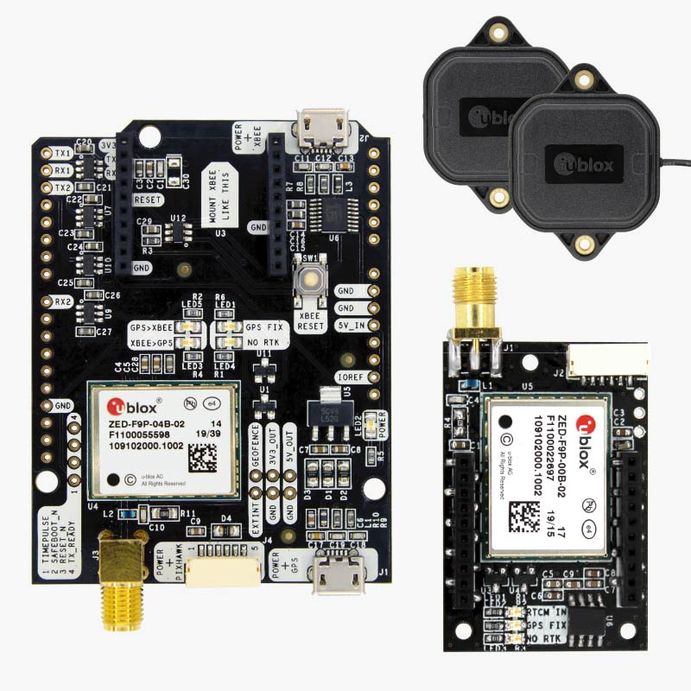

Figure 2: Ardusimple product impression

Using post processing software, also developed by Ardusimple, the recorded positional data from the Rover and Base station are compared. Any distortions, for example caused by clouds, can be accounted for because of the fixed location of the Base station. Using this, the true location of the Rover can be calculated. This surveying method is called “*Post Processing Kinematic (PPK)”* and has the advantage that the Base and Rover do not need a direct line of sight as is required in the more common “*Real Time Kinematic (RTK)”* set-up.

The installation of both the hard- and software of Ardusimple is complex and requires a lot of steps that need to be followed precisely. This is therefore discussed in Appendix B. The appendix contains further introduction into the Ardusimple systems, the installation of all required software, and the preparation of the hardware. Completion of the installation is required before one can start to prepare for a measurement day discussed in section 3.4.

# 3.4 Preparing a measurement day

The execution of fieldwork is an important but time consuming task. Proper preparation of the fieldwork is therefore of the essence. The preceding paragraphs discussed determining which cross sections to take and the installation of a budget GNSS receiver. Using this, this step discusses important considerations to take into account when preparing actual field measurement days. Step by step instructions are found in Appendix C.

The first step is in gaining the necessary permissions from relevant governmental bodies. Using the gained permissions, one can draft a explanatory letter to aid in field communication. This letter could, for example, contain the contact information of the governmental institutions which provided the permissions to execute the measurements.

Working from the obtained permissions, the fieldwork planning should be reconsidered and finalised. Other materials required for execution of the fieldwork measurements should also be collected. Examples of these materials are ropes, pegs, a tripod and a water velocity meter. As each situation requires a different measurement approach, the equipment can vary.

Important is also to gain experience with the instruments at hand and their functioning. It is therefore advised to perform mock measurements and process their data. By executing this mock measurement twice, one can check for irregularities

With al the required equipment set, one is ready for the final preparations of a fieldwork day. During these preparations it is important to consider the terrain and environment one will be working in. Maybe a off-road vehicle is required. These terrains also demand a clear communication of your whereabouts during the day. In case anything happens, one should be able to rely on precaution measures taken in advance. Having somebody that is known to the area is also a must during the preparation and execution of the fieldwork.

# Execution of a measurement

Requiring the completion of all preceding steps, one is now able to perform field measurements. For guidance an elaborated step by step manual is provided in Appendix D. This paragraph provides an overview of the steps that need to be executed per location.

## 3.5.1 Determine a suitable cross section and its bankfull state

Upon arrival it is important to get into contact with the local land owners. By explaining why you are here and the measurements you are planning to perform, you create understanding for the unusual sight of someone performing measurements in the river. Also make sure to inquire about the bankfull state of the river. Often floodmarks provide this information as well, but it is always nice to check this with the locals.

## 3.5.2 Cross section measurement

After familiarizing yourself with the locals and the area, the first measurement can be executed: the cross section. As the quality of the GPS measurements is influenced by local obstructions as buildings, trees, or anything else. The location should have a as clear view of the sky as possible.

The cross section is measured from bankfull state to bankfull state perpendicular to the flow direction of the river. Measurement intervals of half a meter are used with a knotted rope as guidance. It is important to always note the location of the measurement, its characteristics and the mobile reception. On the same page also note which measurements were executed and the order.

## 3.5.3 Water elevation measurement

Using both banks of the river, one can find locations for the water elevation measurement. The rover is placed vertically and stable for at least 10 minutes. Preferably this is done on the same place where the cross sectional measurement has taken place. This water elevation measurement is done for both the determination of the slope of the river, as well as model validation. Again it is very important to note down in which order the measurements were executed.

## 3.5.4 Length profile

Both up and downstream of the cross section, approximately 100 [m], other water height measurements are performed. This time only a single measurement on one of the banks is required. This measurement allows to check the slope of the cross sections against the slope of the entire river. The results of this measurement, together with the bankfull state, are used in the determination of the Manning coefficient.

## 3.5.5 Velocity profile

Using a water velocity meter, a velocity profile of the cross section is built. The same cross section as the cross section measurement in 3.5.2 should be used. The interval of half a meter can also be applied in this case. The velocity measurement is executed at predetermined depths, creating a grid. While one person is executing the measurement, the other is noting the results down. Several results can be communicated: false, zero, or a velocity. Using the total measured area and the speeds per area, the total average water velocity can be determined as well as the discharge. Both are used in the model validation. After completion of the velocity measurement one can wrap up all materials.

## 3.5.6 Slope of the river

Determining the slope of the river using GPS measurements is usually not required. The slope can be determined using the data from the elevation of the cross sections along the river. This is done automatically by the Python script. But if some errors in the elevation data of the cross sections have occurred, this step results in a general idea of the slope. And thus in where to place the cross sectional profiles.

The main idea of the slope determination is based on two general assumptions. Firstly, the fact that the water level is more or less parallel to the river bed. And secondly, that the discharge remains the same over the course of a day, provided that it has not rained.

Using this, a last extra measurement day is prescribed. During this measurement day, one will visit the most upstream and downstream locations, if time allows also locations in between. By measuring the water height at each of these locations, a slope can be determined. Important is to leave the Base at a secure location and logging its fixed position over the entire day. The error it was making before (between several measurement days) will now be equal for all measurements, thus placing them at the right height relative to each other.

# Conclusion

In conclusion, after successful completion of this step one obtained all the required datapoints for post processing and the model building/validation. One has obtained:

* A structured plan mapping the river by making cross sections
* Installed the Ardusimple GNSS receiver
* Familiarised with the system setup
* A strategy on how to deal with inflowing side rivers
* Permissions to execute the fieldwork
* All data resulting from the fieldwork

4. Process data

During the field measurements the SD-card was used to log the positional data relative to the satellites. The conversion from this relative position to files, that serve as input for the HEC-RAS model, takes several steps which are discussed below. To start with this step, the following needs to be installed and completed:

* Fieldwork measurements, discussed in Chapter 3.
* RTK post processing software, installation discussed in Appendix E.
* Python processing is further explained in Appendix F.

# 4.1 RTK software processing

The RTK post-processing software, an open source and continuously updated tool, has been chosen for its reliability, speed and cost-effectiveness (free) in interpreting satellite data.

## 4.1.1 File structure

The first step in post processing is structuring the retrieved data. Each measurement performed by the Rover is saved in a separate .txt file on the SD-card. As they are numbered in the order of the measurement execution, one is able link the file to the measurement. Rename the files into descriptive and recognisable file names. Also make sure to change the “*.txt*” into “*.ubx*” extension and that they are saved to a preferred location. An example:

* LOG00017.TXT → Cross_section_3_Profile.ubx
* LOG00018.TXT → Cross_section_3_Water_Height_1.ubx
* LOG00019.TXT → Cross_section_3_Water_Height_2.ubx
* LOG00020.TXT → Cross_section_3_Upstream.ubx
* LOG00021.TXT → Cross_section_3_Downstream.ubx
* LOG00022.TXT → Cross_section_4_Profile.ubx
* Etc

Depending on how the base station was used, static at the home station, or dynamic by setting it up at each measurement location, the amount of log files are different. For a static home based base, a single log file is generated. Make sure to save this recognisable as the base file, also with “*.ubx*” extension. For the dynamic base placement, each location has its own log file. Make sure to save each location recognisable, also as a base, with a “*.ubx*” extension. An example:

* LOG00003.TXT → Base_section_3.ubx

## 4.1.2 RTK software processing

The raw “*.ubx*” data log files are now ready to be converted into “*.obs*” and “*.nav*” files. For this conversion the “*RTKconv.exe*” file is used. The “*.obs”* files identifies the satellites observed and the signal strength per timestep. The “*.nav*” files contain the positional information about the identified satellites. Both files are required to calculate a precise location which is stored in a “*.pos*” file. The calculations required to create a “*.pos*” file are executed by the “*RTKpost.exe*” file. Appendix E contains a step by step instruction on how “*RTKconv.exe*” and “*RTKpost.exe*” are used.

## 4.1.3 Save the data in the Excel Template

Many different file types were created using the RTK software, among others: “*.pos*”, “*.nav”*, “*.obs*”, “*.pos.stat”*, and “*_events.pos*”. The “*.pos*” files are the one used for further processing. The file names should be noted down in the Excel template and the files itself should be saved in the INPUT folder of the Data Processor package. This is further explained in Appendix F and the Excel template *“input.xlsx”* itself.

# 4.2 Python Processing

This manual comes with a Data Processor package. This is a folder structure, containing Python scripts that can process the data that is provided. All the required information for working with this package can be found in Appendix F in combination with the Data Processor package itself, which provides a brief instruction in the “*README.txt”* file.

## 4.2.1 Opening python file

The Data Processor package contains three Python files: *“RUN_THIS_NOTEBOOK.ipynb”, “SLOPE_DETERMINATION.ipynb”* and *“INDIVIDUAL_CROSS_SECTION.ipynb”*. The first is the main Python file and the latter is only used if an individual cross section needs some more attention.

The user is recommended to use the Anaconda Navigator to access Jupyter Lab and the Python files, as the Python scripts are designed for that specific environment. In Appendix F, it is explained step-by-step how to work with the Data Processor package and how to use Anaconda Navigator to open the Python files.

### Folder Structure

The Data Processor package works with a specific folder structure which is crucial to its functioning. It is important to gain some understanding regarding this folder structure and to not change this structure, as the Python scripts won’t function without it. In short, the folder structure is set up as follows:

Data Processor Package

├── BACKGROUND_PYTHON_SCRIPTS

│ ├── FUNCTIONS

│ │ ├── Import_functions.py

│ │ ├── Interactive_plot.py

│ │ └── my_functions.py

│ ├── Data_trim_tool.ipynb

│ ├── GNSS_import.ipynb

├── INPUT

│ └── input.xlsx

├── OUTPUT

├── RUN_THIS_NOTEBOOK.ipynb

├── INDIVIDUAL_CROSS_SECTION.ipynb

└── README.txt

The package will work based on this folder structure. In essence, the Python scripts take information (filenames and files) from the INPUT folder, process it with Python and export the results to the OUTPUT folder. This means that the user only has to copy information to the INPUT folder and copy results from the OUTPUT folder.

## 4.2.2 Using the Python file

The Python scripts are set up in such a way that they barely need manual programming labour. Once the *“input.xlsx”* file is properly filled in, the Python scripts *“RUN_THIS_NOTEBOOK.ipynb”* and *“SLOPE_DETERMINATION.ipynb”* can run without needing additional input. Only the *“INDIVIDUAL_CROSS_SECTION.ipynb”* needs some user specified input. The exact use of the Python scripts is explained in Appendix F.

### What to do when a weird result is obtained

If one of the cross sections has a weird result, then use the *“INDIVIDUAL_CROSS_SECTION.ipynb”* file to modify this cross section. This file allows you to trim the dataset, so that possible calibration processes at the beginning or unexpected movements at the end of the measurements can be filtered out. Additionally, this code enables you to alter the code for a single cross section, without affecting the others.

Additionally, the Python scripts are tested on several sets of data. If the script gives an error, there are a few steps you can take:

* Check if all needed python packages are installed. The notebook *“RUN_THIS_NOTEBOOK.ipynb”* guides you in this.
* Check if you have uploaded the data correctly. Check:
  + If all the files you mention in the “*input.xlsx”* file are actually in the *“INPUT”* folder;
  + If you’ve spelled the names of the files correctly in the *“input.xlsx”* file.
* Check if you’ve uploaded the correct file format (.pos, .csv or .xlsx).
* Make sure that you haven’t altered the folder structure.
* Check if you used ‘.’ (dot) as the decimal sign in Excel. If this is a ‘,’ (comma), the Python file doesn’t work properly.

# 4.3 Conclusion

In conclusion, the user needs two types of software to process the data, namely:

* RTK processing software
* Anaconda Navigator with Jupyter Notebook

Additionally, the Data Processor Package, which is included with this manual, is needed.

After the raw data of the GPS system has been converted to *“.nav”* and *“.obs”* files with “*rtkconv.exe”*, the positional data can be retrieved using *“rtkpost.exe”*. This positional data (*“.pos”* files) is used as input for the Data Processor Package. The package converts the input into usable output, which consists out of *“.csv”* files of the cross sections, an Excel file with hydraulic parameters of all cross sections, velocity profiles and local slopes. This output can be used as input for the HEC-RAS model and the evaluation of the Manning equation.

5. Build model

A one-dimensional hydraulic model can be developed to identify the critical discharge upstream of the river that leads to flooding at a defined flood point. With the determination of this critical discharge, the travel time required for the water to reach the flood point can be calculated. If this time is adequate, a sensor can be placed at the upstream boundary of the model to provide timely warnings. However, if the calculated travel time is insufficient, the sensor's optimal location must be determined through an iterative process, which involves expanding the model in upstream direction. The model is based on field measurements to replicate the reality as accurately as possible.

To determine the critical discharge, a flash flood has to be modelled, which can be quite challenging depending on the software used. A flash flood is a time-dependent process, hence requiring software capable of simulating unsteady flow. A flash flood is characterized by a rapid rise in water level, necessitating a relatively short simulation time. Additionally, the time steps within the simulation should be short, to accurately capture the dynamics of the flash flood. Measurements of the water level rise should ideally be conducted to define the upstream boundary condition; however, this can be quite challenging due to the high velocity head of the water. Furthermore, the software should be able to model this high velocity head.

For this manual, the model is created with HEC-RAS software, a simulation programme developed by the United States Army Corps of Engineers. The software is open-source and can be downloaded on various websites. As of the time of writing, the newest version is HEC-RAS 6.6. A more elaborate theoretical background of the model is given in Appendices G and H.

To be able to draw conclusions from the model, it should be validated that it represents the physical processes of the river. The results should be consistent with real-time field measurements. This can be a very difficult task due to limited and inaccurate field measurements, complexity of the physical processes of the river, and uncertainties of the model parameters, like Manning's coefficient.

Both model verification and validation are yet to be completed for this manual, as more field measurements and knowledge of the HEC-RAS software is essential to achieve a good result. However, this part of the manual will give guidance on how to approach this, explains the steps that have already been taken and tries to identify the causes of the issues that were encountered. For different approaches, the quality of the result is assessed, in order to give handles in the modelling decisions you might make.

The manual is written in such a way that it mostly functions as a guideline, while new approaches are undertaken. Therefore it is recommended to first read this chapter. Per step, the corresponding paragraphs of Appendix G are mentioned. To follow the steps to create the best functioning model, as is created within this manual, from scratch, go to Paragraphs 1, 2, 3, 4, 5, 6, 7, and 8 of Appendix G.

# 5.1 Alternative manual computations

For data-scarce areas, often simpler methods than models are recommended in order to give an estimation of parameters that are to be determined. Discharges can be calculated based on Manning’s formula, and this can be combined with a method by Leopold & Maddock. By combining these two methods, one should be able to calculate the discharge in a channel based on either a measured width, depth, or flow velocity. This can be used to convert a water level gauge upstream to a discharge. Similarly, based on a (high) discharge, a flow velocity can be determined. This methodology is described in Appendix I. However, since the method did not appear to be valuable in the case study in Narok Town, it is not further implemented in this document. The results are given in the document “*Implementation of a Flood Early Warning System in Narok Town, Kenya*”. (Venutelli, 2005) (Luna B. Leopold, 1953) (Williams, 1978)

# 5.2 Modelling a flash flood

The recommended approach for building a model that can simulate a flash flood consists of three steps:

1. Creating the complete geometry of the part of the river that has to be modelled
2. Creating a steady flow model to calibrate Manning’s coefficient
3. Defining an unsteady model to simulate the flash flood

## 5.2.1 Geometry

To be able to simulate a flash flood, the geometry of the river should be defined as detailed as possible. The level of detail depends on the amount of data available. The geometry, width and elevation of the river, is based on field measurements of the cross-sections at different representative locations, as explained in Chapter 3. Keep in mind that you need to model the section of the river that extends from the expected location of the sensor to the bottleneck of the system, as is determined in Chapter 2.

The course of the river can be modelled by using the built-in function of RAS Mapper, which allows you to add a background layer created with web imagery. RAS Mapper is a graphical interface within HEC-RAS. To do this, a terrain and a projection file must be added. This manual makes use of OpenStreet Maps. After adding the background layer, the course of the river can be drawn either in RAS Mapper or in HEC-RAS. Keep in mind that the program responds slowly when loading OpenStreet Maps in HEC-RAS. The required files are created by following the steps in Appendix A, which is explained in Chapter 2.3.

## 5.2.2 Steady Flow

After completing the geometry, the steady flow data can be specified. The following input is required to run a steady flow model:

### Flow regime

The flow regime can be mixed, supercritical or subcritical. The objective of the steady flow model is to calibrate Manning’s coefficient, which can be achieved by using the validation measurements as input for the flow data. To collect these measurements, the river must be safe to stand in, implying that the water likely has a low velocity head. Therefore, it is reasonable to assume that the flow regime is subcritical. This assumption can be verified by applying the average velocity and depth of the cross-sections, obtained in chapter 4, to the Froude number formula. If Froude’s number is less than 1, the flow is subcritical; if greater than 1, it is supercritical.

### Boundary conditions

HEC-RAS requires boundary conditions as starting values for the program to begin calculations. In a subcritical flow regime, only a downstream boundary condition is necessary. A known water surface elevation or normal depth are recommended, as these can be derived from the field measurements.

### Peak flow data

Since this is a steady flow model, the discharge remains constant over time. Therefore, the model requires a specified discharge as input. However, the discharge can vary along the river, for example, where tributaries enter. This is modelled by adding flow change locations where the new discharge can be specified. The discharge derived from the field measurements is used as input for the peak flow data. Chapter 3.1.1 describes how the discharge of the tributaries is determined.

The objective of the steady flow model is to calibrate Manning’s coefficient. Manning’s roughness coefficient $n$ is used in Manning’s equation to calculate flow in open channels. It represents the roughness or friction of the channel bed and thus the energy loss. This calibration process will be iterative, involving adjustments of Manning’s coefficient until the model output aligns with the observed validation measurements. As a first estimate, the Manning roughness coefficient can be based on literature.[1] Keep in mind that Manning’s coefficient depends highly on the provided water level and velocities. If these measurements are inaccurate, Manning’s coefficient will also be inaccurate.

## 5.2.3 Unsteady flow

The main difference between the steady flow model and the unsteady flow model is that the latter is time-dependent. It does not require a fixed discharge; rather, the discharge can vary over time. The upstream boundary condition is defined by a flow hydrograph, which indicates an increasing discharge as time progresses. The first value of this hydrograph is used as an initial condition for the model. The downstream boundary condition is defined by the normal depth. A more detailed explanation of these boundary conditions can be found in Paragraph 7 and 8 of Appendix G. Furthermore, the Manning roughness coefficient, derived from the steady flow model has to be implemented in the unsteady flow model.

# 5.3 Models

## 5.3.1 Full model

The full model is developed according to paragraphs 1, 2 and 3 of Appendix G. The geometry is created in RAS Mapper, depicting the actual course of the river. All measured cross-sections are included in this geometry. As explained in paragraph 5.2, the steady flow model was first run to determine manning’s coefficient, followed by the unsteady flow model, as explained in paragraph 7 and 8 of Appendix G. A detailed explanation of how to view the results in HEC-RAS is provided in Appendix H. For both models, the validation data is used. The inputs for both the steady and unsteady flow are summarized in Table 1.

Table 1: Input of full model in HEC-RAS

|  |  |
| --- | --- |
| Type of input | Input |
| Geometry | * 13 measured cross sections * Downstream reach lengths correspond to actual distances * Underlaying terrain and projection * Course of the river |
| Flow regime | * Subcritical |
| Boundary conditions Steady Flow | * Discharge 1.85 $\left[{m^{3}}/s\right]$* Upstream known W.S. equal to   1900.85 [m]   * Downstream known Normal Depth equal to 0.00251 [m/m] |
| Boundary conditions Unsteady Flow | * Upstream Flow Hydrograph,   1.85 $\left[{m^{3}}/s\right]$ during 1 hour   * Downstream known Normal Depth equal to 0.00251 [m/m] |
| Slope | * 1 consistent slope |

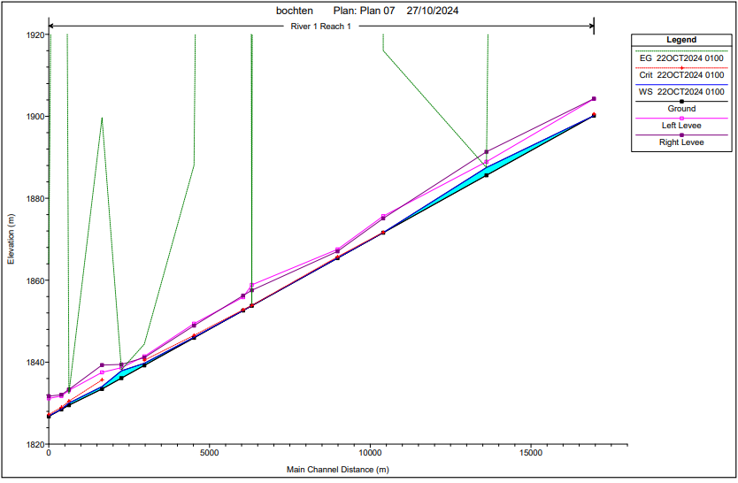For the unsteady flow model, a constant discharge equal to the steady-state discharge of 1.85 $\left[{m^{3}}/s\right]$ is applied throughout the entire simulation time of the flow hydrograph. However, as shown in Figure 3, this resulted in unrealistic output. The figure shows the water levels that were reached after simulating the model one hour, which were found to be inconsistent with the validation data, indicating that the model does not accurately describe the reality.

Figure 3: Output unsteady flow full model

The values in Table 2 correspond to Figure 3 and confirm that the output is not representative of reality. Both the discharge and velocity exhibit negative values, which is not possible. Additionally, the velocity shows unrealistic high values, even though the discharge defined in the flow hydrograph is not particularly high.

Table 2: Output unsteady flow full model

|  |  |  |
| --- | --- | --- |
| River Station | Q Total $\left[{m^{3}}/s\right]$ | Velocity [m/s] |
| 13 | 1.85 | 210.9 |
| 12 | -5.96 | -0.41 |
| 11 | 0.16 | 29.52 |
| 10 | 5.58 | 517.70 |
| 9 | -0.08 | -1.38 |
| 8 | 0.96 | 159.17 |
| 7 | 8.88 | 28.69 |
| 6 | 54.44 | 9.56 |
| 5 | 64.64 | 2.24 |
| 4 | 69.85 | 35.88 |
| 3 | 26.93 | 6.83 |
| 2 | 8.94 | 88.36 |
| 1 | 3.59 | 27.03 |

It was suspected that the problem originated from the terrain data and the projection file uploaded in RAS Mapper. It appears that HEC-RAS either geo-references the cross-sections even when no coordinates are provided, or it still considers the elevation data from the Digital Elevation Model (DEM), despite this data being removed from the cross-sections. The disadvantage of RAS Mapper is that you must specify a projection file and add a terrain layer before you can include web imagery, even if you don’t want to geo-reference your project or use a DEM. It seems that HEC-RAS is primarily designed for creating elevation data using a DEM rather than using field measurements. To confirm this hypothesis, an analysis had to be performed. A simplified model was taken as starting point and expanded step by step to determine the source of the problem. The following paragraphs will elaborate on the intermediate models that were developed during the analysis and serve as a checkpoint for the performance of the model.

## 5.3.2 Model Build-up

This section describes the performance of each intermediate model, as explained in Paragraph 5.3.1. For each model, a conclusion will be drawn regarding its shortcomings and what might have caused the inconsistent results observed in the unsteady full model.

### SIMPLIFIED LINE MODEL

This is the simplest model that can be considered. This model is developed to check whether it reacts the way it is expected to, for both steady and unsteady flow. The model is created by following the steps specified in Pragraph 4 of Appendix G.

#### Input

|  |  |
| --- | --- |
| Type of input | Input |
| Geometry | * No underlaying terrain and projection * Straight line * 2 Rectangular cross sections * Downstream reach length equals 500 m |
| Boundary conditions Steady Flow | * Discharge 1.85 $\left[{m^{3}}/s\right]$* Upstream known W.S. equal to   1900.85 [m]   * Downstream known Normal Depth equal to 0.00251 [m/m] |
| Boundary conditions Unsteady Flow | * Upstream Flow Hydrograph,   1.85 during 1 hour   * Downstream known Normal Depth equal to 0.00251 [m/m] |
| Slope | * 1 consistent slope |

#### Results

For both the steady and unsteady models, the outcomes were as expected. The water elevations remain within realistic ranges. It can therefore be concluded that there are no issues when creating the geometry in HEC-RAS with rectangular cross-sections.

### Expanded Line Model

This model builds on the previous one but will be slightly expanded. First, the rectangular cross-sections will be replaced by the measured cross-sections. This can be accomplished by removing the cross-section data as previously specified and performing step 10a of Paragraph 4 in Appendix G. Use the cross-sections located at the upstream and downstream boundary of the modelled river. Be sure to redefine the main channel bank stations (step 13 of Paragraph 4 in Appendix G). Secondly, the downstream reach length is prolonged to the measured distance between the cross sections (step 11 of paragraph 4 in Appendix G).

#### Input

|  |  |
| --- | --- |
| Type of input | Input |
| Geometry | * No underlaying terrain and projection * Straight line * 2 measured cross sections * Downstream reach length equals 3500 m |
| Boundary conditions Steady Flow | * Discharge 1.85 $\left[{m^{3}}/s\right]$* Upstream known W.S. equal to   1900.85 [m]   * Downstream known Normal Depth equal to 0.00251 [m/m] |
| Boundary conditions Unsteady Flow | * Upstream Flow Hydrograph,   1.85 $\left[{m^{3}}/s\right]$ during 1 hour   * Downstream known Normal Depth equal to 0.00251 [m/m] |
| Slope | * 1 consistent slope |

#### Results

Replacing the rectangular cross-sections with the measured cross-sections and prolonging the downstream reach length to 3500 meter does not result in any significant changes in the model’s output for both the steady and unsteady states. Therefore, it can be concluded that there are no issues with the distance between two subsequent cross-sections and more complex cross-sections.

### Complete Line model

Use the *Expanded line model* as the starting point for this model. The complete line model incorporates all measured cross-sections and, additionally, interpolated cross-sections. Adding cross-section by interpolation enhances the stability of the model, as the step size of the calculations decreases. How to interpolate cross-sections is explained in paragraph 6 of Appendix G. There are two differences from the full model. Firstly, the river is modelled as a straight line, disregarding the actual course of the river. Secondly, this model does not include an underlying terrain or projection file. To add the missing cross-sections and the correct downstream reach lengths, follow steps 5 to 17 of Paragraph 4 of Appendix G. Use step 10a instead of 10b. The correct downstream reach lengths are retrieved from Google Maps.

#### Input

|  |  |
| --- | --- |
| Type of input | Input |
| Geometry | * No underlaying terrain and projection * Straight line * 13 measured cross-sections * Interpolated cross-sections * Downstream reach lengths correspond to the measured values |
| Boundary conditions Steady Flow | * Discharge 1.85 $\left[{m^{3}}/s\right]$* Upstream known W.S. equal to   1900.85 [m]   * Downstream known Normal Depth equal to 0.00251 [m/m] |
| Boundary conditions Unsteady Flow | * Upstream Flow Hydrograph,   1.85 during 1 hour   * Downstream known Normal Depth equal to 0.00251 [m/m] |
| Slope | * 1 consistent slope |

#### Results

For both the steady and unsteady models, the water elevations remain within the expected margins and align with the validation data. Therefore, it can be concluded that the malfunctioning of the full model is most likely related to either the representation of the actual course of the river, including the incorporation of bends, or the underlaying terrain.

### Import full model geometry

To determine whether the underlaying terrain is the cause of the malfunctioning of the unsteady full model, the geometry of the full model, which was created using a projection, was imported into a new geometry file. The geometry could be imported without any linked projection file and terrain data. It had to be imported from the full model because the course of the river could not be recreated in HEC-RAS without web imagery. By deselecting the GIS Cut Lines option, the geometry is no longer georeferenced. An explanation of GIS Cut Lines is provided in Paragraph 5 of Appendix G.

#### Input

|  |  |
| --- | --- |
| Type of input | Input |
| Geometry | * No underlaying terrain and projection * Course of the river * 13 measured cross sections * Downstream reach length correspond to the measured values |
| Boundary conditions Steady Flow | * Discharge 1.85 $\left[{m^{3}}/s\right]$* Upstream known W.S. equal to   1900.85 [m]   * Downstream known Normal Depth equal to 0.00251 [m/] |
| Boundary conditions Unsteady Flow | * Upstream Flow Hydrograph,   1.85 $\left[{m^{3}}/s\right]$ during 1 hour   * Downstream known Normal Depth equal to 0.00251 [m/m] |
| Slope | * 1 consistent slope |

#### Result

The output of the model was found to be identical to that of the *Complete line model*. When the GIS Cut Lines option is selected, the model’s output is not identical and results in unrealistic values, confirming that the terrain data and projection file were indeed the root cause of the problem.

Additionally, it can be concluded that representing the actual course of the river is not the cause of the malfunctioning in the unsteady full model, and that drawing the course of the river does not incorporate bends. The geometry can be exported to a new project without the attached terrain data and projection file. This model does not yield negative velocities or discharges, nor does it result in extremely high velocities.

When comparing the model’s output with the validation data, it was found to align approximately, especially at the most upstream cross-section. This makes sense, as the bends are not incorporated into the model. As you move further downstream, more bends will be encountered, leading to a deceleration of the water and an increase in the water level. This aligns with the validation data. The difference between model’s output and the measured water level increases as you go further downstream. The model’s output will likely be closer to the validation data if bends are incorporated.

### Adding bends to model

As explained in the previous paragraph, drawing the course of the river does not mean that bends of the river are accounted for. Therefore, different approaches need to be considered to add bends to the model. This paragraph elaborates on different possible approaches.

#### QGIS

HEC-RAS recognizes a bend in the river by changing the downstream reach length of the left and right over bank. Doing this manually would require a lot of time and wouldn’t be very precise, as the reach lengths are measured from web imagery. This requires a very good resolution of the web service used. As an alternative, QGIS can be employed. However, burning the river in the DEM led to a resolution which was too coarse to give precise results. Therefore, it was decided not to choose this method. More elaboration on the application of GIS data in HEC-RAS, is given in Appendix H.

To check whether changing the downstream lengths has an effect, a part of the river was adjusted manually. This does have an effect on the model’s results. The results give higher water elevations as expected.

#### Minor Loss Coefficients

Considering that changing the downstream reach lengths is not achievable. Defining minor loss coefficients could be a solution. This coefficient adds an energy loss to a selected cross-section. However, it is very hard to verify whether the selected coefficient is correct as one cannot validate this. This approach is explained in Paragraph 9 of Appendix G.

#### Manning’s Coefficient

The final considered option is to adjust Manning’s coefficient to simulate the energy loss generated by the bends. The coefficient could theoretically be adjusted per section to match the validation data. However, this option was not used as it is not representative for the real situation.

#### Conclusion

The most accurate way of incorporating bends into the model is by adjusting the reach lengths of the left and right overbank for each cross section. However, doing this manually for a long river reach is impractical, as it would require too much time. Therefore, QGIS could be a solution. However, for this case, the results were not precise enough. Nevertheless, this method should still be considered for future projects, as it can lead to the most accurate way of incorporating bends into the model. The two other options shouldn’t be considered as they are either difficult to verify or not representative of reality.

## 5.3.3 Conclusion

The following conclusions were drawn from the intermediate models:

* **Simplified line model**

There are no issues with creating the geometry in HEC-RAS with rectangular cross-sections.

* **Expanded line model**

There are no issues with the distance between two subsequent cross-sections and more complex cross-sections.

* **Complete line model**

The malfunctioning of the full model is most likely related to either the representation of the actual course of the river, including incorporation of bends, or the underlaying terrain.

* **Import full model geometry**

The terrain data and projection file were indeed the root cause of the problem. Additionally, it can be concluded that representing the actual course of the river is not the problem and drawing the course of the river does not incorporate the effect of bends. Furthermore, the model aligns approximately with the validation data.

Adding a projection file is relevant when one wants to incorporate bends into the model. Important is that when one draws the course of the river this does not mean that HEC-RAS sees it as such. HEC-RAS only models for bends when the downstream lengths are taken into account. As was concluded above this cannot be done manually and QGIS did not work in this case. QGIS however should still be considered for future projects. This manual will continue with the complete line model, to elaborate on further steps.

# 5.4 Conslusion based on complete line model

As explained, the difficulty of modelling with HEC-RAS lies in incorporating the bends of the river, which is yet to be understood. However, the critical discharge and corresponding warning time can still be concluded from a model without bends, namely the *Complete line model*. They will be a bit more conservative in the sense that the warning time will be longer in reality since bends cause energy losses due to friction and turbulence. This will result in a lower average velocity of the water and thus, a longer travel time to the flood point.

Computing an exact warning time is not possible with this manual, as there is no sufficient data for the boundary conditions in the unsteady state. Measuring this is very challenging, as measurements in these conditions, a high water level and velocity, go hand in hand with dangerous situations. Therefore, the stage/flow hydrograph is based on the bank-full discharge, determined by the Manning method, at the most upstream cross-section. This discharge is accompanied by a lot of uncertainties, since the bank-full level of the river is based on judgement by sight. The simulation time, the step size of the discharge during the simulation and the initial value of the discharge remains very uncertain as well. The preferred method is conducting measurements to define the necessary flow hydrographs.

Setting the correct boundary conditions when modelling unsteady flow is crucial for getting a representative output. The following boundary conditions should be known to estimate the warning time:

1. Stage/flow hydrograph at the upstream boundary
2. Flow hydrograph for the lateral inflows where tributaries enter
3. The bed slope, used for calculating the normal depth, at the downstream boundary

When one compares the results of the steady- and unsteady model with the verification measurements it can be concluded that the model gives a realistic output. The model itself could therefore be used to model a flash flood provided that the flow boundary conditions are known.

The conclusion on the warming time and the corresponding critical discharge of this model can be found in *Implementation of a Flood Early Warning System in Narok Town, Kenya*. In this chapter, also a brief sensitivity analysis is included. Here, the impact of reducing the number of measured cross-sections is explored. This sensitivity analysis should be expanded with more subjects, such as the number of measurement points per cross-section, or the need of measuring a flow velocity profile. However, since the results of the model so far are unreliable, these analyses are not yet executed. Their conclusions should be implemented in this manual.

# 5.5 Conclusion

HEC-RAS can be used to simulate a flash flood, but it is accompanied by many uncertainties:

* Inaccurate measurements of the water level and velocity can result in an unrealistic Manning’s coefficient. Manning’s coefficient is changed until it corresponds to the water levels and velocities that are provided, therefore, it depends highly on these measurements.
* The upstream boundary condition in case of a flash flood is defined as a stage/flow hydrograph. To be able to define this properly, measurements have to be conducted in these conditions, which is very dangerous. Therefore, the flow hydrograph is based on the bank-full discharge calculated with the Manning method. This discharge is very inaccurate as it is based on judgement by sight of the bank-full level of the river. The simulation time, the step size of the discharge during the simulation time and the initial discharge remains very uncertain as well.
* Bends are not incorporated into the model. When bends would be incorporated, it would result in a higher warning time. Bends lead to a deceleration of the water and an increase in water level.

A model without bends can be used to determine the critical discharge and corresponding warning time. However, it is recommend to use a model with bends, as it will be a better representation of the reality. Therefore, incorporating bends into the model by using QGIS should be further explored.

Alternative manual computations also form a promising method, but should be further explored.

6. Implementation

This chapter describes the implementation of the Flood Early Warning System, and all aspects that play a role in this phase.

# 6.1 Partners involved

A Flood Early Warning System will only be valuable if a partner is willing to be responsible for the system. Responsibilities include protection, maintenance, and verification and transmitting of the warning.

## 6.1.1 Local authorities

In Chapter 1, the local authorities are listed and described. These local authorities are often already involved in flood damage reductions and warning systems. Credibility and clear communication are key in transmitting an early warning, considering that actions taken and therefore the effectiveness of the system will depend on this.

In many countries and regions, general research is done on the subject of early warning systems, often describing stakeholders involved. This is already listed in Chapter 1 as well. Take lessons from found conclusions and apply these to the system you are designing.

## 6.1.2 Local community

The sensor, triggering a warning, will often be located in remote areas, not close to local authorities. To be able to ensure a year-round functioning system, regular checks and tests should be conducted. The involvement of local community could play a important role in this. Protection is considered one of the major challenges as well, also giving way to the role of local community.

Typical failures of a FEWS in the long-term are a failing sensor, empty batteries, malfunctioning solar regulators, or an expired SIM-card.

A possible strategy is to place sensors in the proximity of institutes like schools, governmental companies, or churches. At these institutions, a responsible person can be set in charge of the system, and social control will make sure the responsibility is kept. An added benefit is the accessibility of these locations, which allows for the local authorities to visit and conduct maintenance.

An example on community-oriented flood early warning system is designed by the International Centre for Integrated Mountain Development (ICIMOD), a regional intergovernmental organization working in the Hindu Kush Himalaya mountain range. Their system is based on a river water level monitoring, like in this manual, and the transmission is done by local communities, by means of a clear message system and the designation of roles and a flood risk management committee. (ICIMOD, 2024)

Lessons that are learned from examples like this one, is to design a clear and strict system with a simple message system and clear role distributions. Another lesson learned by former early warning systems in Kenya, according to the Kenya Meteorological Department, is the importance of not relying on governmental payment. Relying on an inconsistent financial supply will affect the reliability of the persons involved. Since constant reliability and willingness to cooperate are vital for a continuous warning system, this is an important aspect. Appreciation and valuation can be rewarded in different ways. More on funding is described in 6.1.3.

## 6.1.3 Funding

Funding is a critical aspect of the implementation of a Flood Early Warning System. In addition to the costs involved in the design, which includes executing the steps above and/or another method, and the costs of the installation of a water level gauge and communication system, continuous costs will be present. These long-term costs are considered the most difficult to supply, since budgeting and long-term payment promises are difficult to estimate and to come by. A list of aspects of these long-term costs is given below:

* Maintenance of the sensor
* Power supply of the sensor
* Maintenance of the power supply
* Compensation of involved local communities
* Costs for the managing party

Typical failures of a FEWS in the long-term are a failing sensor, empty batteries, malfunctioning solar regulators, or an expired SIM-card. All of these failures ensure a complete shutdown of the system, which makes these kind of information-based structures highly vulnerable. However, the costs of these failures are reasonably low.

The sustainability and durability of the system depend on the funding method. It is not desirable to rely on governmental fundings, or funding by (international) organizations. In many African countries, delays in payments by the government are experienced, and the continuation of the financing can alternate due to political changes. Funding by international and/or humanitarian organizations often deals with the difficulty to provide a long-term payment, and it doesn’t contribute to the self-reliance of a community and the sustainability of the system.

It can be concluded that a sustainable financial income should come from the local community itself and be handled by a local authority. How to achieve this, is rather difficult.

TEMBO has documented approaches in terms of the funding in a report on the design of modular Flood Early Warning Systems. As is concluded here, it is stated that in most African countries, local authorities such as Hydro-Meteorological Services are under-staffed and under-funded, to maintain and operate a FEWS. It is also stated, that typically initial funding is provided by international donors, but measures to ensure that the FEWS remains operational often lack. The approach of TEMBO is to design a FEWS in an inverted process, based on the locally available financial supply. A first estimate is given, of an amount of EU 0.05 per inhabitant per year. This amount can come from local and/or national government institutions. The implemented equipment will be maintained by a private entity, such as TAHMO, with sufficient technical staff and rapid deployment capability. (TEMBO Africa, 2024)

A concept that is used by authorities in Kenya is to compensate the involved local community not in means of payments, but in acknowledgement and engagement in the developments. The responsible person could be invited to meetings and/or conferences on the subject. This way, contact is maintained and no financial expectations are risen.

It is recommended to do further research in well-functioning Flood Early Warning Systems in similar areas, and to take lessons from there.

# 6.2 Functioning of the system

After installation, the functioning of the system needs to be defined. With this, two main aspects are aimed at. Firstly, how a trigger of the sensor will be processed and transformed into a warning. Will this be automated or should this be confirmed manually? And if so, how and by whom? Secondly, after a warning is confirmed, how will this be communicated to the community?

## 6.2.1 Processing the warning

The water level gauge will trigger a warning, based on a threshold value. This can either regard a discharge measurement, a water level depth measurement, a flow velocity measurement, or the change over time in any of these parameters. This is part of the design choices made in Chapter 5. When the gauge triggers a warning, this needs to be processed into an actual warning. This process is not extensively investigated for the creation of this manual.

The processing will need to be determined in coordination with the involved parties, determined in Paragraph 6.1. The goal of the process is to confirm the reliability of the trigger, and to convert to an actual warning.

This process will add to the total warning time of the system. An estimate of an addition of 15 minutes is given in Chapter 2. The actual warning time of the system itself, without processing, is determined by the model in Chapter 5. When the process is determined, the real warning time can be concluded. It is an important step to validate this total warning time, based on the required needs established in Chapter 2. If the required result is not met, an iterative revision of the warning system is needed.

## 6.2.2 Communication of the warning

The warning message needs to travel from the source, to the intended recipients. Successful communication methods will differ for different regions, and for different recipients. A recommended approach is given below. The results of following this approach is given in the document “Implementation of a Flood Early Warning System in Narok Town, Kenya".

A first note is to pay attention to the type of warning you will want to transmit. Following the design as is suggested in this manual, there will only be one straightforward possible warning: a flood is coming in a certain amount of time. This amount of time should be known by the recipients beforehand, in order for them to be able to correctly interpret the signal. Another possibility is a warning with multiple risk levels, for example: level 1: low flood risk, level 2: medium flood risk, and level 3: high flood risk. If this is the case, a system based on codes, colours, text, or different sounds need to be designed.

For now, the first option, with only one possible meaning of the warning, is considered. The following steps are proposed in order to get a sense of the effective communication methods in your region. Input of local community and authorities will be very valuable in the process of deciding on a communication method.

1. Define the intended recipients of the warning. This includes everyone who could be benefited by the flood early warning, or who could contribute to anticipatory action. Think of residents, shop owners, employees in shops and offices in the floodplain, visitors, and authorities such as the police or fire department.
2. Hold a brainstorm session to think of all possible communication methods, that would be available in the region, and that would fit in the budget of the project. This list of methods will function as a starting point for the selection.
3. Per type of recipient, think of effective communication methods.
   1. Think of all restrictions and resources a recipient type might encounter. Compare this with the list of possibilities and cross off not effective methods.
   2. Interview representatives per type of recipient. Let them think of communication methods first by themselves, in order not to restrict the possibilities. Then inquire what method would work best for them.
4. Compare the effective communication methods per type of recipient and find corresponding methods. Keep in mind the ratio of recipient types, to give importance to certain factors.
5. Decide on the most suitable communication method.

# 6.3 Selecting a sensor

The threshold value that is concluded in Chapter 5 can be measured in multiple ways, with different kind of sensors. Deciding on the type of sensor includes considerations like costs, energy demand, maintenance and applicability. How to include all these considerations, and an enumeration of possible sensors, is described in this step.

## 6.3.1 Types of sensors

This section discusses the different type of sensors that are available to measure the water height in the river. Several things are important in this. Firstly, the angle in which the sensor is mounted. Some sensors need to be straight above the water, but others can be next to the water and pointed to the water surface under an angle. Secondly, the weight and the required stability are of importance. Another thing to mention is that this section only focusses on non-contact sensors, which do not actually make contact with water. There are however in situ methods that can measure the water height, but these are left outside the scope of this section. This is because in situ methods are more prone to extreme conditions, such as debris that is transported by the river. Non-contact methods are more flexible in that sense and provide more convenience (AGU - Advancing Earth and Space Sciences, 2024).

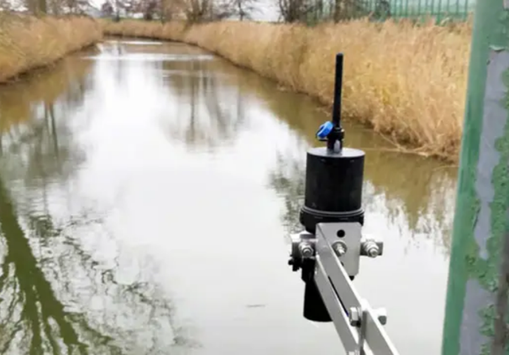The first possible sensor is a radar level sensor. This sensor measures the water level using radar, which means that it should hang perpendicular above the water. Advantages are that these sensors are very compact and robust. They have no troubles in adverse weather conditions. Additionally, they can communicate their measurements through radio signal. (iJiNUS - Groupe Claire, 2024)

Figure 4: A sensor mounted straight above the water level

A Lidar sensor is the second sensor that belongs to the possibilities. Such a type of sensor works by emitting a laser pulse and measuring its time-of-flight till it returns to the sensor, as depicted in Figure 5. An advantage to the radar level sensor, is that such a sensor doesn't have to hang straight above the water, but can also operate under an angle. This does decrease the accuracy, but only on centimetre level, so that could still be applicable for the case of a FEWS. (AGU - Advancing Earth and Space Sciences, 2024) Lastly, it is possible to use a camera. This camera records the flow of the river and can use an open source, such as pyorc (pyOpenRiverCam 0.5.6, 2023), software to analyse the flow. In that way, the camera can 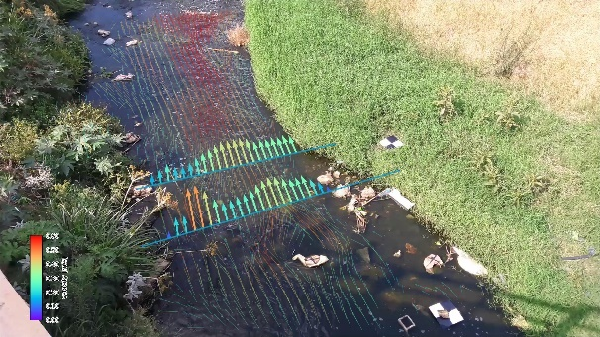measure water level and the flow velocity, which means that a rough estimation of the flow can be made.

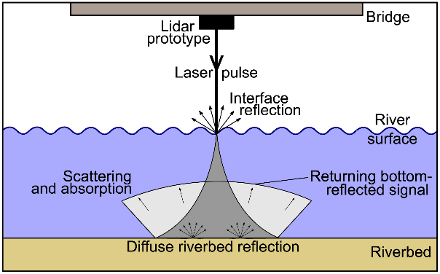

Figure 5: Functioning of a lidar sensor

Figure 6: Camera for water measurement

There are more non-contact methods available to measure water level, such as using GPS. However, these methods are deemed to be less applicable than the sensors above. In short, Table 3 gives an overview of the discussed sensor and their applicability.

Table 3: Summary of possible types of sensors and their required installation method

|  |  |  |
| --- | --- | --- |
| Type of sensor | Straight/under angle | Measures |
| Radar level sensor | Straight | Water level |
| Lidar | Both | Water level |
| Camera | Angle | Water level  Flow velocity |

## 6.3.2 Selecting the sensor

The sensor is a crucial element in the FEWS. Therefore, it is important to consider the different aspects that come into play when selecting a sensor. The previous section discussed the different types of sensors, while this section introduces criteriums that can guide the user to select the proper sensor.

Firstly, the costs of the sensor are important. A very expensive sensor can measure very accurately and possibly multiple things. However, a very expensive sensor will highly impact the implementation costs of a FEWS, which reduces its applicability in small urban areas in Africa. Additionally, what if the sensor gets stolen? It will be very costly to replace it.

Secondly, robustness is important. A sensor that requires a lot of maintenance, is not as suitable for a FEWS, as there is a higher chance of operation being compromised. The sensor for this application will most likely experience adverse weather conditions, so it better be able to withstand such type of conditions.

Additionally, the power required for operation is of concern. In the areas of application, the sensor will likely be placed at a somewhat remote place, which is a difficult location to get power to. It's not impossible, but it could increase the complexity of the FEWS.

Lastly, the communication method should be considered. If data can only be stored on a SD-card for example, how can people ever be warned on time that a flash flood is coming? This criterium is probably less dependent on the sensor itself, but it is important to keep it in mind when selecting one.

In conclusion, when looking at possible sensors, one should consider factors such as costs, robustness, power use and communication methods. These criteriums can guide the user in selecting the proper sensor for the application at hand.

# 6.4 Installation of the sensor

Building on the proceeding steps, the sensor can now be installed. Do mind that there are many different considerations to be taken into account. Looking at previously installed sensors a lot can already be learned. Within Kenya, Ghana and numerous other African countries, many examples of sensors being stolen or destroyed can be found. Destruction can be humanly intended, but also wildlife and weather conditions play a roll. Furthermore, failure of the sensor itself is a possibility, which leads to the requirement of maintenance and repair, and therefore accessibility. Lastly, the functioning of the sensor places important restrictions on its placement, e.g. above or in the water. Depending on the communication of the warning, cell reception might also be a requirement.

## 6.4.1 Location

Looking at the upper boundary condition determined in chapter “*2.2 Gauge placement*”, the minimal required distance between the bottleneck and the sensor is determined. And thus a first rough location of placement is established. Considering the specific placement methods required by each type of sensor, a second constraint on the location is added. Building on this, a couple of characteristics that describes a suitable location should be sought:

* Accessibility to perform maintenance
* Property of governmental or social institutions with limited access for the general public
* Access to a power source or enough year round sunlight for a solar panel
* Possible integration with the existing infrastructure

In case there are no governmental or social institutions available for the placement of the sensor. The option of local involvement should be investigated. This is tricky as often compensation is expected for looking after the sensor. Something that might be discontinued when interest or budget changes occur. From which one can expect the involved local people to stop caring for the sensor.

An alternative to the (monthly) compensation is in making some of the members of the local community a representative for the sensor. This is an idea that followed from Josiah Kahuthu, working at the KMD office of Narok Town. The representative does not receive any financial incentives, but if there is any display of functioning, think of a conference, this person is invited and acts as spokesperson. It is a different approach to the same involvement of the local community.

## 6.4.2 Installation

Each type of sensor requires its own placement and installation. Nonetheless, there are some general considerations to take into account when looking at the installation of the sensor. Starting with the robustness of the sensor and the installation.

Whether the placement of the sensor takes place on governmental/social institutional grounds, or on locally owned land, the construction should be robust and durable. Firstly, it has to withstand all the natural forces involved in flash floods while still being able to function properly. Heavy winds or rains are common and should not interfere, especially in the giving out the warning. On top of that the sensor has to be temper proof. As case studies learned, they often get stolen.

A solution might be found in working with rigid materials like steel or concrete. The materials are both durable and temper resistant. Which both fulfil the requirements discussed above. Combined with placement under for example a bridge, or high up a pole, the chances of the sensor being tempered with are further reduced. The downside of this approach is discussed in the next section.

## 6.4.3 Maintenance

Maintenance might be required at any moment throughout the lifespan of the sensor and therefore it should be accessible. Using the described rigid materials or placement on an inaccessible location, works against the principle of accessibility for maintenance. An option to solve this, is another way of installation, based on the principle of “hiding in plain sight”.

By using everyday items to hide the sensor in, think for example of bee hives, or by placing it on structures that people normally do not interfere with, like power lines, the chance of theft can be reduced. This simply because people notice the sensor less.

Each of the installation strategies have their own up- and downsides and they weigh differently in each application. It is therefore very important to look into the local context before installing the sensor.

Bibliography

AGU - Advancing Earth and Space Sciences. (2024, October). *Online Library*. Retrieved from agupubs: https://agupubs.onlinelibrary.wiley.com/?skip=true

Allen, H. G., David, C. H., Andreadis, M. K., Hossain, F., & Famiglietti, J. S. (2018, April 26). Global Estimates of River Flow Wave Travel Times and Implications for Low-Latency Satellite Data. *Geophysical Research Letters*, pp. 7551-7560. doi:https://doi.org/10.1029/2018GL077914

ICIMOD. (2024, October). *Community Based Flood Early Warning Systems - How does it work?* Retrieved from icimod.org: https://www.icimod.org/mountain/cbfews-how-does-it-work/

iJiNUS - Groupe Claire. (2024, October). *LNR06V4 - Battery Powered Radar Level Sensor*. Retrieved from ijinus.com: https://www.ijinus.com/produit/by-activity-en-en-en/environment-en/lnr06v4-battery-powered-logger-with-integrated-radar-level-sensor/?lang=en#tab-description_tab

Luna B. Leopold, T. M. (1953). *The hdyraulic geometry of stream channels and some physiographic implications.* Washington, D.C.: United States Government Printing Office.

Meyer, A., Fleischmann, A. S., Collischon, W., Paiva, R., & Jardim, P. (2019, Jan 21). Empirical assessment of flood wave celerity–discharge relationships at local and reach scales. *Hydrological Sciences Journal*, pp. 2035-2047.

NASA's Earth Observing Centre. (2024). *Shuttle Radar Topography Mission (SRTM)*. Retrieved from eospso.nasa.gov: https://eospso.nasa.gov/missions/shuttle-radar-topography-mission#:~:text=The%20Shuttle%20Radar%20Topography%20Mission,digital%20topographic%20database%20of%20Earth.

Poole, D. L. (2024). *Rapad hydraulic assessment tool for river floods using hydraulic geometry relations in data scarce areas.* Delft: Delft University of Technology.

pyOpenRiverCam 0.5.6. (2023). *Welcome ty pyOpenRiverCam's documentation!* Retrieved from local devices github: https://localdevices.github.io/pyorc/

TEMBO. (2024, October 4). *Transformative Environmental Monitoring to Boost Observations in Africa*. Retrieved from https://temboafrica.eu/

TEMBO Africa. (2024). *Design Modular Flood Early Warning System (FEWS) - V1.*

United Nations Office for Disaster Risk Reduction. (2024, October). *Flash Flood*. Retrieved from UNDRR.org: https://www.undrr.org/understanding-disaster-risk/terminology/hips/mh0006

US Army Corps of Engineers - Hydrological Engineering Center. (2016). *HEC-RAS River Analysis System User's Manual - Version 5.0.* CPD-68.

Venutelli, M. (2005). *A Constitutive Explanation of Manning's Formula.* Meccanica, Springer.

Williams, G. P. (1978, December). Bank-full discharge of rivers. *Water Resources Research*, pp. Volume 14, Issue 6, page 1141-1154.

Appendix A. Spatial analysis of the catchment using QGIS

# Introduction

QGIS is a geographic information system (GIS) software that is widely used to analyze and visualize spatial information. The software is free and open-source and can be downloaded on Windows, macOS and Linux systems.

By using QGIS, the water system of your location can be analyzed and mapped. The goal of this manual is described below. In QGIS, extra attention should be paid to the method of saving and naming the files, since this is very important, and a clear overview of the created layers should always be present.

# Goal of this step

A Digital Elevation Model with a corresponding projection file is also needed as input for the HEC-RAS model, which is described later in this manual. By following the steps below, the required files will be created, as well as some visualizations and spatial information of the watershed. This is finished after the Paragraph Digital Elevation Model. Another goal of this step is to determine the watershed corresponding to the flood point of your location, and the watersheds of connected side streams in your river reach. The area of these catchments will be calculated.

# Required hardware

For this chapter of the manual, only digital data will be processed. The required hardware therefore is a laptop or computer, with internet connection.

# Required software

The QGIS software can be accessed and downloaded via [the website](http://www.qgis.org) of QGIS, or via [their repository](http://www.github.com/qgis/QGIS).

The latest version, as noted in October 2024, is QGIS 3.38 (Grenoble). The version used for the steps below is QGIS 3.36 (Maidenhead). For any of the QGIS 3 versions, the steps below will be suitable. [2]

# Step by step instruction

The step by step instruction is subdivided into three parts. First a QGIS project is created and the area of interest is selected. In the second part, elevation data is imported and processed. In the third part, channels and drainage basins of your area are delineated.

Many of the steps are based on YouTube videos of Hans van der Kwast, of the IHE Delft Institute for Water Education. [3] Multiple other free step-by-step instructions for hydrological applications in QGIS can be found on [[LINK](http://www.gisopencourseware.org/)].

## Area of interest and projection file

1. Open the QGIS desktop app on your computer
2. Click on **New Empty Project**
3. In the top bar, go to **Quick Map Services**, select **OSM** and then **OSM Standard**. This will give a window of OpenStreetMap on your screen. By hand, zoom in and go to the area of your interest.
4. Now select a projection zone. Click on the  icon in the bottom bar, which will open the **CRS** tab of the **Project Properties** interface. Here, select an appropriate Coordinate Reference System, preferably a WGS 84 UTM zone. The correct zone for your area can be found on the internet. Every Coordinate Reference System also has an EPSG code that corresponds. After selecting a WGS UTM zone, the window below will show a red selection of the included part of the earth; make sure the purple cross, defining the area you just zoomed into on your window, is inside the red selection. Click **Apply** and **OK**.

## Digital Elevation Model

1. To download elevation data, there are many possibilities, varying over different locations in the world. The method that is used in this manual is downloading Shuttle Radar Topography Mission (SRTM) data. In QGIS, a plug-in for SRTM data is available. Go to [4] on your top bar and select **Manage and Install Plugins**. Search for **SRTM-Downloader** and **Install Plugin**. Now the SRTM-Downloader should be visible under the **Plugins** menu.

*SRTM is a dataset of NASA and is open-source. The mission of February 2000 managed to cover approximately 80% of the Earth's Surface, namely between 60 degrees North and 56 degrees South, at a resolution between 30 and 90 meter.* ***Invalid source specified.***

AGU - Advancing Earth and Space Sciences. (2024, October). *Online Library*. Retrieved from agupubs: https://agupubs.onlinelibrary.wiley.com/?skip=true

Allen, H. G., David, C. H., Andreadis, M. K., Hossain, F., & Famiglietti, J. S. (2018, April 26). Global Estimates of River Flow Wave Travel Times and Implications for Low-Latency Satellite Data. *Geophysical Research Letters*, pp. 7551-7560. doi:https://doi.org/10.1029/2018GL077914

ICIMOD. (2024, October). *Community Based Flood Early Warning Systems - How does it work?* Retrieved from icimod.org: https://www.icimod.org/mountain/cbfews-how-does-it-work/

iJiNUS - Groupe Claire. (2024, October). *LNR06V4 - Battery Powered Radar Level Sensor*. Retrieved from ijinus.com: https://www.ijinus.com/produit/by-activity-en-en-en/environment-en/lnr06v4-battery-powered-logger-with-integrated-radar-level-sensor/?lang=en#tab-description_tab

Luna B. Leopold, T. M. (1953). *The hdyraulic geometry of stream channels and some physiographic implications.* Washington, D.C.: United States Government Printing Office.

Meyer, A., Fleischmann, A. S., Collischon, W., Paiva, R., & Jardim, P. (2019, Jan 21). Empirical assessment of flood wave celerity–discharge relationships at local and reach scales. *Hydrological Sciences Journal*, pp. 2035-2047.

NASA's Earth Observing Centre. (2024). *Shuttle Radar Topography Mission (SRTM)*. Retrieved from eospso.nasa.gov: https://eospso.nasa.gov/missions/shuttle-radar-topography-mission#:~:text=The%20Shuttle%20Radar%20Topography%20Mission,digital%20topographic%20database%20of%20Earth.

Poole, D. L. (2024). *Rapad hydraulic assessment tool for river floods using hydraulic geometry relations in data scarce areas.* Delft: Delft University of Technology.

pyOpenRiverCam 0.5.6. (2023). *Welcome ty pyOpenRiverCam's documentation!* Retrieved from local devices github: https://localdevices.github.io/pyorc/

TEMBO. (2024, October 4). *Transformative Environmental Monitoring to Boost Observations in Africa*. Retrieved from https://temboafrica.eu/

TEMBO Africa. (2024). *Design Modular Flood Early Warning System (FEWS) - V1.*

United Nations Office for Disaster Risk Reduction. (2024, October). *Flash Flood*. Retrieved from UNDRR.org: https://www.undrr.org/understanding-disaster-risk/terminology/hips/mh0006

US Army Corps of Engineers - Hydrological Engineering Center. (2016). *HEC-RAS River Analysis System User's Manual - Version 5.0.* CPD-68.

Venutelli, M. (2005). *A Constitutive Explanation of Manning's Formula.* Meccanica, Springer.

Williams, G. P. (1978, December). Bank-full discharge of rivers. *Water Resources Research*, pp. Volume 14, Issue 6, page 1141-1154.

1. Before you are able to download SRTM data with the plugin, you will need an account. A login menu will pop up while you are downloading and will give this [link](https://urs.earthdata.nasa.gov/users/new). Here, anyone can create an account in order to get access. Do this first, then proceed.
2. Select **SRTM-Downloader** under the **Plugins** menu. A window will open where you can select the area of interest. Click on **Set canvas extent** to download elevation data of the area that you zoomed into in step 3. Make sure the entire watershed of interest is included in this canvas extent, rather too large than too small. It will download multiple tiles, depending on the size of your area. The **Output-Path** can remain the automatic given option. Make sure the box **Load Images to QGIS** is selected and click on **Download**. The different tiles will appear in the layers box in your main window as a group called ‘srtm_images’ and will also appear as 1 layer all together.

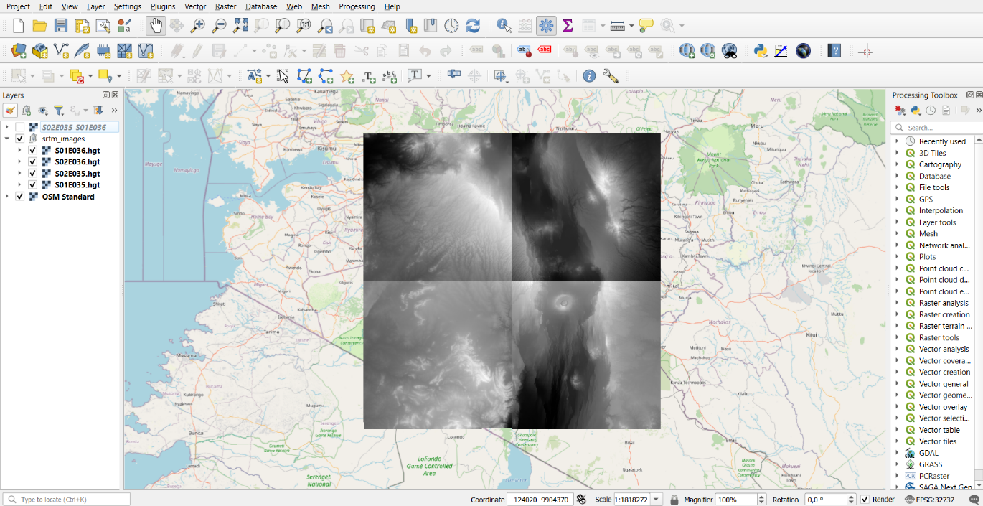

Figure 7: SRTM elevation data downloaded in a QGIS project for Narok county, Kenya

1. By selecting the separate tiles identify which tiles you will need to cover the watershed of interest. Delete the tiles that are not of interest (right click on tile in layers list and select **Remove layer**). Now mosaic the elevation tiles: from the **Raster** menu select **Miscellaneous**, then **Build virtual raster**. As **Input layers** select the tiles that you want to use, click **OK** on the right side and then uncheck all other boxes in the window. On the right side of the box *[Save to temporary file]* click on the three dots and select **Save to file…**. Give your file a clear name, for example *DEM_mosaic.vrt*. Now click **Run**. The new mosaic layer will appear in the list of layers, probably called **Virtual**.
2. Now reproject this file as a TIFF file. Select the **Virtual** layer, go to the **Layer** menu on top and select **Save as…**. Select as **Format** GeoTIFF in the drop-down menu. Click on the button with three dots and give the layer a name, for example *DEM_mosaic.tif*. Make sure the correct **CRS** is selected that you chose in step 4, then click **OK**.
3. Delete all unnecessary layers in the list of layers, except for the TIF file of *DEM_mosaic* and the *OSM Standard map*.
4. Make a subset of the elevation layer. From the **Raster** menu select **Extraction** and then **Clip Raster by Extent…** As **Input layer** use the DEM_mosaic layer.Clip a hand drawn box on the screen () to select approximately the area that you will need, from river source to flood point. Again, rather too large than too small. Drawing the box will be easiest on the OpenStreetMap layer, so make sure beforehand that this is the upper layer. Via the three dots, **Save to file** as TIF file, for example named *DEM_subset.tif*. Now click **Run**.
5. In the elevation data, there is probably some missing values and so-called sinks, which can occur at lakes or other difficult points. The SAGA plug-in is used to fill those sinks in the layer. If SAGA is not already in the Processing Toolbox of your QGIS, you first need to install it as a plugin, in a similar way as in step 5. Then search for the option **Fill sinks (wang & liu)** in the **Processing Toolbox** (). As DEM use *DEM_subset*, keep minimum slope at standard value. We are only interested in the **Filled DEM** option, so here save a file via the three dots, as *DEM_filled.sdat*, and click **Run**. It might take a while, depending on the size of your area.
6. Again, delete all layers that are no longer required. This is good practice in QGIS, since a clear overview of the different layers is important to prevent mistakes. Only keep *OSM Standard* and *DEM_filled*.
7. The DEM is now approximately finished. In order to create visualizations of the elevation data, style the properties of the layer. Go to the **Layer properties** menu by double clicking on the *DEM_filled* layer. In **Symbology** select Singleband pseudocolor as **Render type**. From the **Color ramp** drop-down menu, choose **Create new color ramp**, in the new window select **Catalog: cpt-city**. In this catalog, under the tab Topography, choose elevation. Choose **Apply** and **OK**.
8. Create a hillshade layer below the DEM layer to visualize hills. Right click on the layer DEM_filled and **Duplicate Layer**. In the **Processing Toolbox**, search for **Hillshade**, use the *DEM_filled copy* as input and click **Apply**. Right click on the new layer and **Save as** GeoTIFF file, for example called *DEM_hillshade.tif*. Delete the old layer *Hillshade*. Now, go to the properties of the new layer *DEM_hillshade* and under **Layer Rendering**, select Multiply as **Blending mode**. Choose **Apply** and **OK**.
9. 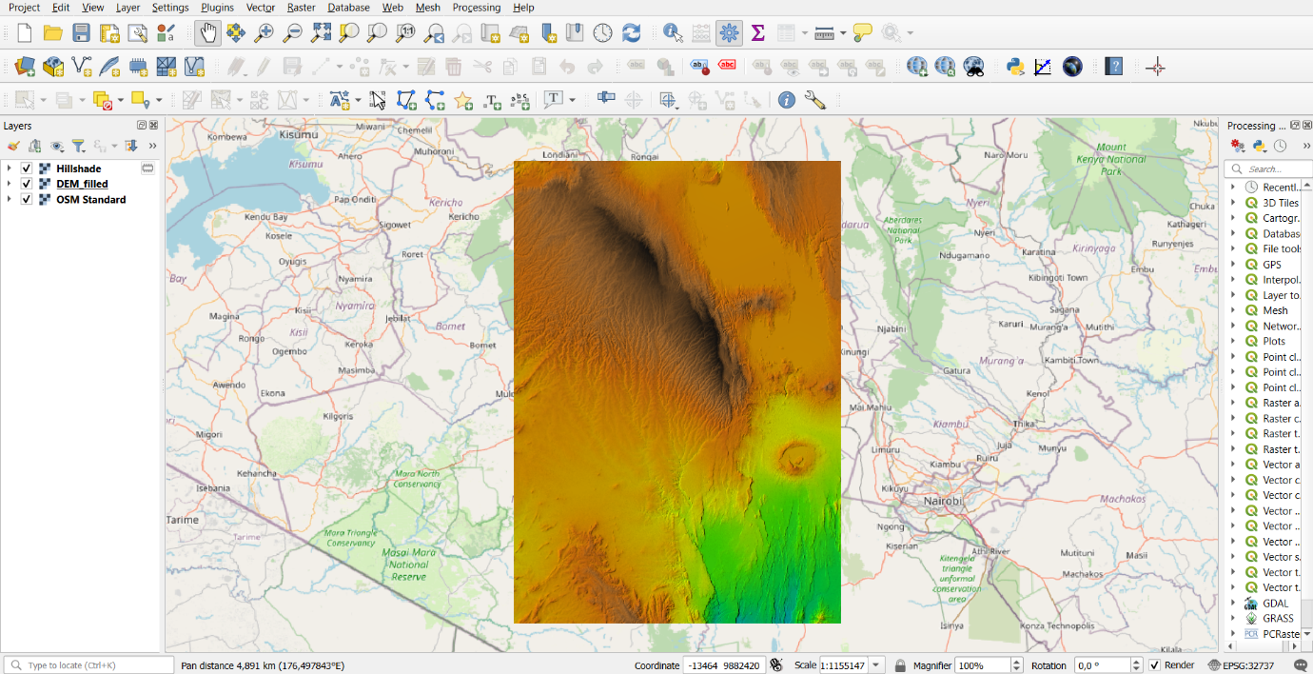As input for the HEC-RAS model, as is described in another chapter, both a TIF file and a corresponding projection file (PRJ) are required. For this, we will use the *DEM_filled*. In the QGIS folder on your computer a prj-file will already be present, called *DEM_filled.prj*. The *DEM_filled* layer is only a sdat-file at the moment. Right click on the layer and choose **Export** and **Save as…**. As **Format**, select GeoTIFF, click on the three dots and save the file as *DEM_filled_GeoTIFF.tif* in the same folder as all other layers. Make sure the **CRS** is the same as you selected in step 4, then click **OK**. Copy the style of the old *DEM_filled* layer, by right-clicking and selecting **Styles** and **Copy style**. Right-click on the new *DEM_filled_GeoTIFF* layer and select **Styles** and **Paste style**.

Figure 8: Result of the step Digital Elevation Model, in QGIS

## Delineate streams and catchments

In QGIS, based on the elevation data, you can delineate the natural streams, as well as the borders of (sub)catchments. Depending on the comprehensiveness of the study that you are conducting, you can choose whether to follow the steps underneath. The result will be a visualization of the total catchments, different sub catchments, for example for side streams connecting to your river reach, together with the streams.

1. The SAGA plug-in, that is installed in step 12, will again be used in this step. Search in the **Processing Toolbox** for the option **Channel network and drainage systems**. In the window that pops up, use as **Elevation** the *DEM_filled* file (not *DEM_filled_GeoTIFF*), The threshold is based on the Strahler order that you want to display. This will depend on the water system that you are looking at. Use for example **threshold** 5 or 6. Keep the box **Subbasins** selected. We are only interested in the channels and drainage basins. For the options **Flow Direction [optional]**, **Flow Connectivity [optional]**, **Strahler Order [optional]**, **Drainage Basins [optional]**, and **Junctions [optional]** on **Skip Output**, via the three dots on the right side. For the options **Channels** and **Drainage Basins**, choose **Save to File** and save both as a shapefile (shp) with clear names in the general folder for this QGIS project, for example *channels.shp* and *drainagebasins.shp*. Then click **Run**. This will take a while, depending on the size of the area of interest.

*The Strahler stream order is used to define stream size, based on the hierarchy of tributaries. A stream is considered as a mathematical tree, where the first stream, coming from the spring, has Strahler number 1. When another first order stream connects, the streams together form a stream with Strahler number 2. Only when another second order stream connects, the stream will get Strahler number 3.*

1. Adjust the channels and drainage basins, as wanted. For the channels, go to the **Properties** of the layer, make the lines blue. For the drainage basins, go to the **Properties**, choose Categorized at the top and then click **Classify**. All drainage basins will now get a different colour.

*The streams that are now delineated, are purely based on elevation data of the terrain. The further away from the source, the more this will deviate from the actual stream. Due to human intervention, erosion, and many other factors, a stream can change its course. By selecting the channels layer together with the OpenStreetMap layer, you can check the accuracy of the defined channels. For our purpose, it is not a problem if the channels are a bit of, since it is only used to give an overview of the water system and to define the watershed, which will still be correct. In addition, this method will always give errors for flat areas and lakes, which will be expressed as straight lines in parallel.*

1. Now you’ll have many small sub basins However, you are interested in the total watershed from the flood point in your area of interest. Use the **Coordinate Capture** tool to find the coordinates of the flood point. This is a plugin, that can be installed via **Manage and Install Plugins** under the **Plugins** menu. The tool will appear in the bottom left corner, first click **Start capture**, then select the flood point in your screen. The coordinates will stay visible in the box in the corner.
2. In the **Processing Toolbox**, you will find the tool **Upslope area** under the SAGA package. With this tool, you are able to delineate the upslope area from a certain point. This will approach the watershed area from that point. Copy and paste the coordinates as **Target X coordinate** and **Target Y coordinate**, use the (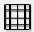) coordinates. Use *DEM_filled.sdat* as **Elevation**, and save the file via the three dots, for example as *catchment_floodpoint.sdat*.
3. Select the new layer, go to the **Raster** menu, to **Conversion** and choose **Polygonize (raster to vector)**. Save the layer as *catchment_floodpoint.shp*.
4. Change the **Properties** as needed. Choose a colour for the shapefile like blue and make the **Opacity** 40%.
5. The shapefile probably doesn’t consist of only one piece but has many small parts at the edge of the watershed. These smaller parts can be deleted via the **Attribute Table** () of the layer. In this table, choose **Field Calculator** (). Select the box **Create a new field**, give as **Output field name** the name *Area (m^2)*. As **Expression**, type *$area* in the white box and click **OK**. Now for every attribute of the layer, the area will be shown in the table. By clicking at the top of the column, you can order the attributes based on the area. Only keep the large attributes and delete all other attributes by selecting them (they will turn yellow with red edges in the main window) and clicking **Delete selected features** ().
6. Repeat steps 3-7 for any side streams that connect to the river reach that you are looking at. First select the coordinates at a point in the side stream just a little bit upstream from the junction and then create the watershed corresponding to that point. Give these shapefiles a clear name as *catchment_sidestream1.shp* and give them another colour with opacity 40%. Also determine the area as described in step 7.
7. Add labels to the different sub catchments, by going to the **Properties** of a layer, on the left side go to **Labels**, choose **Single label** and as **Value** select *Area* which you added yourself. Play with the Text/Buffer/Placement to get the view as you like. Note that all areas are determined in square meters.
8. 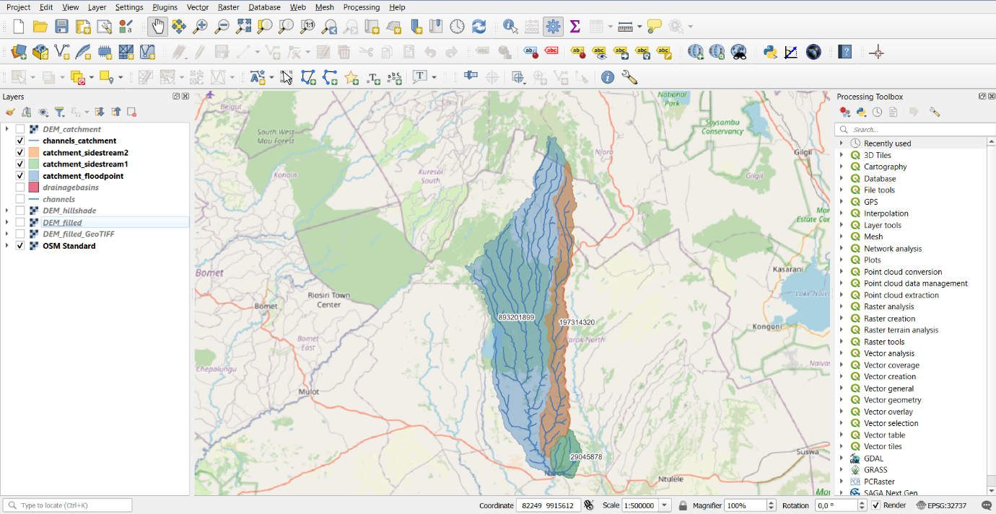Now clip the channel layer to the catchment of the flood point, since this is the only area you are interested in. Select the channels layer, and go the **Vector** menu, select **Geoprocessing tools** and choose **Clip**. As **Input layer**, choose the *channels.shp*, and as **Overlay layer** choose *catchment_floodpoint.shp*. Save as *channels_catchment.shp*.

Figure 9: View of delineated (sub) catchments, with water streams, in QGIS

1. The same can be done for the Digital Elevation Model. Go to **Raster** menu, select **Extraction** and choose **Clip Raster by Mask Layer**. As **Input layer** choose *DEM_filled*, as **Mask layer** choose *catchment_floodpoint*. Specify a NoData value, like 0, save as *DEM_catchment.sdat*. Copy and paste the style of the old *DEM_filled* layer and apply to this layer. Make all 0-values transparent.

# How to save a QGIS project?

In order to properly save a QGIS project, all layers need to be saved correctly, by using the **Save as** option. Save all layers in 1 folder, and refrain from moving these files once saved.

Under the **Project** menu, select **Save as** and save the QGIS project as a project file on your computer. Give the project a clear name, such as *[Rivername]-Project.qgz*.

## Save as GeoPackage

In order to save QGIS projects in a more compact manner, and to also be able to share the spatial information, a project including all layers and their corresponding files can be saved as a GeoPackage. Start with a window displaying the QGIS project, with all layers that you will want to include. There are two options:

#### Exporting the entire project

In the **Project** menu, select **Package Project**. Here, select as **Format** GeoPackage and specify the name and location of the file, for example *[Rivername]-GeoPackage.gpkg.*

#### Exporting layers individually to a GeoPackage

For each layer, do the following: right-click on the layer in the Layers list, select **Export** and then **Save Features As…**. In the **Format** drop-down menu choose GeoPackage. Click on the button with three dots and specify a name and location for the GeoPackage, for example *[Rivername]-GeoPackage.gpkg*. As **Layer Name** specify a name for that layer within the GeoPackage. For clarity, use the same name you were already using. Now click **OK** and repeat for the other layers.

## Save layer properties

By sharing or moving layer files, the properties of these files can get lost. These properties can include coloring, labeling, transparency, etc. To prevent this from getting lost, you can save a layer style separately. A saved style can always be loaded into a layer from the computer it is stored on. To save a style, go to **Layer Properties** by double clicking on the layer. At the bottom of the **Symbology** window, select the **Style** drop-down menu and choose **Save Layer Style**. Save the style as QGIS QML style file and select a name and location via the three dots, for example *DEM_style.qml*. Click **OK**.

# How to export images from QGIS?

After gathering and analyzing spatial data in QGIS, you can export this spatial information as maps. These maps can include multiple views of the main window, a legend, scale bars, extra blocks and arrows, etc. This way you can export the gathered data exactly as you want to.

## Creating a basic print layout

1. Under the **Project** menu, choose **New Print Layout**. A new window will open, while the main window remains open as well. First, you will be asked to give the print layout a name. In this name, clarify what you want to show in this print, for example elevation data or catchment delineations

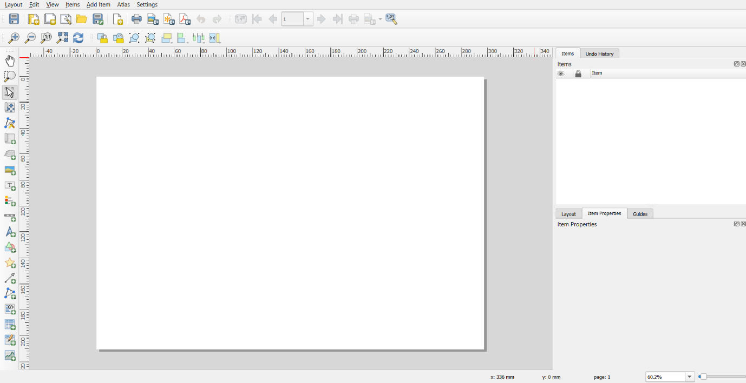

**5**

**4**

**2**

**3**

**1**

Figure 10: Print Layout window, with circles around the options that will be used in these steps

1. Click **Add Map** (circle 1 in Figure 8) and create a field on the paper. In this map, automatically the view will be given that is also in your main window. In your main window, select the layers you want to show and the approximate zoom-level. When a change is made in the main window, this will update in the map window.
2. Add a title to your map, via **Add Label** (circle 2). The text, font, and size can be added in the window in the bottom right corner (**Item Layout**).
3. Add a legend to your map, via **Add Legend** (circle 3). In the bottom right window, you can select the layers you want to feature, by deselecting the box **Auto update**.
4. For correctness of the map, also add a scale bar via **Add Scale bar** (circle 4), and a North arrow, via **Add North Arrow** (circle 5). Select a place to place them with your mouse.

## Expanding the Print Layout

By following the steps above, a basic map is created. There are many other options available in **Print Layout**, of which an overview is given here.

* You can include more than 1 map on a print layout, for example including a zoomed-in section. Simply add another map and modify the content.
* Add grids or graticules to help with reading locations. This can be customized as you like, changing intervals, line styles, and labels.
* Add custom shapes, such as rectangles, circles, polylines, arrows, and markers. This can be done for decoration, emphasis, or annotating areas of interest.
* Add external images such as logos, photos, or other visualizations to the print layout.
* Insert a table with information. This can be filled with a list of attributes from a layer.
* You can also add attribute charts, such as bar charts, pie charts, etc.
* Customize layout settings as you like. As default, the print layout will be given in A4 and landscape-oriented, but this can be customized. It is also possible to create multi-page layouts.
* Any element that is placed, can be customized and styled as you like: text styles, fonts, colors, line thickness, symbols, etc. Additionally, you can adjust transparency levels and apply blending modes.

## Exporting a Print Layout

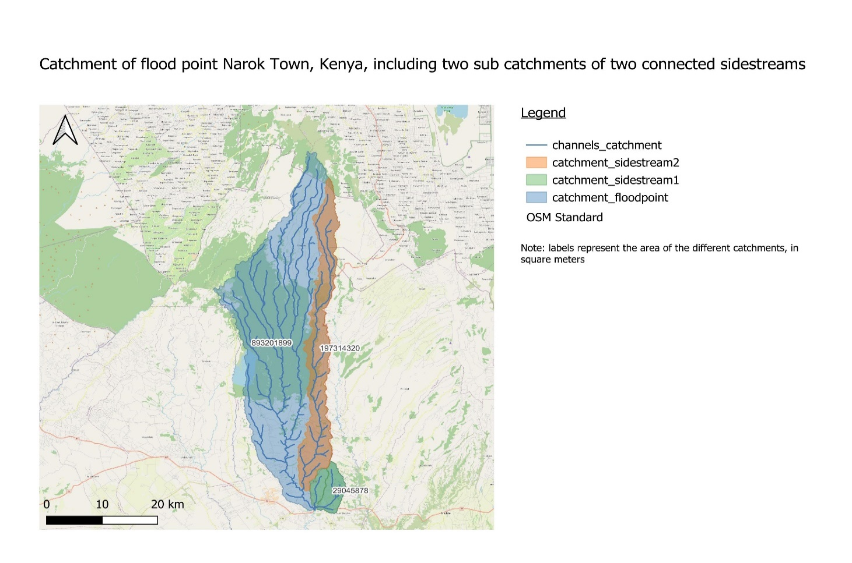While working on a print layout, make sure to save the project in between. When finished, the print can be exported, as image or as PDF. Under the **Layout**, choose **Export as Image** or **Export as PDF**. As default, the name of the print layout will be given to this new file.

Figure 11: Exported JPG file of a print layout, in QGIS, showing the total catchment of the flood point and two sub catchments, with their area in m^2

If you want to create multiple prints, with a consistent layout, then first create a print layout exactly the way you want all to be. In this layout, under the **Layout** menu, choose **Save as Template**, and save with a clear name in the folder you were using. From the main window of QGIS, add a new print layout. In this new blank window, choose **Add Items from Template** under the **Layout** menu. Now select the template that you created and change anything that needs to be changed. [5]

Appendix B. Installation Manual GNSS Receiver

# Introduction

This appendix discusses the use of the ArduSimple surveyor kit for cross-sectional and longitudinal river profile measurements. The ArduSimple set-up was choses for its ability to provide high-precision GNSS positioning affordably.

For the surveying Post Processing Kinematic (PPK) methods are used. This rather than the more commonly used Real Time Kinematic (RTK). The fundamental distinction between PPK and RTK lies in the timing of the corrections applied to the data. Where RTK corrects data in real-time (during the measurement process), PPK applies these corrections afterwards, during post-processing. This key difference offers greater flexibility for fieldwork. With PPK, the base and rover do not need to maintain visual contact, which is typically required in RTK setups. Consequently, the distance between the base and rover can extend up to 15 or 20 kilometres, making PPK particularly advantageous for surveying in challenging terrains. This method proved useful for the project in Narok, Kenya.

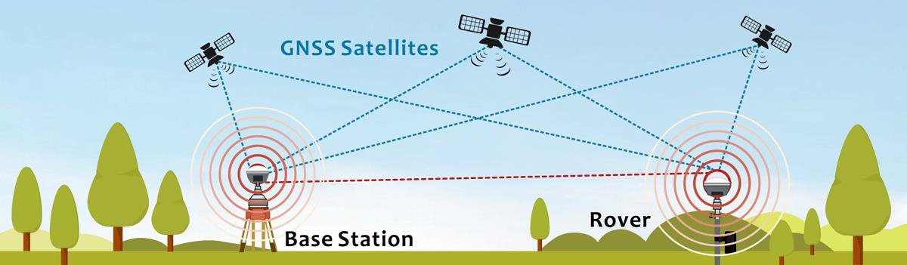For more information on PPK and RTK please follow this [[LINK](https://coptrz.com/blog/ppk-or-rtk-which-is-best/#:~:text=RTK%20is%20applying%20correction%20to,capturing%20images%20from%20a%20site)].

Figure 12: Overview Ardusimple setup based on RTK [[LINK](https://link.s]pringer.com/article/%5d10.1007/s12517-021-08857-8/figures/1)]

# Goal of this step

* Hardware installation of the ArduSimple GNSS base and receiver
* U-Centre Software installation
* RTKsoftware installation
* Software set-up on the ArduSimple GNSS

# Required Hardware

**ArduSimple:**

* 2x simpleRTK2B Pro [[LINK](https://www.ardusimple.com/product/simplertk2b-pro/)]
* 2x Serial data logger [[LINK](https://www.ardusimple.com/product/serial-datalogger-to-microsd/%22)]
* 1x U-Blox GNSS Multiband antenna ANN-MB-00 [[LINK](https://www.ardusimple.com/product/ann-mb-00-ip67/)]
* 1x Budget Survey GNSS Multiband antenna (IP66) [[LINK](https://www.ardusimple.com/product/survey-gnss-multiband-antenna/)]
* Thread adapter for the Antenna [[LINK](https://www.ardusimple.com/product/adapter-survey-gnss-multiband-antenna/)]

**Other**

* 2x USB-A to USB-C cable +/- 0.5 [m]

# Required Software

* U-Center
  + The installation of U-centre is discussed under “*U-centre Installation”*
* RTKconv, RTKpost
  + The installation of RTKconv and RTKpost is discussed under “*RTKsoftware Installation”*

# Step by step instruction

## 1. Hardware installation Ardusimple Gnss reveiver and base

1. Unpack both simpleRTK2B Pro boards. In the figure below the ports that will be used are circled. The corresponding names to the number are given in the list below. In further steps the name and number are used as reference. For more information about the board and it’s functioning follow this [[LINK](https://www.ardusimple.com/simplertk2b-pro-hookup-guide/)].
   * (1) XBEE socket
   * (2) POWER+GPS USB
   * (3) GPS/GNSS Antenna
   * (4) XBEE switch
   * (5) POWER+XBEE USB

Figure 13: Overview of the simpleRTK2B Pro board

**1**

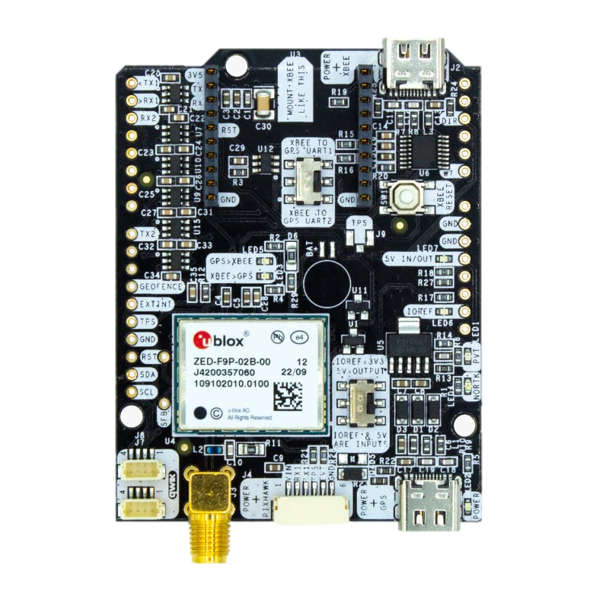

**3**

**2**

**5**

**4**

1. Both port *(2) POWER+GPS USB* and port *(5) POWER+XBEE USB* can serve as power sources. The board is designed to seamlessly switch between power supplies without disrupting its operations, which is crucial during field measurements. Please ensure to:
   * Always connect your computer to port *(2) POWER+GPS USB* for communication.
   * Always connect a power source to port *(5) POWER+XBEE USB*.
2. Make sure *(4) XBee switch* is set to “XBEE to GPS UART2”. Following the orientation of Figure , the switch should be in left position. Do this for both boards.
3. Unpack both *Serial data loggers*. They can be installed directly onto the *(1) XBEE socket* of the *simpleRTK2B Pro* boards. Make sure all pins of the *Serial data* logger are connected. See Figure 14 below for the correct installation and orientation. Do this for both boards.

Figure 14: Correct installation and orientation of the Serial Data logger

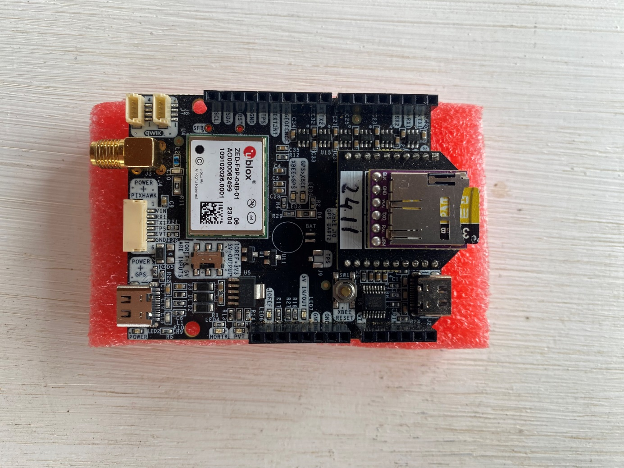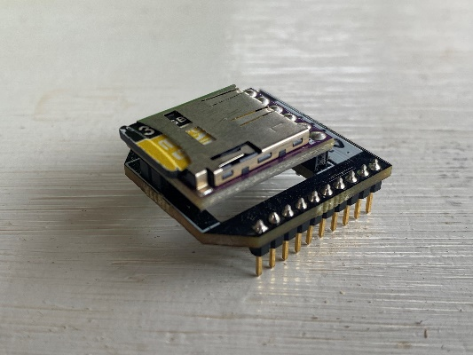

**1**

1. Carefully use a knife to modify the simple RTK2B Pro’s cardboard packaging. Create openings that ensure cable access to ports *(2) POWER+GPS USB*, *(3) GPS/GNSS Antenna*, and *(5) POWER+XBEE USB* while the lid is closed. Refer to Figure below for guidance. Do this for both boards.

Figure 15: Modify the cardboard package

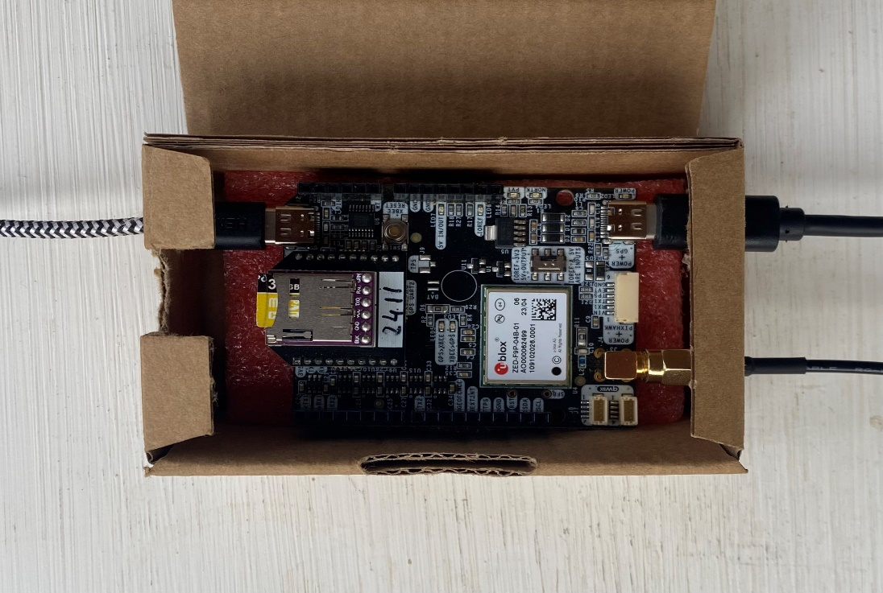

**3**

**2**

**5**

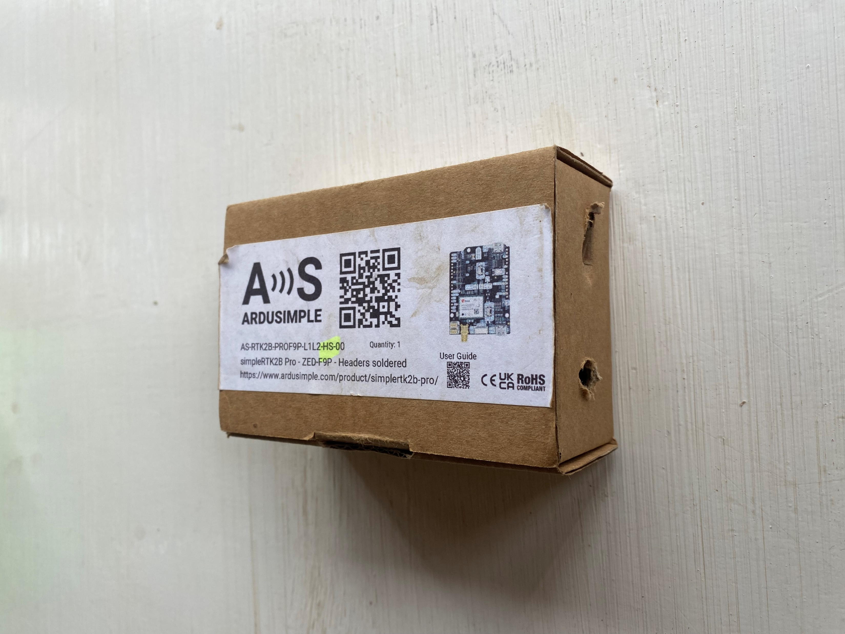

1. 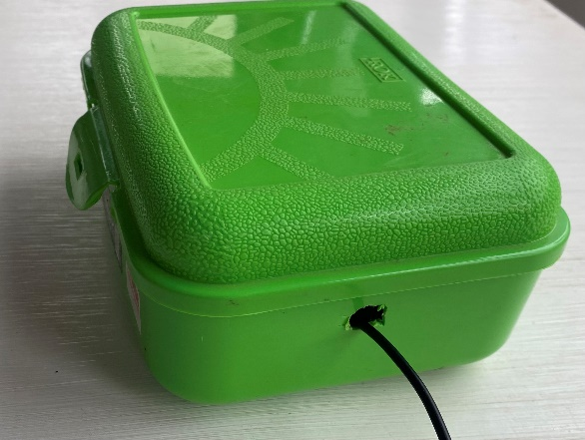Modify the container holding both the board and the powerbank to allow the antenna cable to be routed externally. An example is given in Figure 17.

Figure 16: External routing of the antenna cable

1. 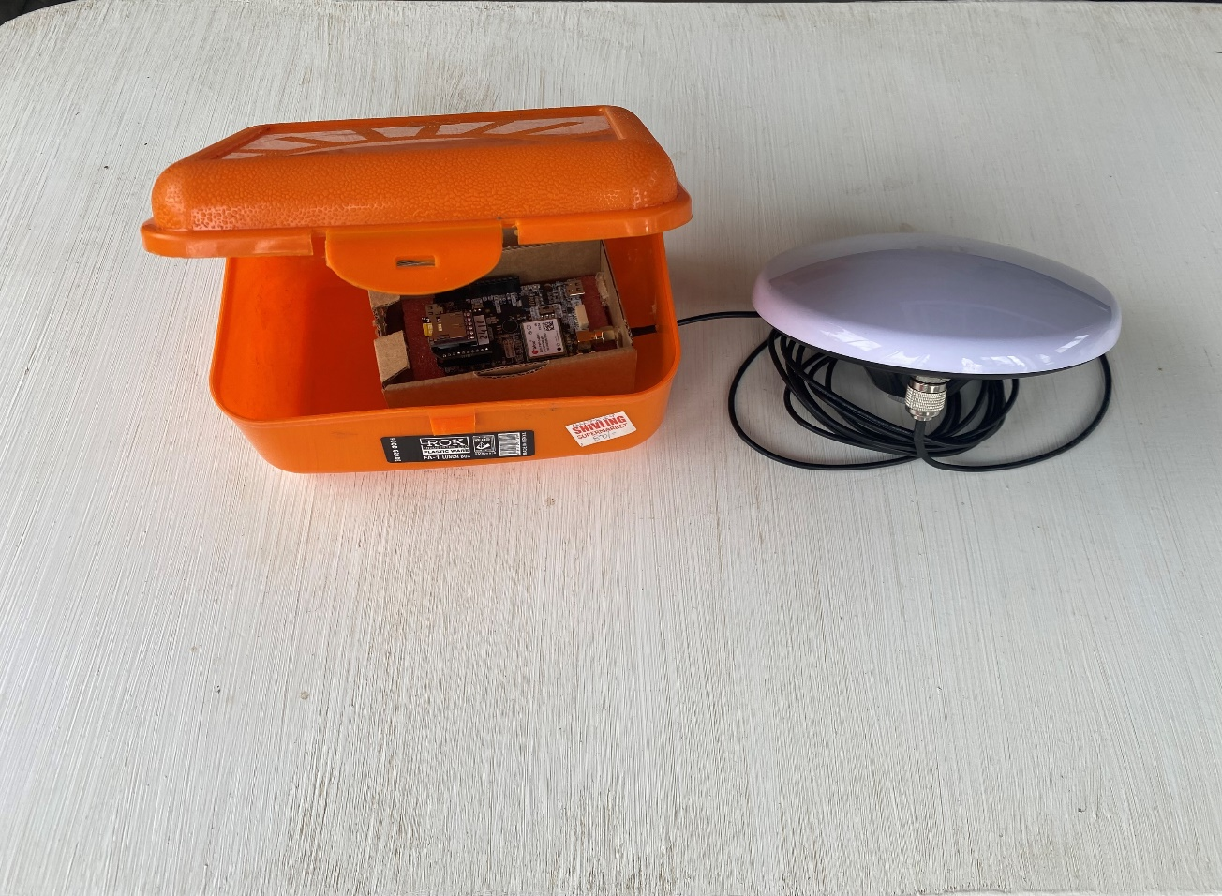Remove the *Budget Survey GNSS Multiband Antenna (IP66)* from its packaging. Connect the provided antenna cable to port *(3) GPS/GNSS Antenna* on the board and to the antenna port on the Multiband Antenna. Ensure the board stays within its cardboard packaging. Refer to Figure 16 for guidance. This configuration will serve as the Rover setup.

Figure 17: Rover configuration

1. 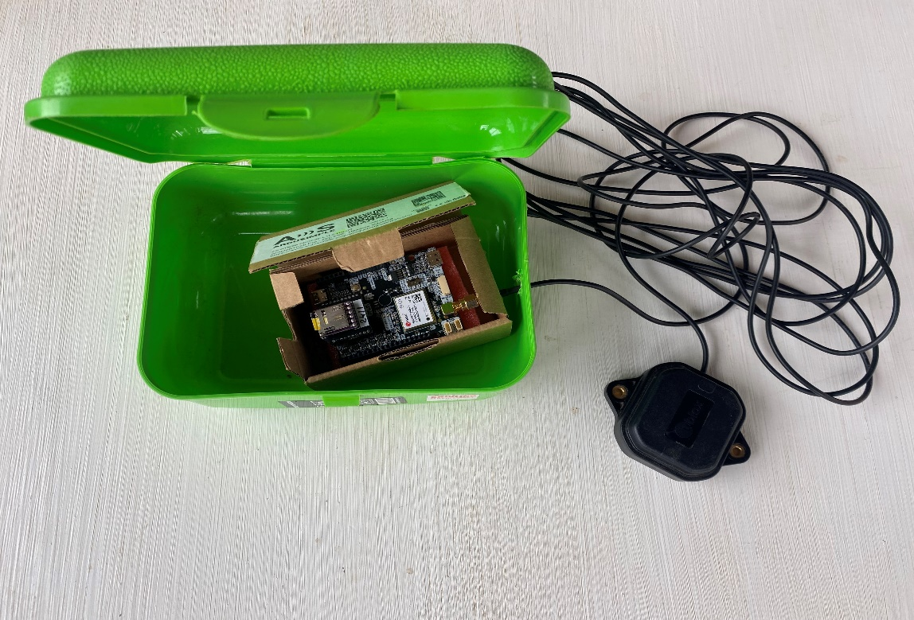Remove the *U-Blox GNSS Multiband antenna ANN-MB-00* from its packaging*.* Connect the provided antenna cable of the Multiband antenna to port *(3) GPS/GNSS Antenna* on the board. Again ensure the board stays within its cardboard packaging. Refer to Figure 18 for guidance. This configuration will serve as the Base setup.

Figure 18: Base configuration

1. The Base and Rover are ready for configuration. Proceed to the next step “*U-Center software installation”*.

## 2. U-Center software installation

1. Open your preferred web browser (e.g., Chrome, Firefox, or Edge).
2. Proceed to the U-Blox website and find the u-center page or follow this [[LINK](https://www.u-blox.com/en/product/u-center)].
3. Click the **Download** button on the U-Center software page. Please note that there is also an U-Center 2 version available, this is NOT the one to use.

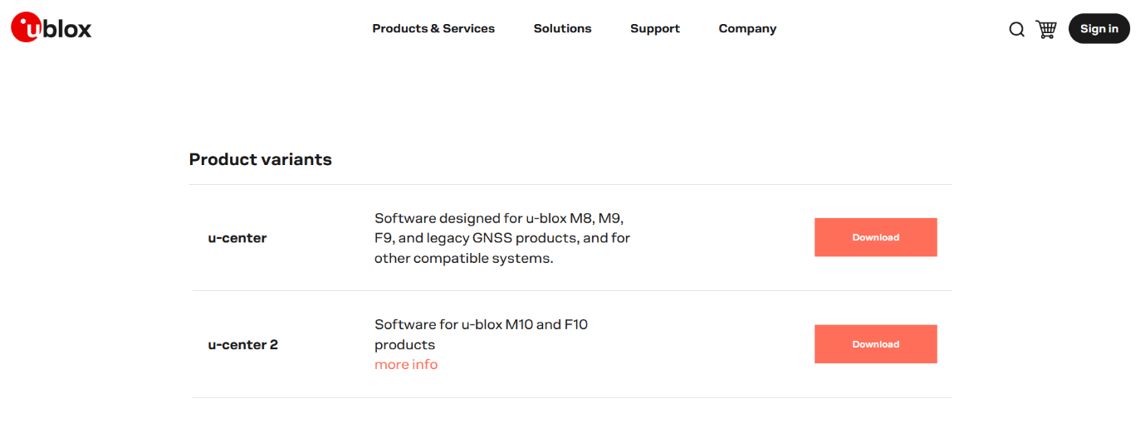

1. Wait for the download to complete.
2. From your *download* *centre*, open the downloaded zip folder.
3. Double click (left button) the **u-centre_v24.05.exe** file. One might be prompted with an anti-virus software message “*Do you want to allow this app to make changes to your device?*”. Click **Yes** or **Run** to allow the installer to open.
4. A setup window will appear. The first requesting to select a language. In this demo, English is set by clicking the **OK** button.

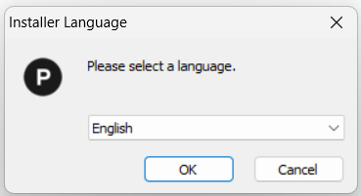

1. Click **Next** on the introduction screen.
2. Read and accept the License Agreement by clicking **I Agree**.
3. At the “*Choose Components”* step, make sure “*u-center 24.05*” and “*Drivers”* are selected. Then click **Next.**

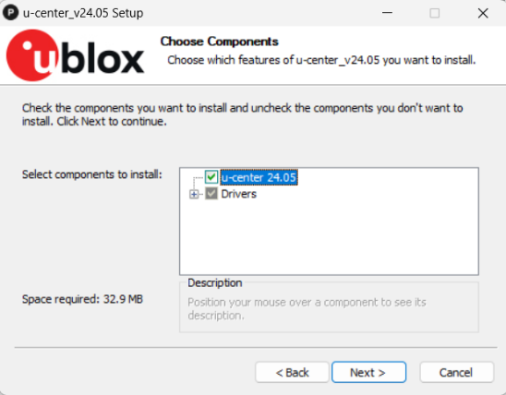

1. The last step, “*Choos Install location”*, offers the opportunity to choose an installation folder. One is set by default. To change this location click **Browse…** and find a preferred location. Then click **Install.**
2. Wait for the installation process to finish.
3. When the installation is complete, click **Finish**. The software automatically opens.
4. The software is now ready to install the drivers on the base and rover. Proceed to the next step “*Configuration of the GNSS Base and Receiver”.*

## 3. RTKsoftware installation

1. Again proceed to your preferred browser (e.g., Chrome, Firefox, Edge).
2. Proceed to GitHub and find the rtklibexplorer page by following this [[LINK](https://github.com/rtklibexplorer/RTKLIB/releases)].

*In case the link to the GitHub page does not work:*

Proceed to this [[LINK](https://www.ardusimple.com/how-to-do-post-processing-kinematic-ppk-with-free-software-rtklib/)]. If the link also does not work, the proceed to your preferred search engine (e.g. Google, Bing, Ecosia) and paste the following title:

“*How to do Post-Processing Kinematic (PPK) with free software RTKLIB”*

One should be able to find a page with the corresponding title on the Ardusimple website. When scrolling down, under “*Required software”*, RTKLIB GUI app is depicted in light-blue.

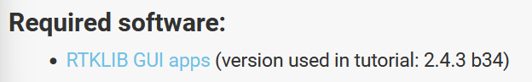

Follow this link to the GitHub Page. Then continue with step 3.3.

1. On the GitHub page, under the release note, “*Assets”* is found. The “*demoX_bXXk.zip”* folder depicted in light-blue. Depending on the version of the last release the numbers can change. For this tutorial the “*demo5_b34k.zip*” was used. By clicking on the **demoX_bXXk.zip** the files are downloaded.

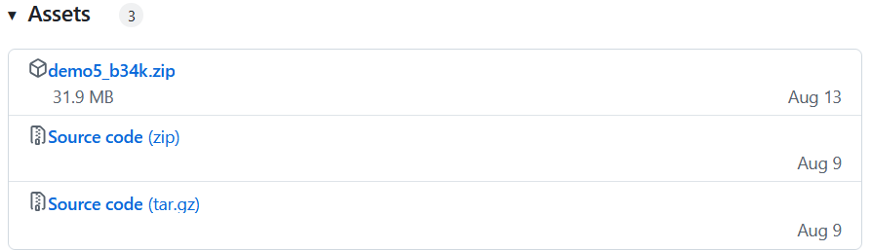

1. From your download centre open the downloaded .zip folder. By copying the “*demoX_bXXk*” folder inside the .zip folder, relocate the “*demoX_bXXk*” to a preferred location.
2. Open the folder and check if the following .exe files are present:
   * rtkconv.exe
   * 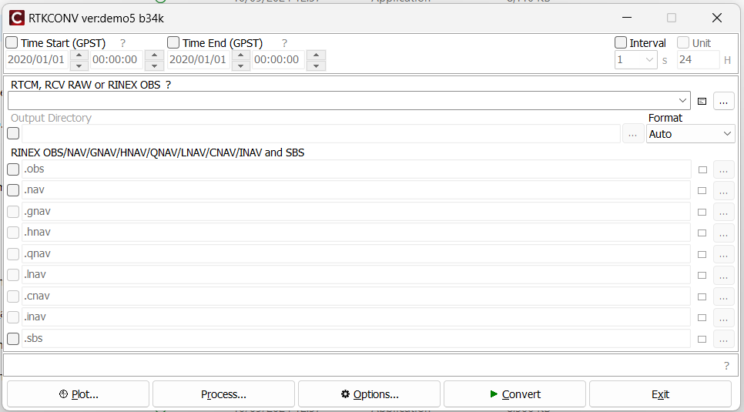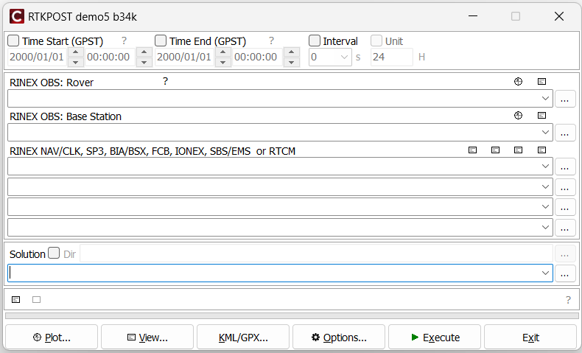rtk.post.exe
3. Now the required RKTsoftware is installed and ready to use. Proceed to the next step: “*Configuration of the GNSS Base and Receiver”.*

## 4. Configuration of the GNSS Base and Receiver

Please note that any software is prone to updates. This manual is written for the current version of the software (U-Center v24.5). If any of the following step fails, or if you are in need of further clarification, please refer to the following [[LINK](https://www.ardusimple.com/how-to-configure-ublox-zed-f9p/)].

c

1. Make sure the Rover and Base are connected to their antenna’s. See Figure and Figure how they are properly connected.
2. Place the antenna’s in such a position that they have a good view of the sky for testing functionality.
3. 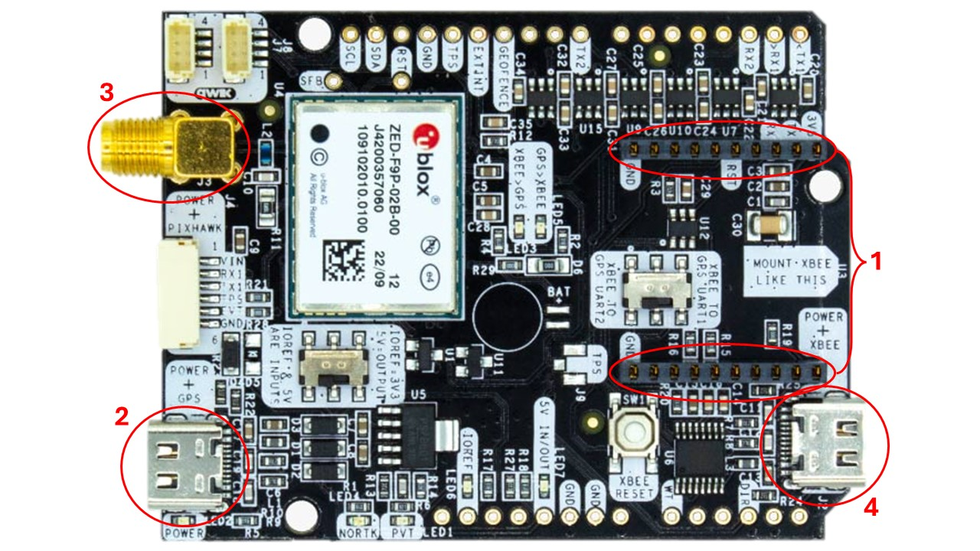Connect the computer to the board of the Base. Use the *(2) POWER+GPS* *USB*, this is a USB-C type of connection.
4. Open u-center. Select the **COM** port to connect your Base. If all is good, the connection symbol will turn green. If the Base does not show, one can restart U-Center. This often resolves the issue. Otherwise check the Device Manager of your PC to find the receiver.

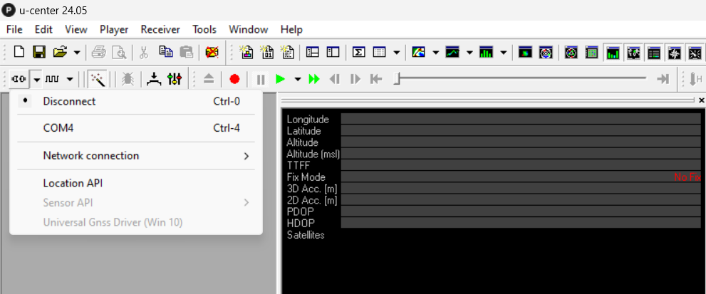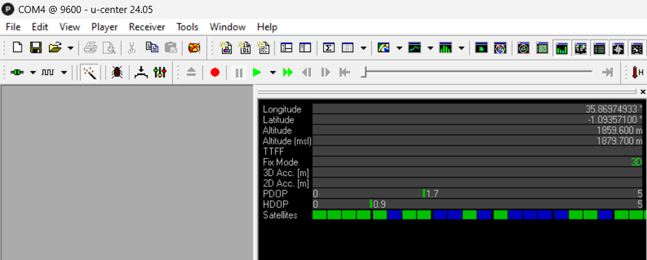

1. Check the firmware version of the Base by going to **View -> Message View -> UBX -> MON -> VER**. The firmware is either 1.13 or 1.32. In this case it is 1.32 as seen in the screenshot below.

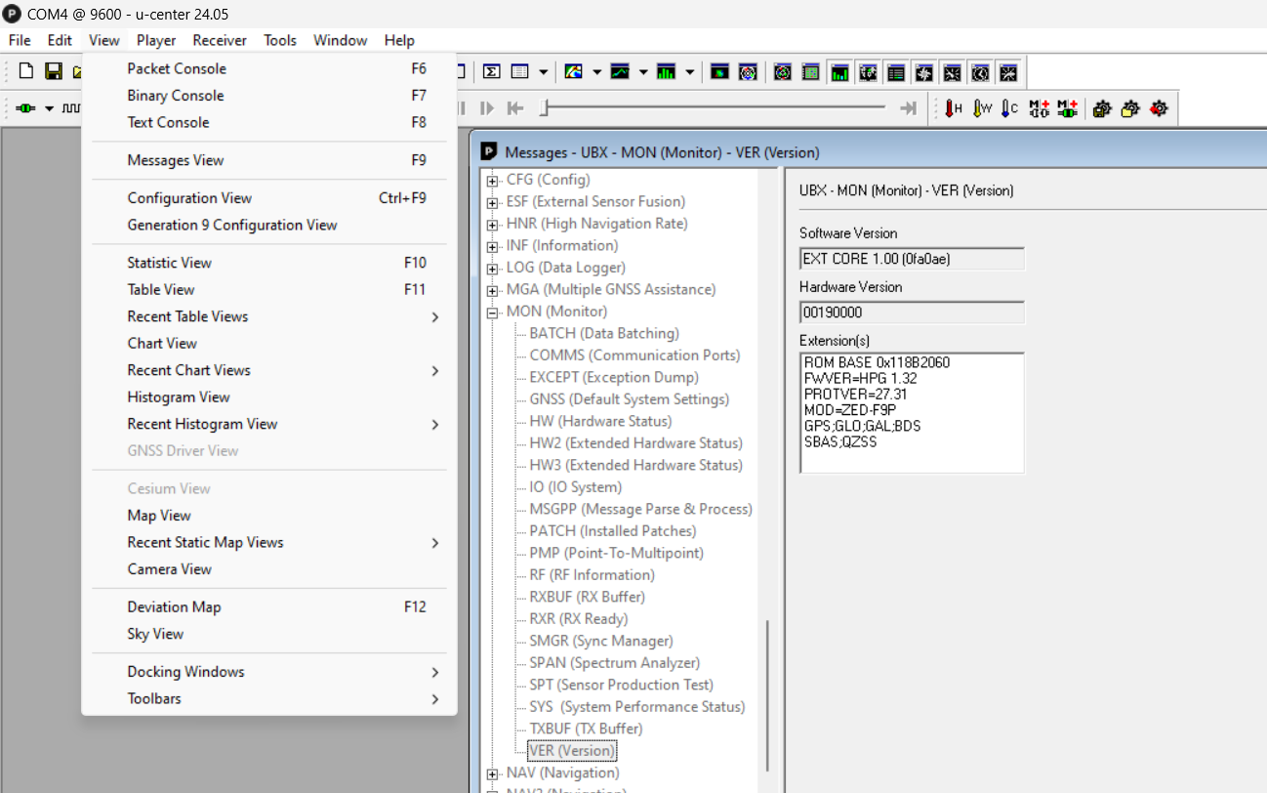

1. Download the Firmware update from this [[LINK](https://www.ardusimple.com/wp-content/uploads/2022/09/UBX_F9_100_HPG132.df73486d99374142f3aabf79b7178f48.bin_.zip)].

*In case the link to the file does not work:*

This file is found halfway through this [[PAGE](https://www.ardusimple.com/how-to-configure-ublox-zed-f9p/)], under “*Firmware version check”* the two firmware versions are depicted in light-blue. Make sure to download the 1.32 version even if the 1.13 version was installed. Click the light-blue button **Version 1.32**.



1. Open the downloaded zip folder containing the Firmware update. The zip folder should contain a “.bin” file. Relocate this file to a preferred location. This file is from now on referred to as the “Firmware Update” file.
2. 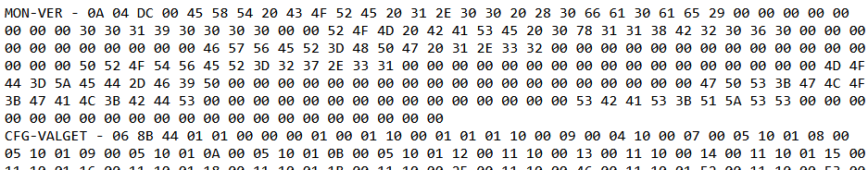Download the base configuration file using the following link: [[BASE](https://www.ardusimple.com/wp-content/uploads/2022/09/simpleRTK2B_FW132_Base-00.txt)]. One is redirected to a page which should look like this:

Now use **Ctrl+A** to select all entities. Then copy this selection by using **Crtl+C**. Open *Notepad* or any other text processor and use **Crtl+V** to paste all entities. Now save this file as a “.txt” file in the same location as the Firmware update from *step 4.7.* This file is from now on referred to as “Base configuration file”.

1. Repeat the same steps for the rover configuration file, found via this link: [[ROVER](https://www.ardusimple.com/wp-content/uploads/2022/09/simpleRTK2B_FW132_Rover_1Hz-00.txt)]. The file created is from now on referred to as “Rover configuration file”.

*In case the link to the files does not work:*

The files are found halfway through this [[PAGE](https://www.ardusimple.com/how-to-configure-ublox-zed-f9p/)], under “*Examples of configuration file”*. Make sure to download the files from the FW 1.32 column. The following files need to be downloaded:

* + Base (column FW 1.32)
  + Rover 1 Hz (column FW 1.32)

To download the files, click the light-blue **File** button and then follow *step 4.8.*





Download the data logger configuration file from this [[LINK](https://www.ardusimple.com/wp-content/uploads/2022/09/simpleRTK2B_FW132_PPK_UART1&2&USB_1Hz-00.txt)]. Again, use **Crtl+A**, **Crtl+C**, to copy all entities and save them as a “*.txt*” file as described in *step 4.8*. This file should be saved in the same location as the Firmware update and the Base & Rover configuration files. This file is from now on referred to as “Data logger configuration file”.

*In case the link to the files does not work:*

The files are found at step 5 on this [[PAGE](https://www.ardusimple.com/how-to-build-a-portable-ppk-data-logger/)]



1. Return back to u-center
2. Make sure the Base is (still) connected to the laptop and check if the COM-symbol is green (see *step 4.4*)
3. Change the baudrate which is running in U-Center. Click the **downward arrow** next to the wave symbol . Then select **115’200** and the **Magic Wand button**.

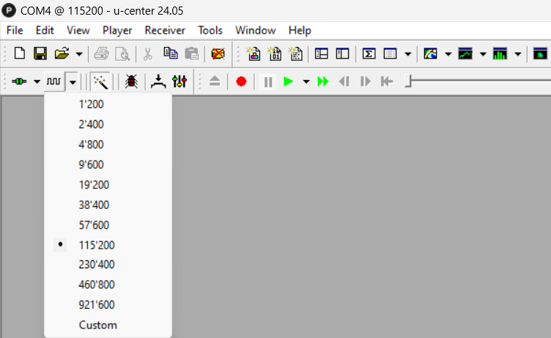

1. Update the Firmware of the Base. Go to **Tools -> Firmware Update…**. In the pop-up window, under “*Firmware image”* select **…** and select the firmware update file. Check the box in front of “*Use this baudrate for update”* and choose **115200**. Then select **GO** in the lower left corner.

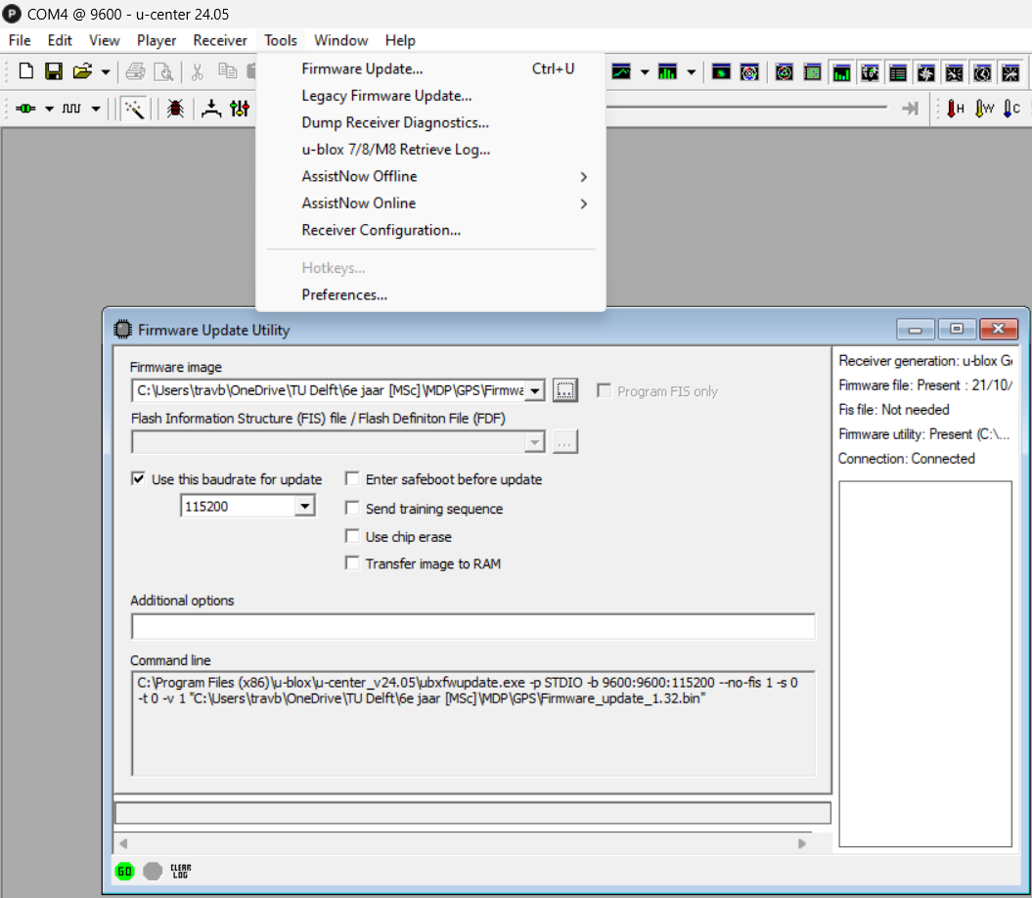

1. Load the “*Base configuration file*” to the receiver. Go to **Tools -> Receiver Configuration…**. Select Generation **u-blox Generation 9**. Select the “*Base configuration file”* saved in *step 31* by using the **…** button. Then click **Transfer file -> GNSS**.

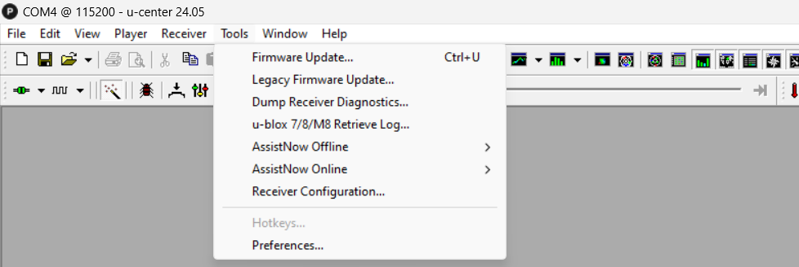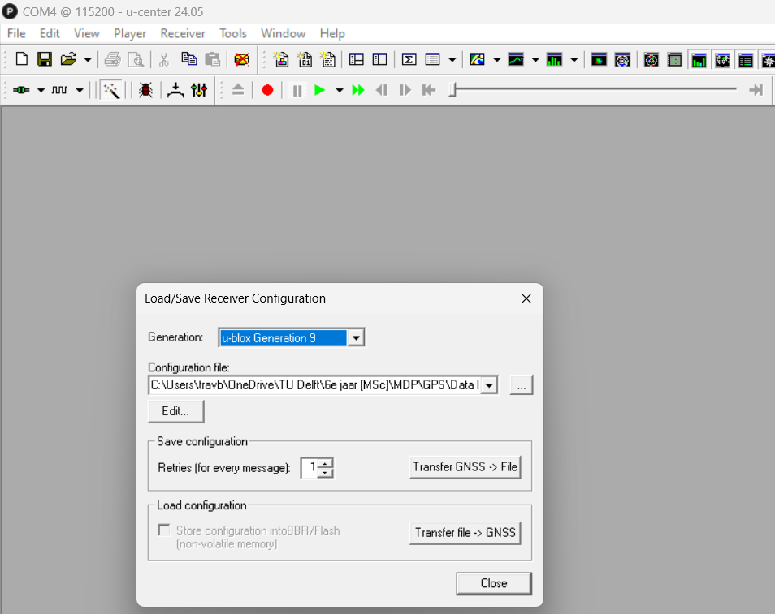

1. Save the configuration to the Base. Go to **View -> Messages View**. In the newly opened window go to **UBX -> CFG (Config)** and select **Save current configuration**. Then click **Send**.

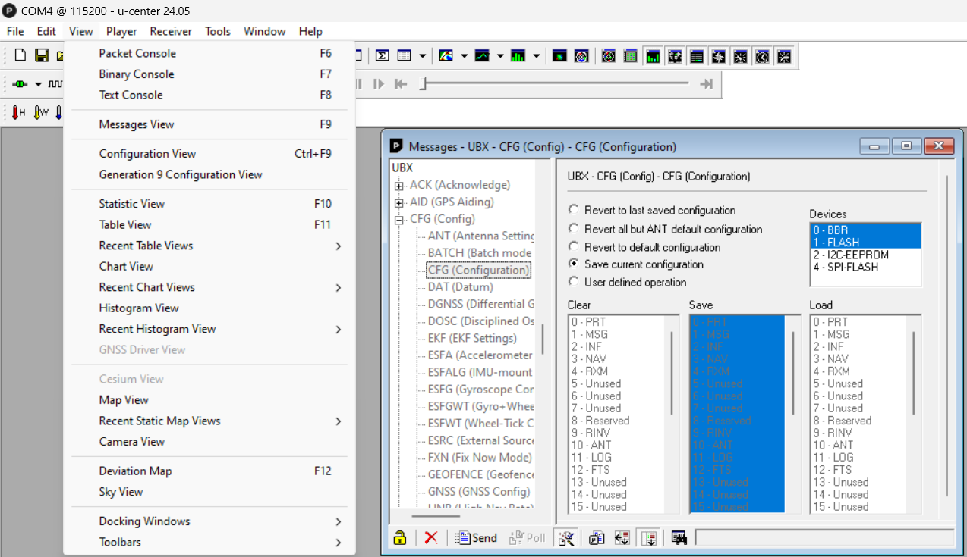

1. Load the “*Data Logger configuration file*” to the receiver. Follow *Step 4.15* but remind to upload the data logger file.
2. Again save this configuration by repeating *Step 4.16*.
3. In the menu bar go to **View -> Generation 9 Configuration View**. For the application in Africa, make sure the following Systems and Signal Controls are selected.
   * GPS -> 1C/A & L2C
   * Galleo -> E1 & E5b
   * BeiDou -> B1 & B2
   * GLONASS -> L1 & L2

Also check **RAM** and **Flash**. Then click **Send Configuration**.

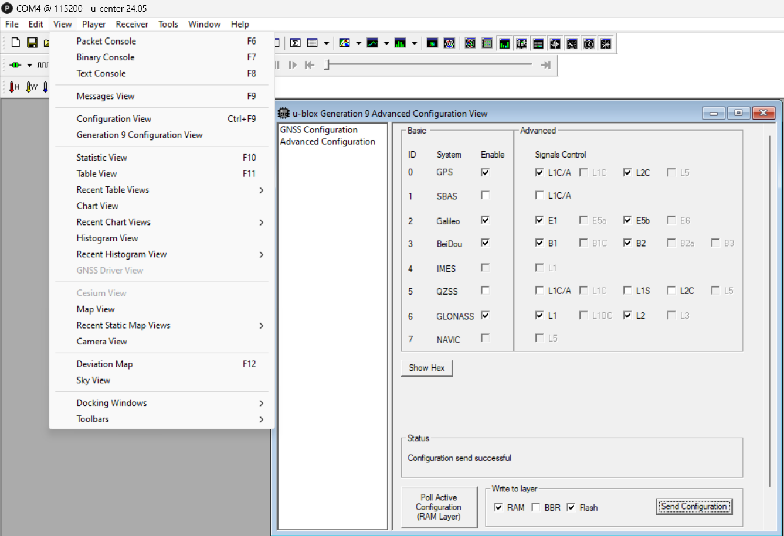

1. In the menu bar go to **View -> Messages View**. In the pop-up window, right click **NMEA** and choose **Disable Child Messages**.

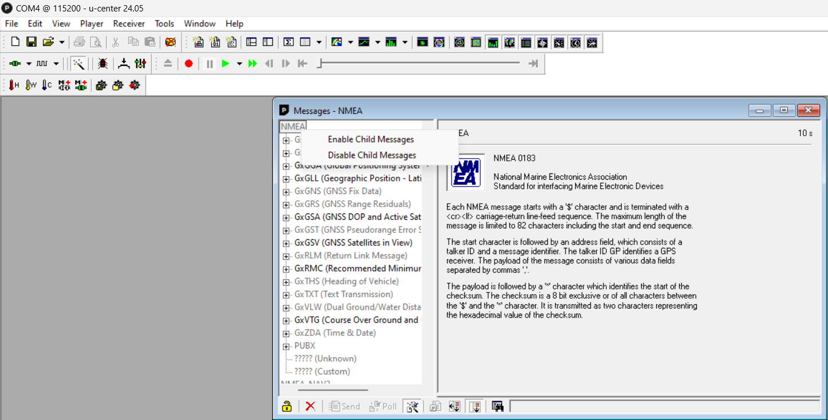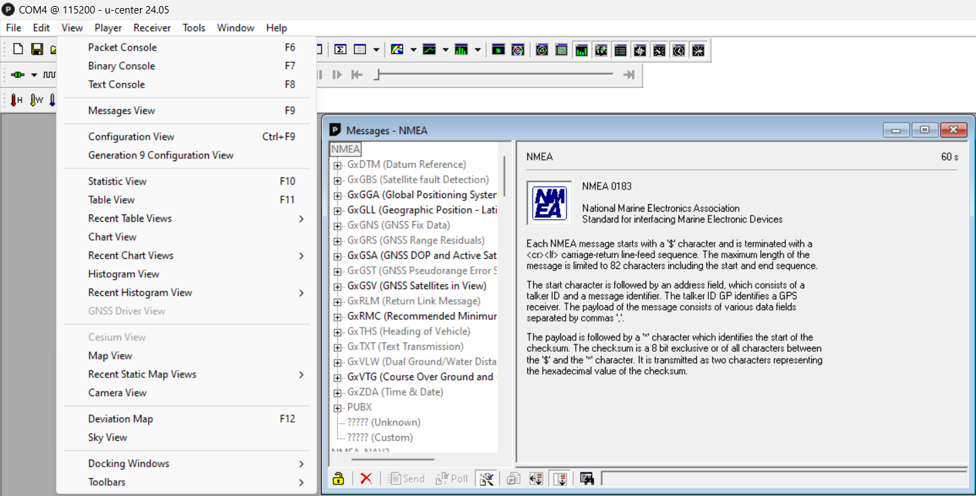

1. Still in the *Messages View*, go to **UBX -> LOG -> CREATE**. Make sure “*Maximum safe size”* is selected, and the box in front of “*Circular log*” is checked. Then click **Send**.

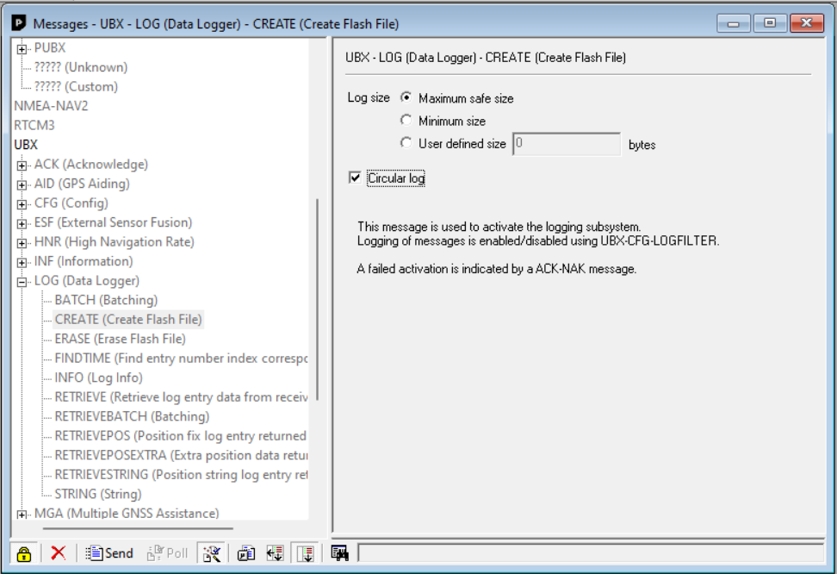

1. Still in the *Messages View*, go to **UBX -> RXM -> RAWX**. Right click and choose **Enable Message**.

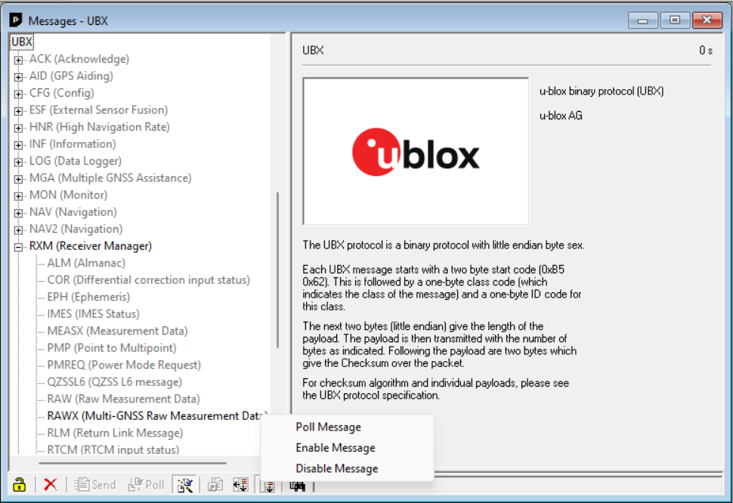

1. Still in the *Messages View* and under *UBX*, right click **SFRBX (Subframe Data NG)** and then click **Enable Message**.

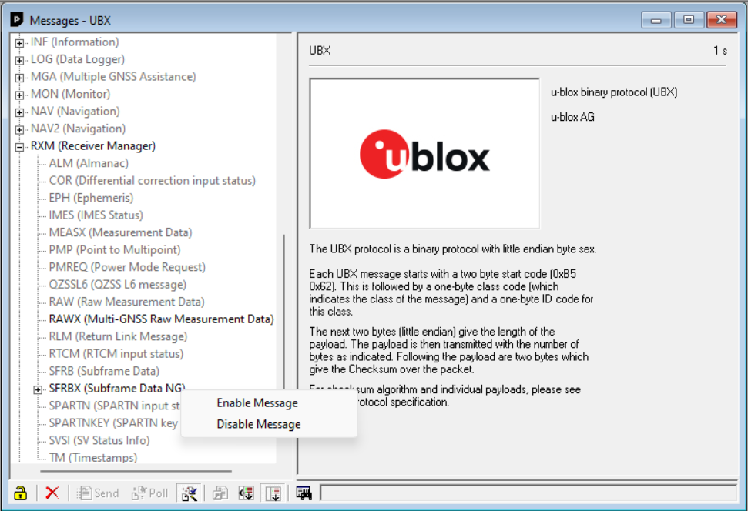

1. Now save the configuration again, following from *Step 4.16*.
2. The base is now all set! One can remove the power.
3. Connect the Rover to your computer using port *(2) POWER+GPS USB*. And open U-Center.
4. Redo *Step 4.14* till *4.24*. Make sure to upload the “*Rover Configuration file*” in *Step 4.15*.
5. Both the Base and Rover are ready for field measurements. The nest step (5) discusses how the field measurements should be set up.

Appendix C. Fieldwork preparation

The execution of fieldwork is an important but time consuming task. Proper preparation of the fieldwork is therefore of the essence. This appendix discusses how and where to get the right permissions for measurement execution, and what is needed for execution.

# Permissions for measuring

When executing field measurements, one is often always working on land that is owned by others. This can be land owned by governmental institutions, businesses, or families. Permission to enter the areas of interest are therefore very important to gain in advance.

The first step is in contacting the governmental institutions. Water management is often governed on many different levels, from country to local municipal level. Each with its own governing body or authority. Because each country has a different management structure, it is impossible to describe who or which authority to contact for each situation. But a nice rule of thumb is: the bigger the river, the less local the authority.

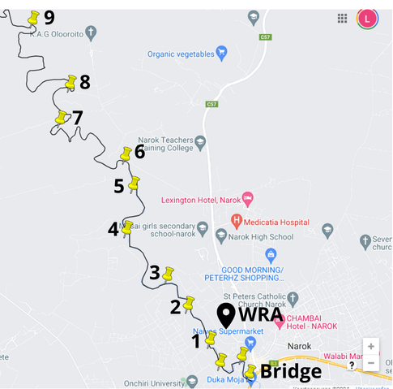 Before contacting the authorities it is important to have a detailed plan of your fieldwork execution. This plan entails the locations of measurement, the timeframe, the way of execution, and the possible support required form the authority. Below in Figure 19 an example of visualisation is given.

Figure 19: Example of visualisation

After obtaining the required permissions of the governmental bodies, one can start contacting the other landowners, both businesses and families. Doing online research on who the owner of which plot of land is, can be quite challenging. Therefore, an alternative approach is recommended: doing a in-person visit of the potential measurement sites. By acquainting yourself with the people and businesses one will get a good feeling of the possibilities and limitations of the chosen locations. This visit can be combined with the Exploration of cross-sections mentioned in *Exploration of* cross-sections.

Taking possible language barriers into account, it is advisable to carry a document which discusses the intent for measuring in several languages. An example is given below under *“Letter for communication”*.

## Letter for communication

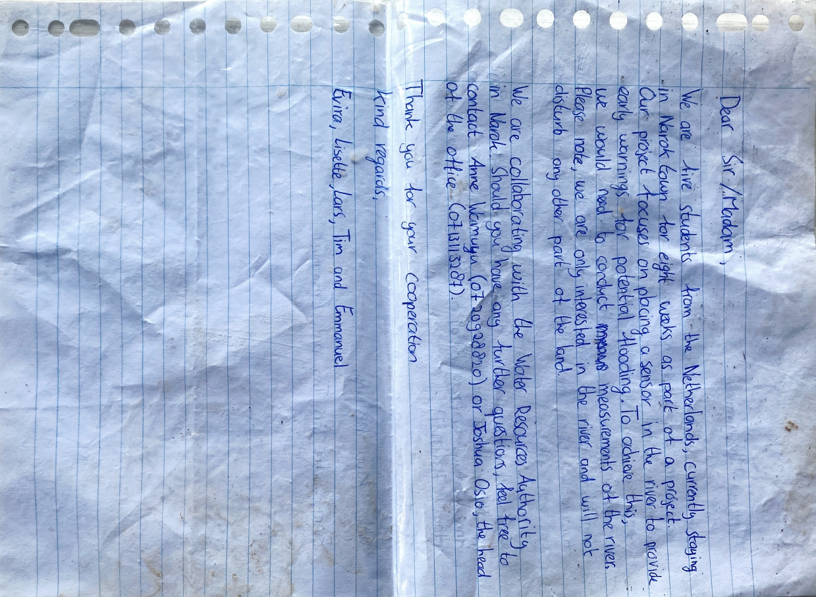The letter is a form of proactive communication. This example contains details about the project, the planned measurements, and the permissions gained by governmental institutions. Numbers for contact were also provided. In light of language barriers, the example letter was drafted both in English and Swahili.

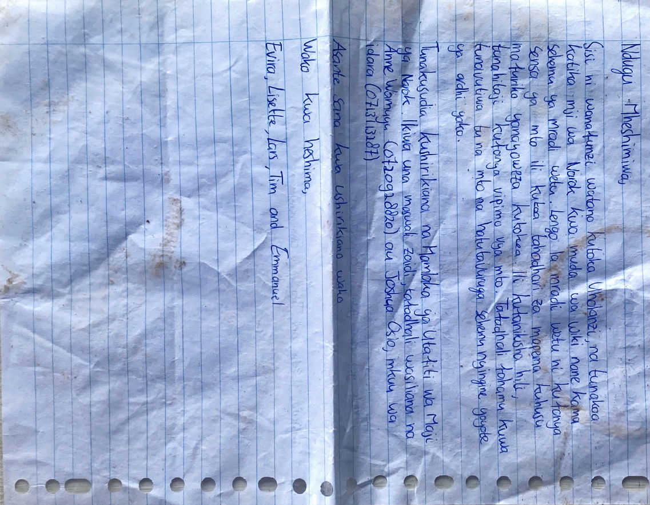

# Required equiptment

The last step in preparing the fieldwork is in obtaining the right equipment. The list below is indicative, if other materials or types of equipment are up for the job, feel free to use those instead. After the equipment list some are elaborated on.

### List of equipment

* 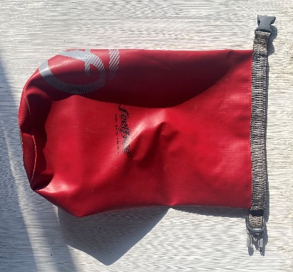Rover setup (including SD-card)
* Base setup (including SD-card)
* 2 Powerbanks (10.000 mAh at least)
* 2x small (lunch) container to hold the simpleRTK2B pro boards and their powerbanks
* Pole for survey GNSS antenna [[LINK](https://www.ardusimple.com/product/pole-for-survey-gnss-antenna/)] (recommended)
* Surveying tripod
* Drybag (depicted on the right, Figure )
* Rope with half meter markings
* 4x Tent peg [[LINK](https://en.wikipedia.org/wiki/Tent_peg)]

Figure 20: Drybag

* Water velocity meter
* Pen and paper
* Wading boots / swim suit
* Letter for communication
* First Aid kit

## Rope with half meter markings & Tent peg

During the cross sectional measurements it is important to follow a perpendicular line to the waterbody. And perform the measurements at the determined interval, recommended at most half a meter. But this of course depends on the scale of the river. This scale also determines the rope length required. Half meter marks are made by making small knot in the rope as displayed in Figure below. The advantage of having a knot each half a meter is in the fact that it is also a place to tie the rope down.

To tie the rope down tent pegs can be used. But also sticks with a sharpened point are more than suitable for the job.

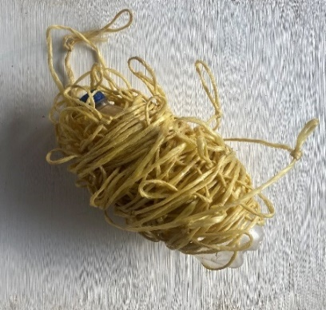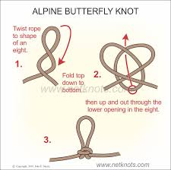

Figure 21: Knotted rope

## Water velocity meter

There are many different options in determining the water velocity, all with their own benefits and limitations. A flow probe is a more commonly used device and advised in this application. Make sure it has height markings to get an accurate overview of the height. Below an example in Figure .

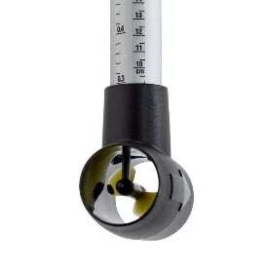

Figure 22: Water probe

# Perform test measurements

Before heading out for any measurements that will be used for the modelling or Manning calculations, it is very important to execute mock measurements. By repeating the same mock measurement twice and processing the data, one can check for unexpected results. Checking the correct functioning of the equipment and execution of the measurement beforehand, saves a lot of time compared to discovering irregularities afterwards. An example of a mock measurement is spanning the knotted rope across stretch that has some height variations, this does not have to be meters. The GPS can then be used to measure the same stretch and the same points over different days. This should of course yield the same results. If this is not the case, one should try to trouble shoot. Try to pinpoint whether the problem is hardware or software related. The problem can also lie in the way the measurement is executed. Only by playing around one can get a good grasp of the problem at hand.

## Height measurement instability

A special case of problems that one can encounter is in the instability of height measurements. This means that between two different days, the same measurement returns a different value for the elevation. If after troubleshooting the problem remains unsolved, a way of dealing with it is found. This is discussed in *3.5.5* Slope of the river and should only be executed when the instability in height measurement is encounterd.

Appendix D. Fieldwork execution

The execution of cross-sectional measurements is a time consuming task. But it should be done with precision and care to make sure that all measurements are worthwhile. In this step by step manual a fieldwork day is explained per step. All measurements should be executed with at least two people.

# 0. Preparations

1. Arrange transportation, taking into account the terrain surrounding the measurement locations. Do note that sometimes off-road (4x4) is required.
2. Collect and pack all materials described under “*List of equiptment*” in appendix E, don’t forget to fully load the power banks.
3. Determine the placement of the Base station. There are two options: leave the base at the home station, or set it up each measurement location.
4. Prepare enough water and food. A fieldwork day is physically demanding.
5. Inform involved people where you are planning to go and the expected schedule. In case anything goes wrong, others know where to start looking.

*Placement of the Base station:*

The placement of the Base station is measurement specific and can vary between fieldwork days. It is therefore important to consider the placement for each measurement day.

**At home station**

Leaving the Base at a predetermined (safe) location with an unobstructed view of the sky is advantageous because there is only once the need for calibration. At the day of the fieldwork one powers the Base station and leaves it to calibrate. At the end of the measurement day one can unplug the Base station. All data is logged on a single file on the SD-card. It is important to note that the maximum distance between the Base and Rover is 20 km (as the crow flies).

**At location**

If the distance of 20 km is exceeded, or because of other considerations, one can also take the Base to each measurement location. When placing the base it is important to place the base perfectly horizontally and let it find a fix for at least 20 minutes.

# 1. Arrival on measurement location

1. Upon arriving inform the local land owners of your presence. Reconfirm that you have permission to enter the premises for execution of the measurement.
2. If possible, inquire about the bankfull state of the river. Otherwise, search for bankfull markings.
3. Based on the determined bankfull state, settle on a proper location for the cross section. It is important to keep in mind to take an as undisturbed section as possible. If necessary, also settle on a location for the Base.
4. Place the antenna of the rover on the pole and make it lean upright. Make sure the base is placed perfectly horizontal on the tripod.
5. Use *(5) POWER+XBEE USB* port to Power the Rover (and Base) using the battery packs. For the Rover, make sure the SD-card is NOT inserted. The base should have the SD-card inserted. Remember that both need a clear view of the sky. Set a timer for at least 20 minutes, but preferrable 30 minutes.

*Calibration time:*

This is the amount of time needed to get a proper fix with cm-level accuracy. The time required can vary depending on the cloudiness, location (non or some obstructions), and the amount of satellites. It is therefore advised to always wait around 30 minutes before starting the measurement.

1. Place the rope perpendicular to the river stream on the determined location. Use the peg’s to tie the rope down, this both directly next to the water and at the edges of the bankfull state. See the illustration in the **Error! Reference source not found.** on the next page.

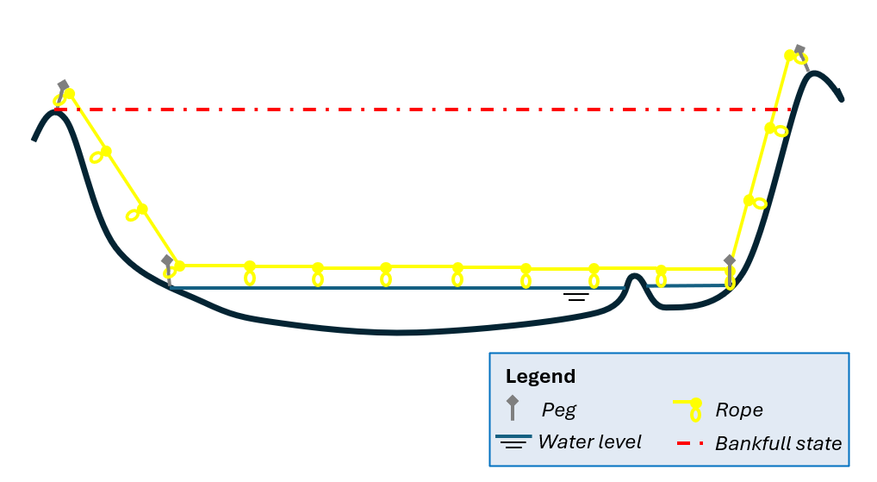

Figure 23: Visualisation of rope placement

1. Note down the place, date and time of the measurement at the top of the paper. Then describe the type of material of the riverbed, if there is telephone reception, and the length of the Rover stick.
2. Once the timer has finished, one can start doing the GPS measurement as described at step 2. If the timer has not yet finished one can also choose to do the velocity measurement described in step 5.

# 2. GPS measurement

1. Wait for the timer to run out, such that the Rover (and Base) had a calibration time of 30 minutes with a clear view of the sky.
2. Take the Rover go to the first measurement point. Make sure to hold the rover steady pointed towards the sky during the walk.
3. Place the stick vertical at the place of the first measurement.
4. Slide the SD-card into the slot such that the data of the Rover is logged.
5. Place the carton box in the container together with the battery pack.
6. Place the box in the drybag.
7. Start a one minute timer which is on repeat. For example download a interval training app.
8. Wait for the timer, after 1 minute, go to the next measurement point. Again make sure the rover is steady and vertical.
9. Repeat the process until the entire cross section is measured.
10. At the last point wait the one minute and then remove the SD-card. Do **NOT** remove the power.
11. Now perform the *Water elevation measurement* explained in step 3.

# 3. Water elevation measurement

1. Start at the side of the river alongside the rope.
2. Place the rover vertical exactly at the place where the water stops and the land starts. The bottom of the stick attached to the rover should be at the same height as the water.
3. Slide the SD-Card back to start logging the measurement.
4. Measure the water height for at least 10 minutes. And then remove the SD-card.
5. Repeat the measurement on the other bank of the river. Again place the Rover vertical and steady at the same level of the water. Don’t forget to slide the SD-card in and out to perform the measurement.
6. Now perform the *length profile measurement* described in step 4.

# 4. Length profile

1. Find a place approximately 100 meters upstream.
2. Take the Rover to this place holding it steady and upright.
3. Repeat the water elevation measurement by placing the Rover steady at the same height of the water level.
4. Slide the SD-card in to start logging the measurement.
5. Wait for 10 minutes. Then remove the SD-card.
6. Now find a point approximately 100 meters downstream.
7. When walking always keep the Rover steady and upright.
8. Place the Rover again steady and upright at the water level height.
9. Slide in the SD-card to make it log.
10. Wait for 10 minutes.
11. Remove the SD-card and the power of the Rover.
12. If applicable, also remove the power of the Base station.
13. Note down all measurements that were performed and their order. E.g.:

#1 Cross profile

#2 Water height left bank

#3 Water height right bank

#4 Upstream point

#5 Downstream point

# 5. Velocity measurement

1. Count the number of knots spanning the entire river.
2. 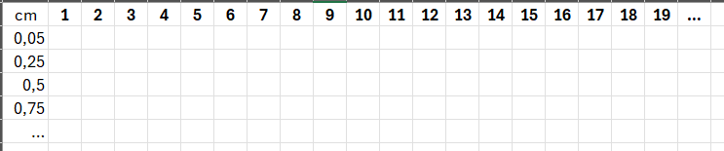Number all the knots on the peace of paper next to each other. Determine the height interval in which the velocity is measured. Note these underneath each other. The essence is to make a table similar to the one depicted below.
3. There are four things that can be noted down:

* **X** – The measurement is false, the water depth is not sufficient to perform a measurement
* **0** – The water depth is sufficient, but there is no flow
* **Value** – The water depth is sufficient and there is a flow measured
* **Blank** – All knots between the bankfull state and the start of the water should be left blank

1. Prepare the velocity meter and check the units it is measuring in
2. Now start the measurement at the first knot that is above the water. Note the number of the knot, counting from the bankfull state. Leave the numbers lower than this number blank.
3. Execute the water velocity measurement. Note that this measurement can also be a false measurement noted by an **X**.
4. For each knot try the water velocity measurement. If the first depth, e.g. 5 cm, is successful (zero measurement is also considered as successful), then try the deeper depth, e.g. 25 cm. Communicate the result: value, zero or false. Keep increasing the depth by the set intervals until the bottom is reached and the measurement is false. The other person notes the result down.
5. Continue repeating step 5.7 until you have had all the knots above the water.

# 6. Finish the measurement

1. Check if all measurements are performed.
2. Remove the pegs and the rope from across the river.
3. Pack the Rover (and Base).
4. Remove all thrash.
5. Go back to the mode of transport.
6. Repeat Step 1 to 6 for all measurements executed on the same day.

# 7. Slope of the river

Only execute this step if the elevation determination of the cross sections contain errors!

Determine how many measurements are feasible to execute on a single day.

1. Take into account that the most upstream and downstream locations must be visited. If time allows, one is free to add measurements in between for improved accuracy.
2. Revisit Step 0 and make sure all is arranged for a safe and useful measurement in the field;
3. On the day itself, place the base at a secure location and let it log its position for the entire day
4. Arrived at each location, the Rover should calibrate for at least 15 minutes.
5. Try to find the spot where the initial cross section measurement took place.
6. Redo step 3. Measuring the water elevation at both sides of the river. Each side at least 10 minutes.
7. One can consider doing an extra profile measurement (only taking five points) and a water velocity measurement for extra model validation.
8. Note all measurements performed down before continuing to the next location.

Appendix E. RTK Software processing

This appendix discusses the RTK processing software used for post-processing of the logged measurements. It is a step by step instruction and builds on the software download executed in Appendix B. Before one can start it is important that each log file is recognisable as the measurement itself and that the “*.*TXT” extension is changed to “*.*ubx”. This is also discussed in *4.1.1 structure*. The example given:

*Rover file:*

* LOG00017.TXT → Cross_section_3_Profile.ubx
* LOG00018.TXT → Cross_section_3_Water_Height_1.ubx
* LOG00019.TXT → Cross_section_3_Water_Height_2.ubx
* LOG00020.TXT → Cross_section_3_Upstream.ubx
* LOG00021.TXT → Cross_section_3_Downstream.ubx
* LOG00022.TXT → Cross_section_4_Profile.ubx
* Etc.

*Base file*

* LOG00003.TXT → Base_Loc_3.ubx
* Etc.

It is important to note that one should NOT use “*.UBX*” (in capital) extension. This will lead to errors later in the process.

# RTKconv.exe

* + 1. With the proper file structure in place, one can proceed and open “*rtkconv.exe*”. To open double click **rtkconv.exe**.
    2. Within the window select **Options**

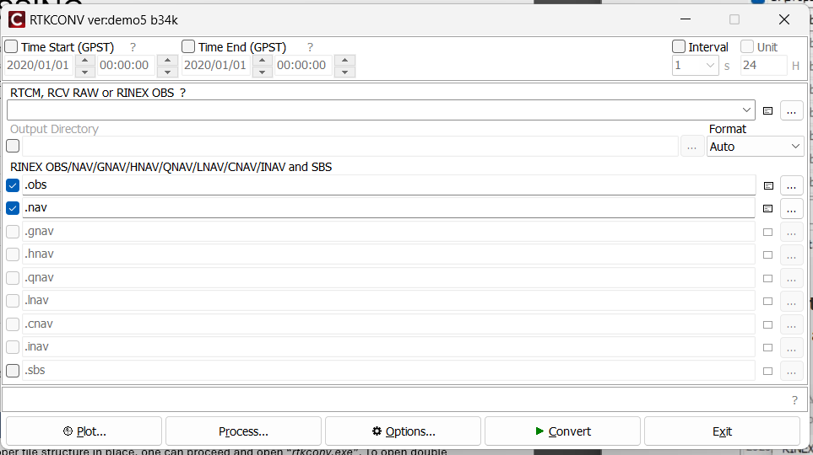

* + 1. In the options menu make sure to select the highlighted options below. Pre-selected features that are not selected in the image should be deselected. Then hit **OK**.

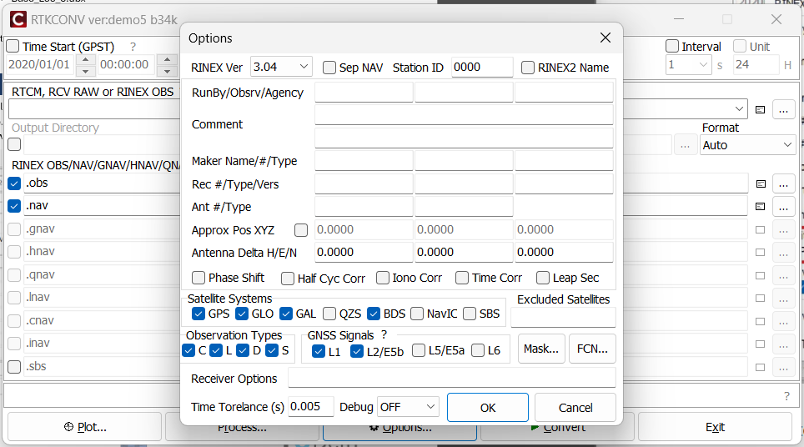

* + 1. Using the **…** button under *RTCM, RCV RAW or RINEX OBS* one can select the “*.ubx*” file of the measurement. Then check the boxes in front of the file output “*.obs*” and “*.nav*”. The last step is to click **Convert**. The newly generated files are saved in the same location as the “*.ubx*” file, if you want to change this, use the **…** behind the file output line.

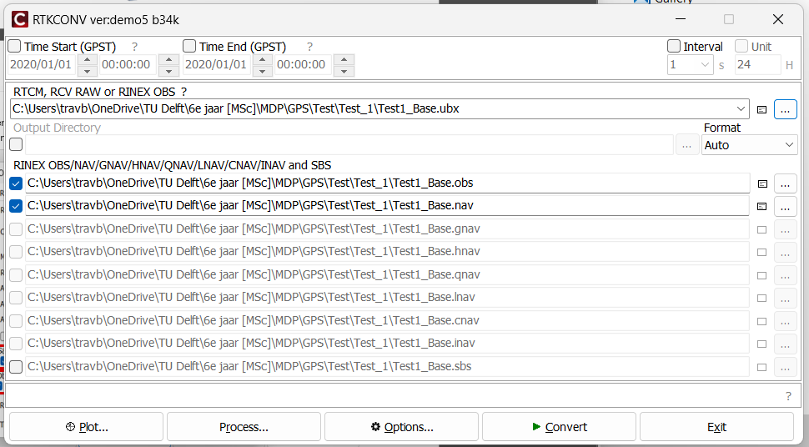

Preferred file_path

Preferred file_path

Preferred file_path

Preferred file_path

Preferred file_path

Preferred file_path

Preferred file_path

Preferred file_path

Preferred file_path

Preferred file_path

Preferred file_path

* + 1. Now click the **plot** button. A new popup window will load. Similar like the one below.

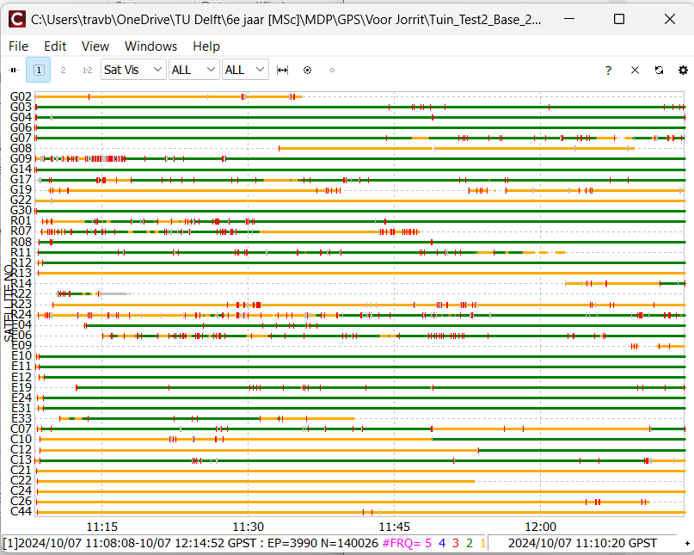

Preferred file_path

* + 1. Here verify that there are observations from all constellations. Green indicates dual frequency measurements, yellow is single frequency. GPS observations will be a mix of both. Other things to note:

-> Red ticks indicate cycle slips. Too many of these will make it difficult to get a decent solution.

-> Gaps in the data usually indicate the receiver lost lock.

-> If all measurements are grey, please check if a “*.nav*” as well as a “*.pos*” file were generated. And select **Convert** again before plotting

-> Grey bands indicate that they are below the elevation threshold, too many of these means the quality of the data is low. In that case it is better to record the logs in a location or time with better view of the sky.

*Trouble shooting:*

Due to updates to the software it can happen that functionalities change or get lost. As stated at the download instruction, “*demo5_b34k”* was used in this instruction. For updated instructions on the functioning of the RTKconv follow this [[LINK](https://www.ardusimple.com/how-to-generate-rinex-files-with-simplertk2b-for-ppk/)].

* + 1. Repeat step 4 for all files, including the base files.
    2. When all files are converted into “*.obs*” and “*.nav*” files, one can close RTKconv.

# rtkpost.exe

* + 1. Open *“rtkpost.exe”* by double clicking **rtkpost**.**exe**

Preferred file_path

* + 1. Once opened, select **Options**

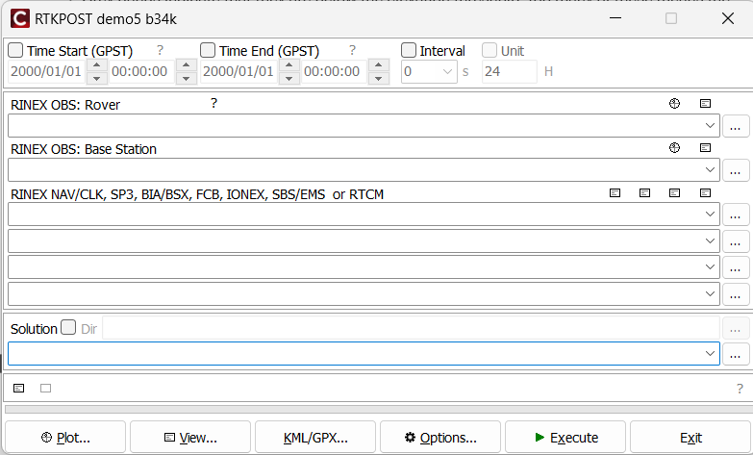

* + 1. In the first setting screen, select **Load…**. From the same folder as the “*demo5 RTKLIB*” executables select **demo5_m8t_5hz.conf** and click **open.**

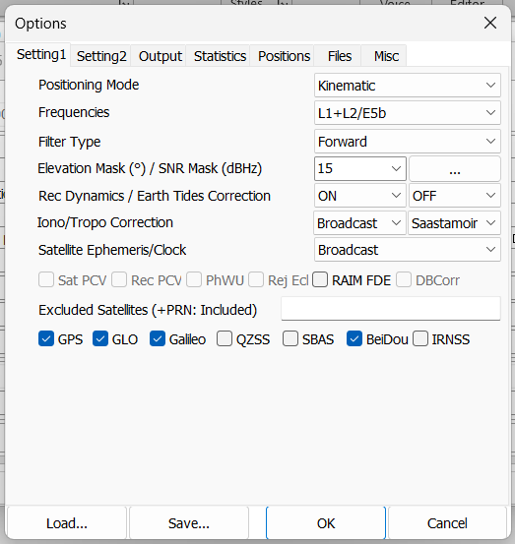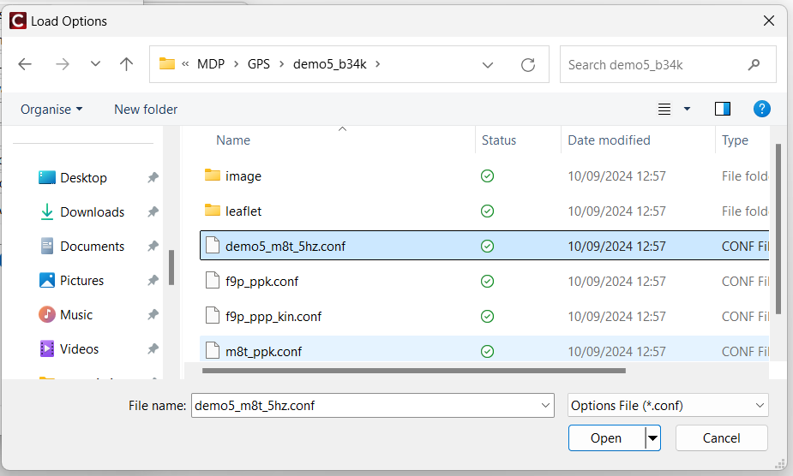

* + 1. After opening the configuration file one is returned to the “*Setting 1”* page. For Frequencies, make sure to select **L1+L2/E5b**. The other fields should be set correctly, but make sure to check the field. Then click **Setting 2** page. Here apply **Fix and Hold**, **ON**, **OFF** for “*Integer Ambiguity”*. Again check the other fields, but these should be correct. Then click **OK**.

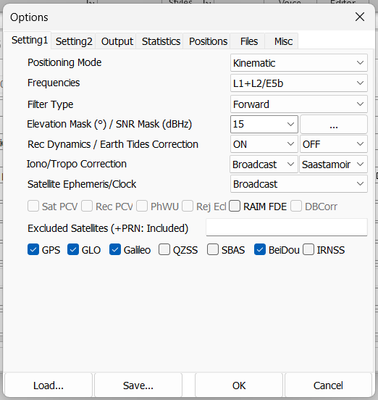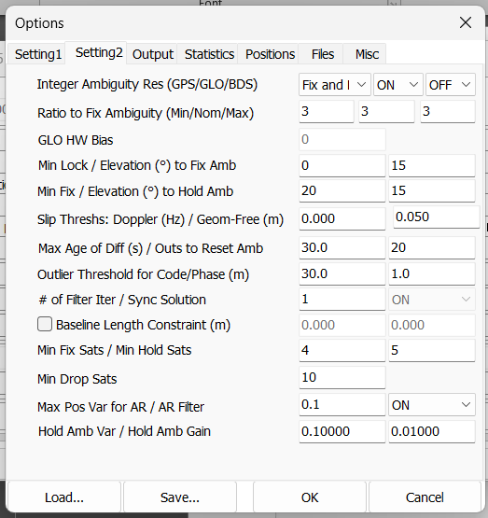

* + 1. In the main window use **…** to upload:

- the “*.obs*” file of the Rover

- the “*.obs*” file of the Base

- the “*.nav*” file of the Rover

Then click **Execute** to run the solution. The bar at the bottom will show the solution status as it runs and will report any errors. You should see a mix of Q=1 and Q=2 as the solution runs. When you see **done** when the conversion is finished.

*If only Q=0 is displayed:*

Something is wrong and needs trouble shooting. Go back to the **Options** window and go to the “*Output*” page. Then select **Level3** en then hit **OK**. Rerun by clicking **Execute**. Then open the \*\***.trace** file in the solution folder for additional information. Follow the following [[LINK](https://www.ardusimple.com/how-to-do-post-processing-kinematic-ppk-with-free-software-rtklib/)] if further troubleshooting is required.



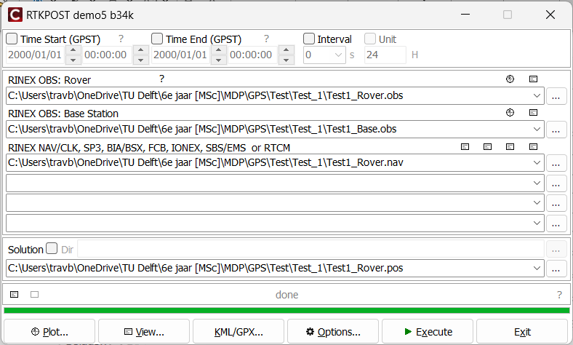

Your own file path

Your own file path

Your own file path

* + 1. 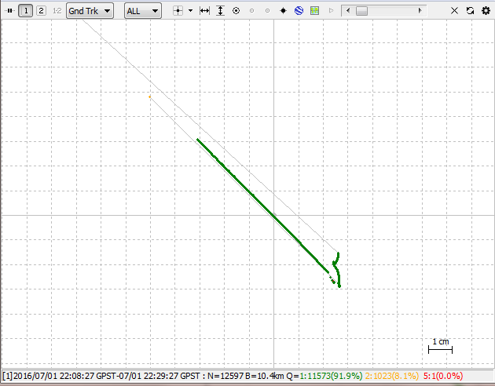Click **plot** to visualize the solution with RTKPLOT

- Q=1 solution means Fix: accuracy is centimetre level

- Q=2 means Float: accuracy is submeter level

- Q=5 solution stands for Single, which is usually meter level

* + 1. Most of the measurement should have acquired Q1 precision to be able to further process the cross section. For this the Python file is required and this is discussed in *4.2 Python Processing*.

Appendix F. Python processing

# Introduction

This Appendix shows how to use the Data Processing package to process the collected data. The instruction consists out of four steps:

* + 1. Selecting the input data.
    2. Generating the output.
    3. Generating the localised slopes.
    4. Process individual cross sections if needed.

# Goal of this step

* The goal of this step is to process the measurements into usable input for the HEC-RAS model.

# Required Hardware

* Computer

# Required Software

* Data Processor package
  + This manual is accompanied by the package, so no further downloading is required.
* Anaconda Navigator with Jupyter Lab installed
  + Download from the Anaconda site: [[LINK](https://www.anaconda.com/products/navigator)]

# Step by step instruction

## Selecting input data

* + 1. Start by opening the Data Processor package folder. This can be found in the same download folder as this manual. The folder structure is shown below. The folder structure is further explained in ‘README.txt’. 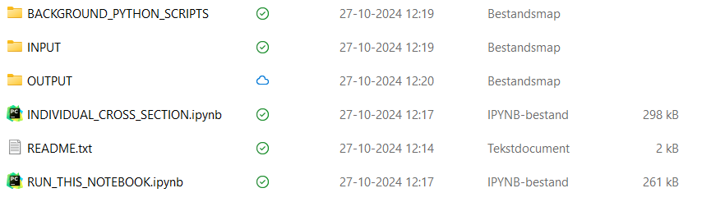
    2. Go to INPUT and open ‘input.xlsx’. This is the Excel file in which you provide the input data. It exists out of two sheets: ‘Explanation’ and ‘Input’. Make sure you first read the ‘Explanation’ carefully, before starting to work with the file.
    3. Fill in the input sheet with the correct filenames for each point. Here, an example of how this should look like is given:  Make sure you use the ‘.’ as decimal sign, otherwise the Python script won’t work.
    4. Copy all the files, which you filled in in the ‘input.xlsx’ file, to the INPUT folder. So based on the example above, the INPUT folder should look like this: 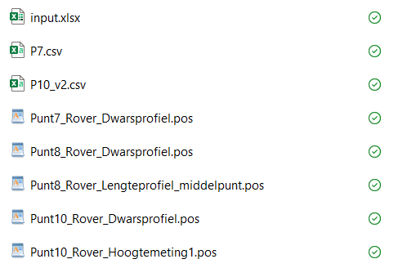
    5. Double check if all the files that are in the ‘input.xlsx’ are located in the INPUT folder. If this is not the case, the Python script won’t be able to find the correct files.

## Generating the output

* + 1. Launch the Anaconda Navigator by searching for ‘Anaconda’ in the search bar.
    2. Within the Anaconda environment, launch Jupyter Lab: 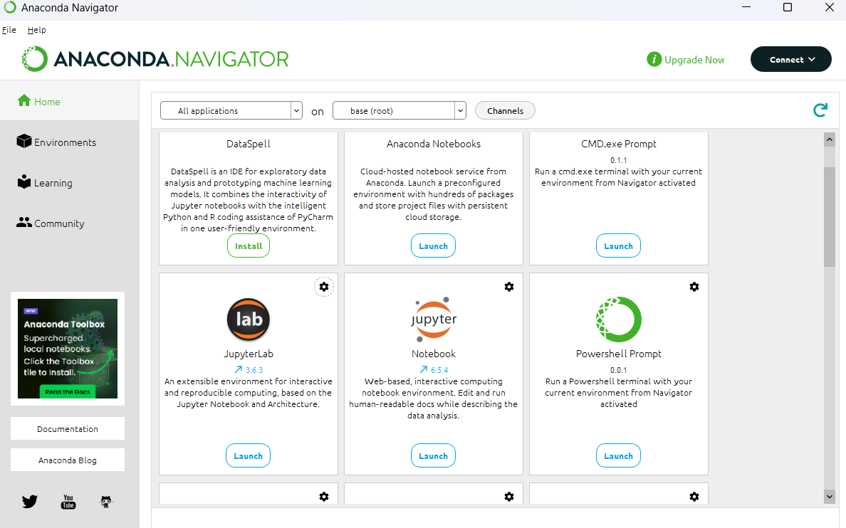
    3. When in Jupyter Lab, browse through the directory on the left side of your screen and find the Data Processor folder. 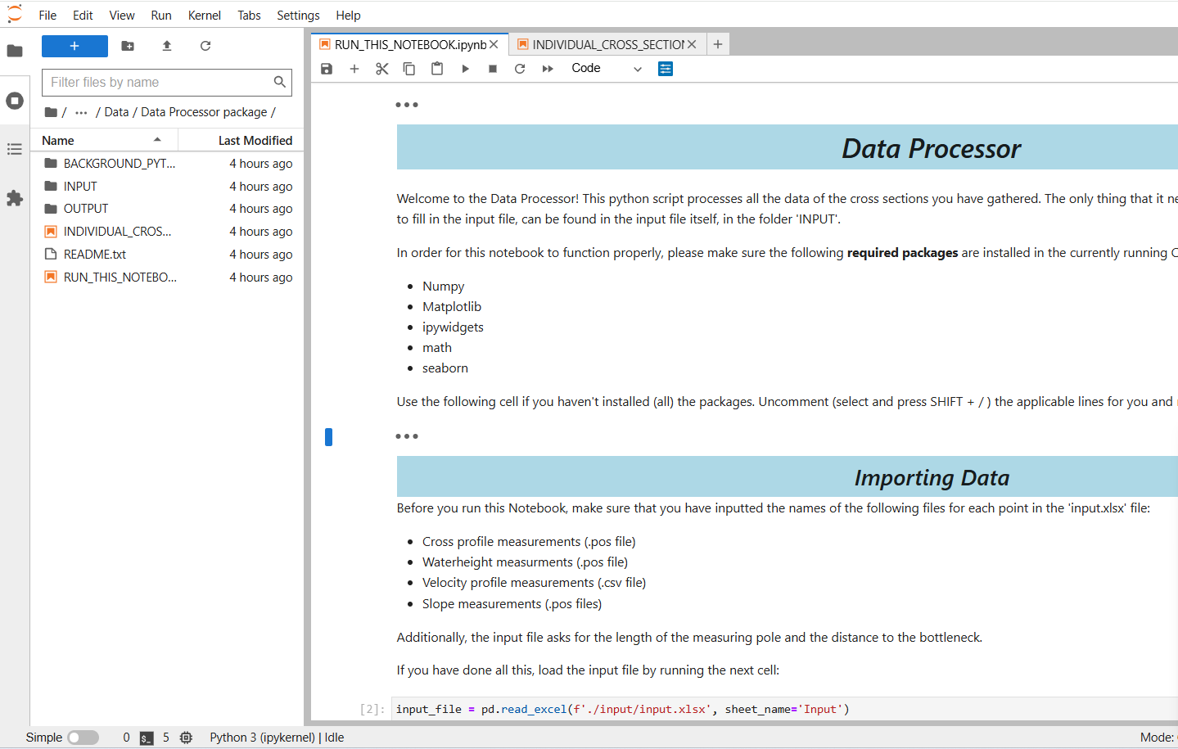
    4. Open the ‘RUN_THIS_NOTEBOOK.ipynb’ notebook from the Data Processor package.
    5. Click on the two arrows in the top left of your screen: 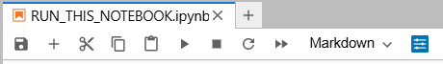
    6. Click on ‘Restart’ to run the notebook. 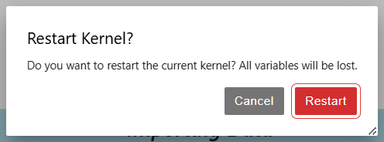
    7. After the notebook is completed, the output files are automatically saved in the OUTPUT folder in the Data Processor package: 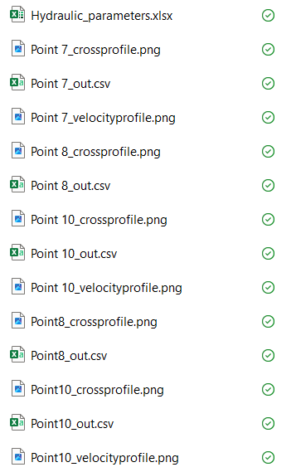

## Generating the localised slopes

For both the boundary condition of the HEC-RAS model and the evaluation of the Manning equation, the localised slope is needed. This sub step explains how to use the Python script, that was designed to do just that.

* + 1. Open the ‘input.xlsx’ file, which can be found under the INPUT folder.
    2. Go to the ‘Local_slopes’ sheet.
    3. In this sheet, fill in the names of the local slope measurements. For each cross section, three .pos files are needed: upstream, downstream and at the location of the cross section. A filled in template, should look like the following: 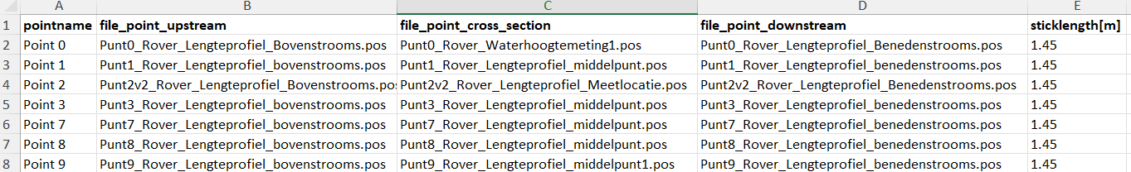
    4. Upload all the files, which you wrote down in the previous step, to the INPUT folder.
    5. Repeat steps 1-3 from the GENERATING THE OUTPUT substep.
    6. Open the ‘SLOPE_DETERMINATION.ipynb’ notebook.
    7. Repeat steps 5 and 6 from the GENERATING THE OUTPUT substep.
    8. The Excel file with the localised slopes can be found in the OUTPUT folder with the name ‘Local_slopes.xlsx’.

## Process individual cross sections (if needed)

Sometimes, the ‘RUN_THIS_NOTEBOOK.ipynb’ is not sufficient for every cross section. It could occur that a cross section requires a bit more work, as the cross section shown in the following figure, for example: 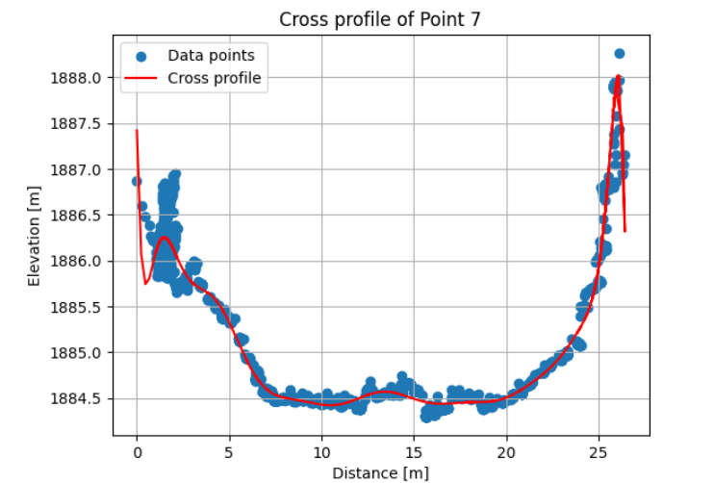

As can be seen, the cross profile doesn’t seem to fit that well on the outer parts of the cross section. For this reason, the Data Processor package includes a notebook that can be used for individual cross sections, namely ‘INDIVIDUAL_CROSS_SECTION.ipynb’.

* + 1. Make a copy of the ‘INDIVIDUAL_CROSS_SECTION.ipynb’ notebook and open it in Jupyter Lab (in the same manner as in step 3 of previous sub step ‘GENERATING THE OUTPUT’).
    2. Repeat steps 2 and 3 of the previous sub step ‘GENERATING OUTPUT’. This will give an error for the second code cell, but ignore that one and move on to the next step.
    3. Fill in the required file names and other information in the first code cell, as is done in the following figure and click on ‘Import data’. 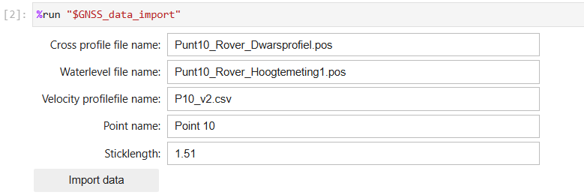
    4. Run the second code cell (SHIFT + ENTER)
    5. Run the third code cell (SHIFT + ENTER) and click on ‘Run this cell when data is loaded’.
    6. The data trim tool will show up. This tool allows you to cut of data points at the beginning and the end of the dataset. The two accompanying plots will help you to determine the correct cut-off points: The red part shows what is cut off the dataset. Once you’re happy with the cut, click on ‘Cut Dataset’. 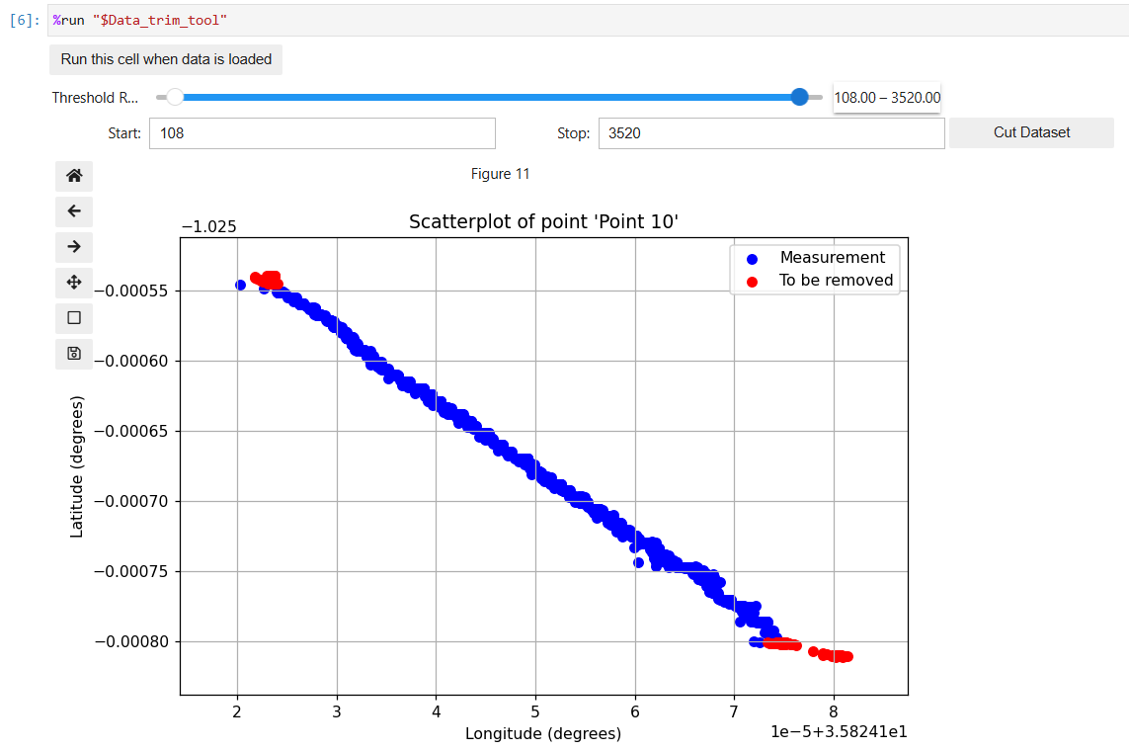

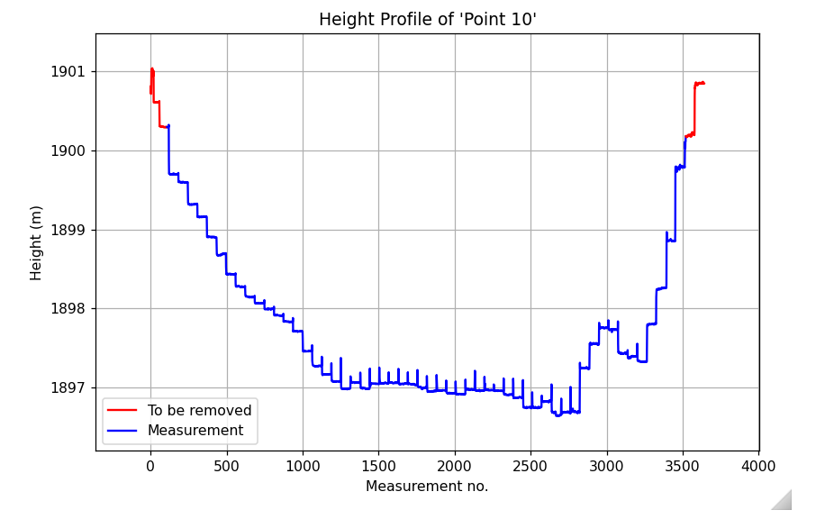

* + 1. Run the remaining two code cells. The output based on the new cross-section is generated and stored in the OUTPUT folder of the Data Processor package. Only the hydraulic parameters aren’t stored separately. You need to copy them yourself. However, as only the outer parts of the cross sections change, the values of the hydraulic parameters will probably be the same as in the excel file the previous notebook exported. 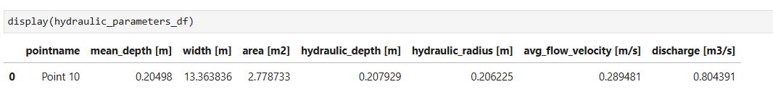

Appendix G. HEC-RAS

# Introduction

This Appendix shows the steps that need to be taken to build a one-dimensional hydraulic model in HEC-RAS. It is subdivided in different aspects of modelling with HEC-RAS:

* How to start a new project
* How to create the geometry
* How to enter the cross-section data
* How to export geometry data
* How to specify a steady flow model
* How to specify an unsteady flow model

The blue boxes give background information about the specific terminology of HEC-RAS.

# Goal of this step

* Create a steady and unsteady one-dimensional model in HEC-RAS
* Finding a correct Manning’s n Value
* Simulate a flash flood
* Determine the critical discharge and corresponding warning time

# Required Hardware

* Computer

# Required Software

* HEC-RAS (This manual uses HEC-RAS version 6.6)
  + Download HEC-RAS on the following website: <https://www.hec.usace.army.mil/software/hec-ras/download.aspx>
  + If this website is unavailable, search for *download HEC-RAS* in your search engine and download HEC-RAS.

# Step by step instruction

## 1. Starting a new project

1. Create a folder on your computer named HEC-RAS. Use a directory path of your own choice. Add the *DEM_filled.tif* file and the *DEM_filled.prj* file that were created in QGIS, see Appendix A.
2. Open HEC-RAS on your computer. The main HEC-RAS window will show:

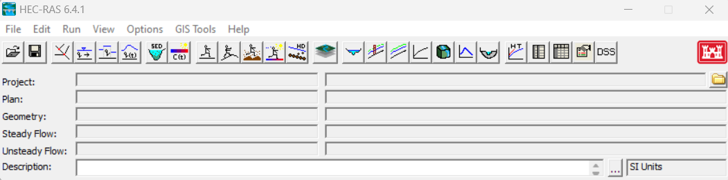

1. To start a new project, go to the **File** menu and select **New Project**.
2. Select the drive and path you want to work in by double-clicking the folder you created in step 1 in the directory box.
3. Enter a project title and file name. The project file must have the extension “.prj”.
4. Press **OK**.
5. 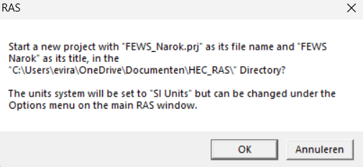A message box appears with the title of the project and the directory that the project is going to be placed in. If the information is correct, press **OK**.
6. Select the unit unit system you would like to work in by selecting **Unit system (US Customary/SI)** from the **Options** menu of the main HEC-RAS window. This manual uses **System International (Metric System).**

## 2. geometry in RAS MApper

***Geometry in HEC-RAS or RAS Mapper***

*The course of the river can be modelled by using the built-in function of HEC-RAS that allows you to add a background layer created with web imagery. For this a terrain and a projection file have to be added. This manual makes use of OpenStreet Maps. Since OpenStreet Maps takes a long time to load in HEC-RAS, the geometry can also be created in RAS Mapper, which is a graphical interface within HEC-RAS. This paragraph and paragraph 3 explain the RAS Mapper method. Paragraph 4 explains the HEC-RAS method.*

1. 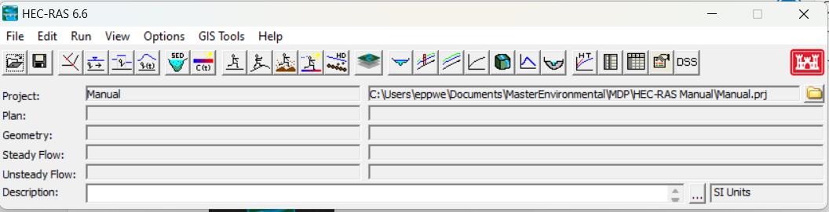Click on the **View/Edit Geometric Data** button.
2. The Geometric Data window will open. Click on **File | Save Geometry Data As**.
3. Enter a title for your geometry file and double-click on the HEC-RAS folder. Press **OK**. You have created a geometry file.
4. Click on the **RAS Mapper** button:
5. 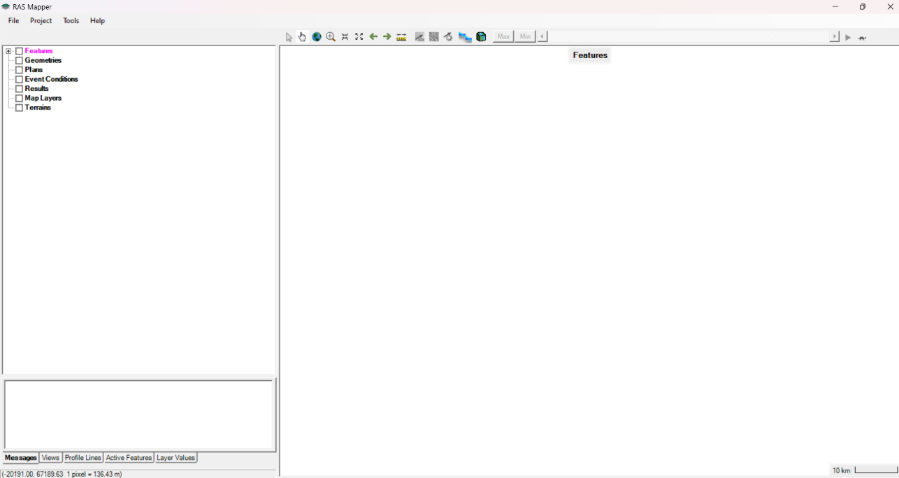The RAS Mapper interface will open as shown below and is comprised of a menu system, data layers list, status window and the mapping window.
6. 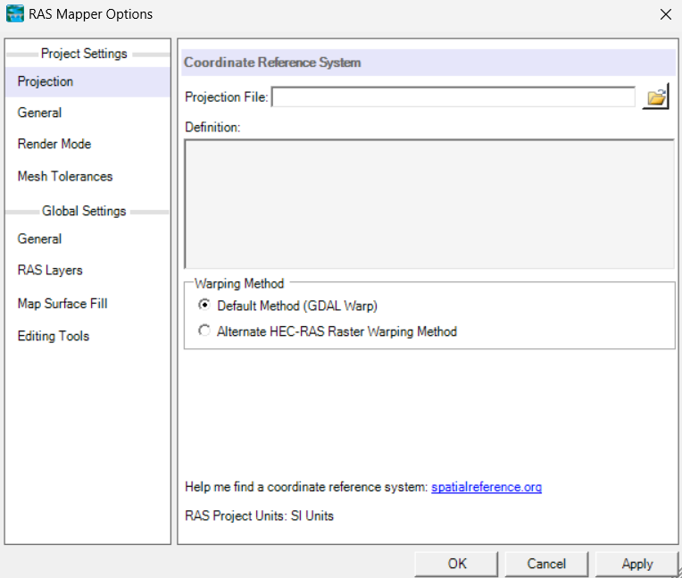Click on **Project |** **Set Projection**.The following window will open.
7. Search for the projection file by clicking on the following button . Choose the projection file *DEM_filled.prj.* It should have the extension ”.prj”. Click on **Apply**  and **OK**.
8. Click on **Project** in the main RAS Mapper window and select **Create New RAS Terrain**.
9. 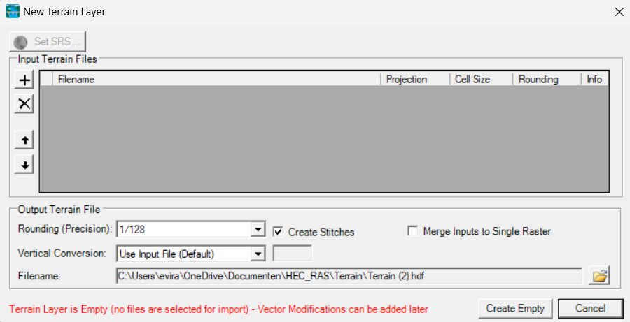The New Terrain Layer window will open as shown below. Click on the **plus** button  to load a Digital Elevation Model. Choose the *DEM_filled.tif* file.
10. Click on **Create**.
11. The Creating Terrain window will open. If the task was completed successfully, the window will display “Terrain Complete”.

***Terrain layer and projection file***

*Setting a projection for your project will ensure that the terrain and geometric data are all in a common coordinate system. A terrain layer and projection file are not necessary for the purposes of this model since all the data is not georeferenced. The data doesn’t consist coordinates. RAS Mapper only allows you to load a background layer, such as OpenStreet Maps, if you have created a terrain layer. Therefore, a terrain layer and projection file are still applied.*

1. Click on **Project** in the main RAS Mapper window and select **Add Web Imagery** to add background imagery. The data is temporarily downloaded from the selected web service and then projected to the coordinate system specified in RAS Mapper. Different web services are possible. In this manual **OpenStreet Maps** will be used.
2. The OpenStreet Maps layer will appear on the RAS Mapper window after clicking on the **OpenStreet Maps** option and pressing **OK**.
3. Click on the **plus** button in the data layers list located in front of **Geometries**. Right-click on **Geometry** and select **Edit Geometry**. All the possible layers associated with **Geometry** appear. Now you can start creating the River System Schematic. When selecting a layer it should appear in magenta as shown below:
4. 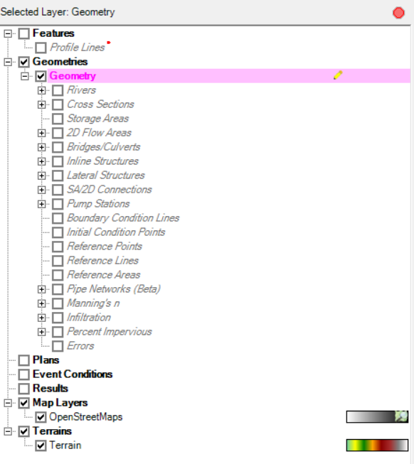Select **Rivers** and make sure the **Add New Feature** button is selected. You can now start drawing the river, beginning from the point where you took your most upstream field measurement. It is essential to draw the river in the downstream direction, as HEC-RAS considers this the positive flow direction. Follow the river’s course as depicted in the OpenStreet Maps layer. For simplicity, model the river as a single reach. Tributaries will be accounted for later.

***River System Schematic***

*In HEC-RAS, a river is modelled as a sequence of reaches. The River System Schematic illustrates how all the reaches are interconnected. The reaches are separated by junctions, where tributaries enter or exit the main river. Tributaries do not necessarily need to be modelled using junctions. A simpler approach is to model the river as a single reach and incorporate flow change locations, which will be explained later on.*

1. Select **Cross Sections** in the Data Layers List and select the **Add New Feature** button. Draw the cross sections at the locations of your field measurements. Each cross-section will be automatically assigned a river station in RAS Mapper. The values of the river stations can be changed later in HEC-RAS.

***River stations***

*Each cross-section is assigned a river station, which is a numerical value. This is done on a reach-by-reach basis. The most upstream cross-section in a reach should be receive the highest river station value. River stations do not indicate the exact location of a cross-section within a reach; instead, they provide information about its position relative to the other cross-sections on that reach.*

1. 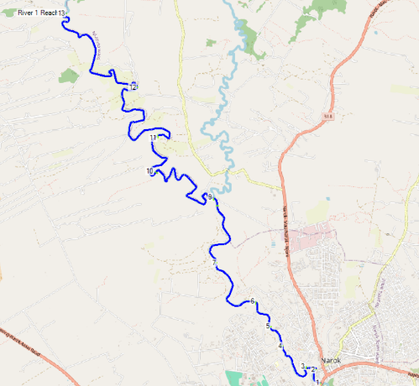The model should look something like this:
2. Deselect the OpenStreet Maps layer in the Map Layers group, which can be found in the Data Layers List. Only the geometry and the terrain layer will remain visible. Verify if the river aligns properly with the Digital Elevation Model.
3. Click on **File** in the main RAS Mapper window and click on **Save**.
4. Close RAS Mapper.

***Slope of the river***

*When using the CSV files generated in chapter 4 as input for the model, HEC-RAS automatically computes the corresponding slope.*

## 3. cross-section data after creating in RAS Mapper

1. Click on the **View/Edit geometric data** button.
2. Optional: click on the **Select layers to view in background** button 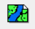 and select **OpenStreet Maps**. HEC-RAS will respond more slowly if the OpenStreet Maps layer is loaded, however, it provides more visual information.
3. To change the values of the river stations click on **Tables | Names | River Stations** in the Geometric Data Editor. The most upstream cross-section of a reach should have the highest value.
4. 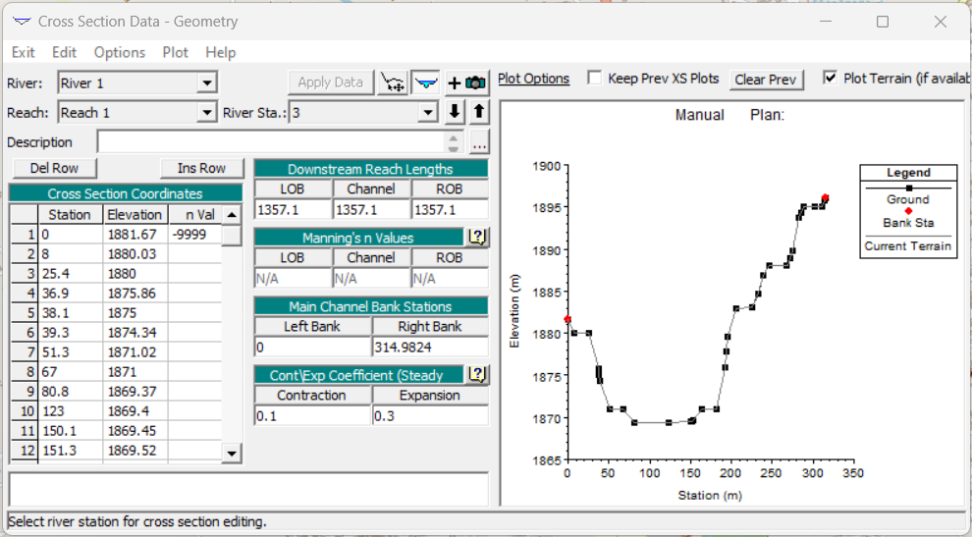Now we will add the measured data to each cross section. Click on the **Cross section** button in the left menu of the Geometric Data Editor. The following window will show:
5. Use the drop-down menus to select the River, Reach and River Station of the cross-section to which you are adding the data. Then, include a brief description of a feature or landmark that characterizes that particular cross-section.
6. Copy and paste the cross-section data from the CSV file corresponding to that particular cross-section, which was generated in *chapter 4*.
7. If the column *n val* appears in the Cross Section Coordinates table, it can be deleted by going to the **options** menu and deselecting **Horizontal Variation in n Values**.
8. Enter the Manning’s n Values that were found in literature and given in *chapter 5.1.1*. Enter the same value for the LOB, Channel and ROB Manning’s n Values, since the river will be modelled as a main channel without a LOB and ROB.
9. Add the Main Channel Bank Stations. The left bank station should correspond to the lowest Station, while the right bank station should correspond to the highest. This way, the river is modelled as a channel without a left and right overbank, for simplicity.
10. Leave the Cont/Exp Coefficients as they are.
11. Click on **Apply Data**.
12. Repeat steps 35 to 41 for each cross section.
13. Click on the **File** menu of the Geometric Data Editor and click on **Safe Geometry Data**.

## 4. Creating geometry in hec-ras without Open street maps

***Geometry in HEC-RAS***

*As explained in the preceding paragraph, the geometry can be created in RAS Mapper with a background layer. It is also possible to create the geometry in HEC-RAS itself. No background layer is used in this case to enhance the reaction rate of the program. It is more difficult to model the course of the river in this case, therefore, the river is modelled as a straight line.*

1. Start with the *Creating a new project* paragraph of this Appendix G except for step 1.
2. Click on the **View/Edit geometric data** button.
3. 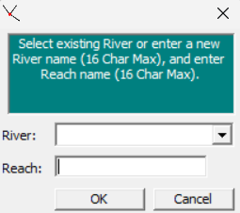Click on the **Add new River Reach** button 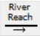 to draw the river. Draw the river as a straight line and double-click to finish the line. The following screen will show:
4. Enter a name for the river and the reach.
5. Click on the **Edit and/or create cross-section** button 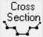.
6. Click on the **Options** menu of the **Cross Section Data Editor**.
7. 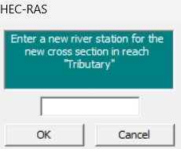Click on **Add a new Cross Section**. The following screen will show:
8. Enter a value for the river station.
9. Use the drop-down menus to select the River, Reach and River Station of the cross-section to which you are adding the data. Then, include a brief description of a feature or landmark that characterizes that particular cross-section.
   1. Copy and paste the cross-section data from the CSV file corresponding to that particular cross-section, which was generated in *chapter 4*.
   2. If you want to model a rectangular cross-section, you don’t need to use the CSV file; you can manually enter the Station and Elevation data as needed
10. Enter the Downstream Reach Lengths. Enter the same value for the LOB, Channel and ROB.
11. Enter the Manning’s n Values that were found in literature and given in *chapter 5.1.1*. Enter the same value for the LOB, Channel and ROB Manning’s n Values, since the river will be modelled as a main channel without a LOB and ROB.
12. Add the Main Channel Bank Stations. The left bank station should correspond to the lowest Station, while the right bank station should correspond to the highest. This way, the river is modelled as a channel without a left and right overbank, for simplicity.
13. Leave the Cont/Exp Coefficients as they are.
14. Click on **Apply Data**.
15. Repeat steps 7 to 15 for each cross section.
16. Click on the **File** menu of the Geometric Data Editor and click on **Safe Geometry Data**.

## 5. import geometry data

1. Create a new project by following steps 2 to 8 of the paragraph *Starting a new project*.
2. Click on the **View/Edit geometric data** button.
3. 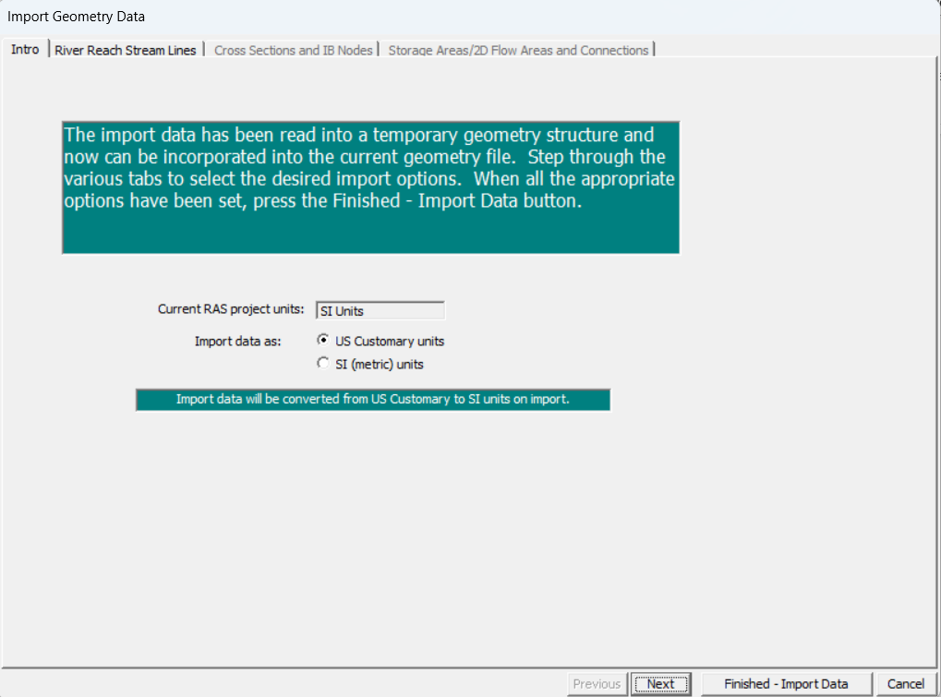In the Geometric Data Editor click on **File | Import Geometry Data | HEC-RAS format**. Double-click the geometry file that you created in step 2 and 3 of the paragraph Geometry*.* The following screen will appear:
4. Select **SI (metric) units** , click on **Next**.
5. In the window illustrated below, click  **Next**.
6. 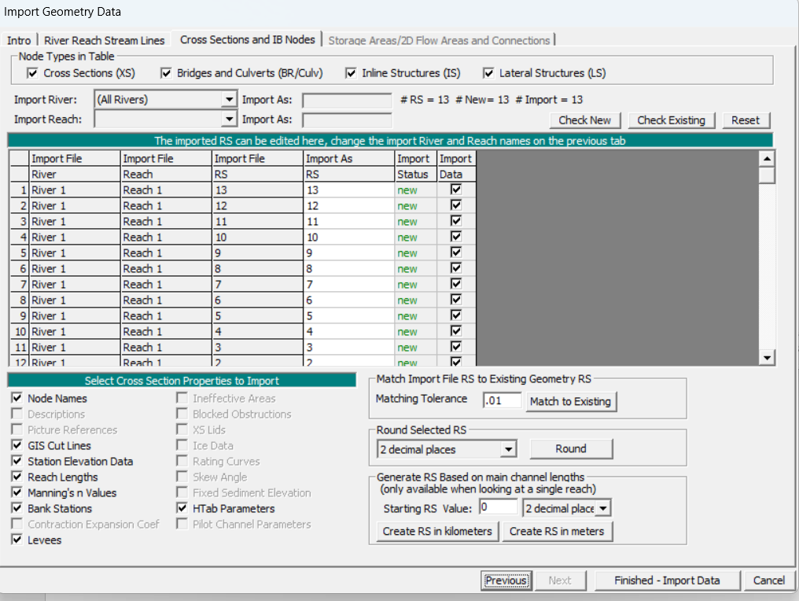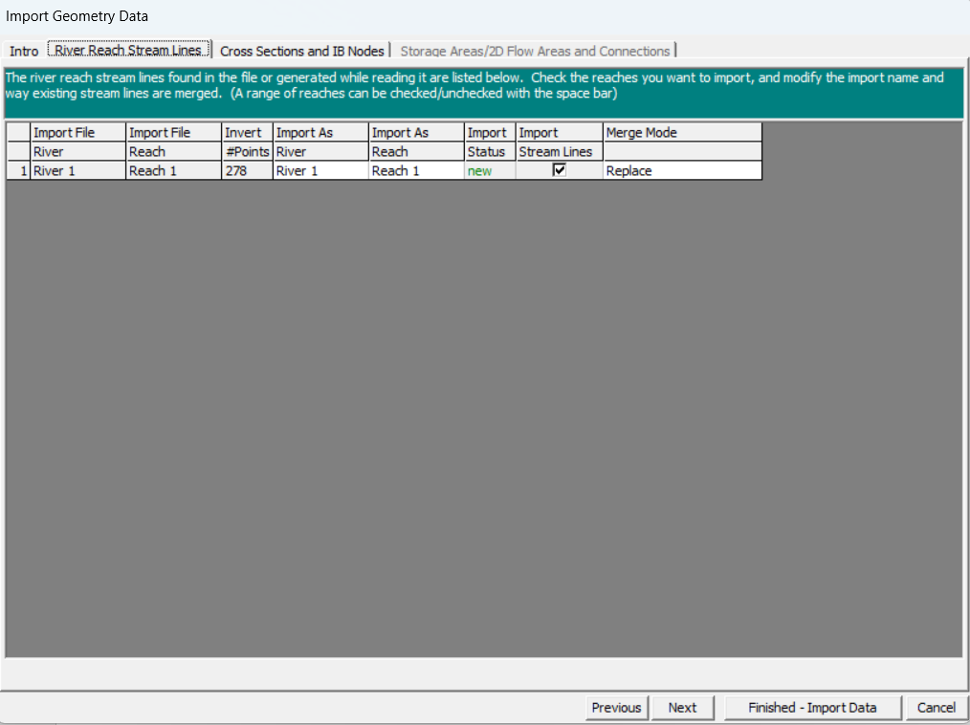The following window appears:
7. Deselect **GIS Cut Lines** and **HTab Parameters**, now click **Finished-Import Data**.
8. 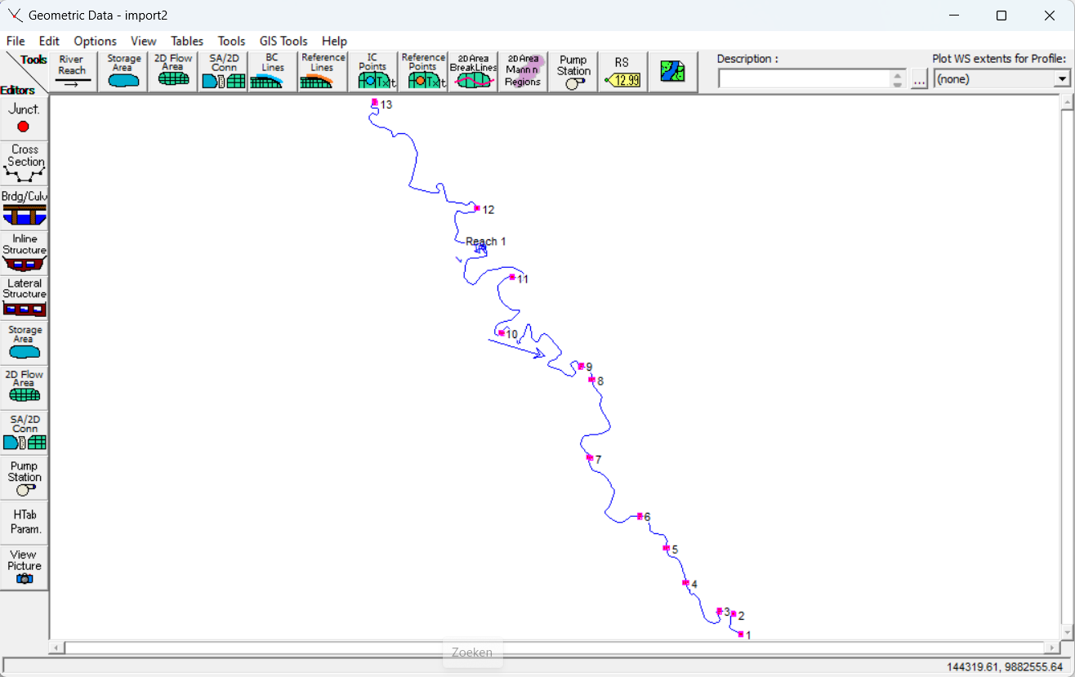Your geometry should now look similar to this:

***GIS Cut Lines***

*GIS Cut Lines in RAS Mapper are lines used to define specific boundaries within a model, particularly for creating cross-sections. They ensure that the model accurately captures the terrain contours and river geometry. By deselecting GIS Cut Lines, the model is not georeferenced, meaning it is not linked to a specific coordinate system.*

***HTab Parameters***

*HTab Parameters refers to Hydraulic Table Parameters that define the relationship between flow rate and water surface elevation. You should deselect the HTab Parameters option when importing geometry data from one model to another to prevent that hydraulic tables and settings from the new model are overwritten by those of the old model.*

## 6. Interpolate cross-sections

1. Click on the **Tools** menu of the **Geometric Data Editor**.
2. Click on **XS Interpolation**.
3. 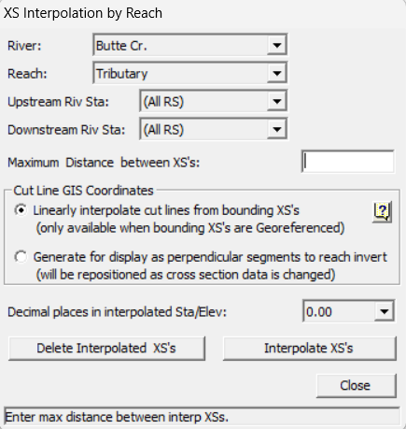Click on **Within a Reach**. The following window will show:
4. Select the correct River and Reach for which you want to add interpolated cross-sections.
5. Define the maximum distance between two cross-sections.
6. Click on **Interpolate XS’s**.
7. Click on **Close**.
8. The interpolated cross-sections will be displayed in the geometry.

## 7. Steady flow model

1. 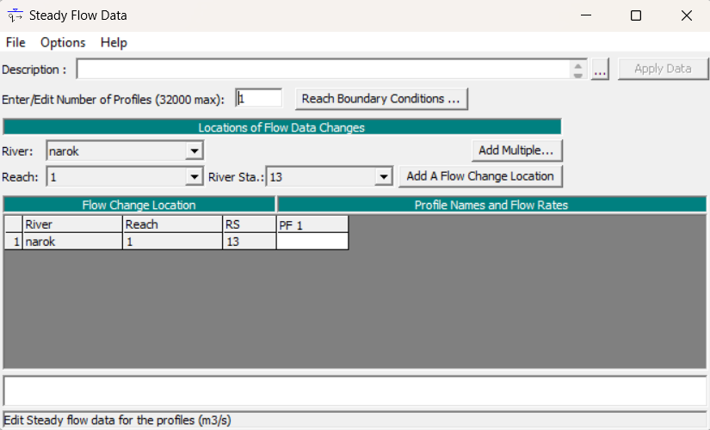Click on the **View/Edit Steady Flow Data** button 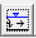 in the main HEC-RAS window. The following window will show:
2. Enter the number of profiles to be computed. A profile indicates a flow data scenario.
3. Select the desired River, Reach and River Station for which you want to specify the discharge.
4. 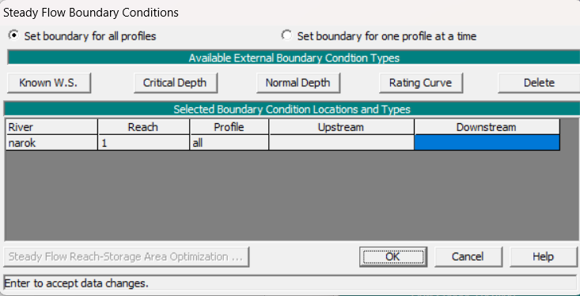To enter the boundary conditions click on **Reach Boundary Conditions**. The following window will show:
5. Enter the downstream boundary condition, assuming a subcritical flow regime as was explained in *chapter 5*. Click on **OK**. You will probably use either a Known W.S. or the Normal Depth. Use the validation measurements as explained in *chapter 4*. If you model the river with multiple reaches, you should specify boundary conditions for each reach.

***Known W.S.***

*A known W.S. refers to a known Water Surface level.*

***Normal Depth***

*When selecting this boundary condition, you need to enter an energy slope that will be used to calculate the normal depth at that location. If the energy slope is unknown, you can approximate it by using either the slope of the water surface or the slope of the channel bed. In this manual the slope of the channel bed is used.*

***Flow regime***

*If the flow regime during the validation measurements was mixed, you should define both the downstream and upstream boundary condition. If the flow regime was found to be supercritical, only an upstream boundary condition needs to be defined.*

1. Add the desired discharge in the empty cell under **Profile Names and Flow Rates**.
2. Click **Add a flow change location** to specify the new discharge of the river at the points where tributaries enter (or exit) the main river.

***Add a flow change location***

*This is a simplified method for incorporating tributaries into the model. A more detailed approach is modelling the tributaries themselves and adding junctions. If you choose this method, you will need at least two cross-section measurements for each tributary, along with boundary condition data corresponding to those tributaries. Additionally, you need additional information about the junctions, such as the junction length.*

1. Click on **File | Save Flow Data AS**, save the data in the folder you are working in and give the file a title.
2. 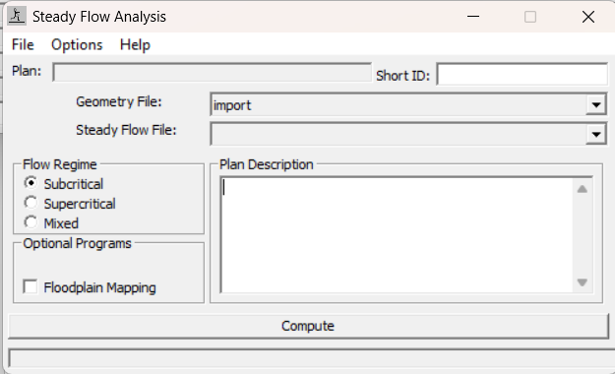Click on **Steady Flow Analysis ** to run the steady flow model. The following screen will appear:
3. Choose between subcritical, supercritical and a mixed flow regime, based on the conditions during the validation measurements. You will likely need to choose a subcritical flow regime.
4. Select the correct **Geometry** and  **Steady Flow File** you have created when following this manual.
5. Click on **Compute** and all the calculations will be performed.
6. Click **View | Detailed Output Tables** to display the results.
7. Compare the results, mainly the hydraulic depth and water surface elevation, with the validation measurements.

***Finding the correct Manning’s n Value***

*Finding the correct Manning’s n Value is an iterative process. The result of this paragraph functions as a starting point. Manning’s n Value will be adjusted at each iteration step until a value is found that results in a minimal error between the validation data and the output of the model, mainly the hydraulic depth and water surface elevation.*

## 8. Unsteady flow model

1. 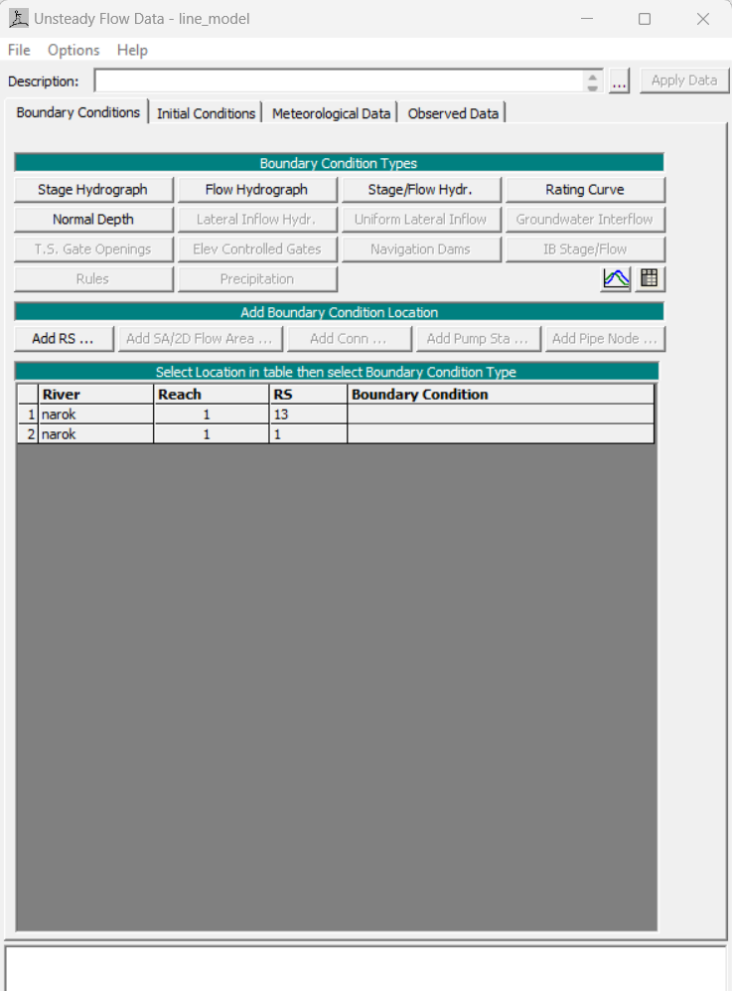Click on the **View/Edit unsteady flow data** button . The following window will show:
2. Specify the upstream and downstream boundary conditions. The upstream boundary condition is defined by a flow hydrograph, while the downstream boundary condition is specified as the normal depth. It is important to note that the flow regime does not need to be specified. For each reach, an upstream and downstream boundary condition are required when the flow is modelled as unsteady.

***Simulation with validation data***

*The unsteady flow model will be run using the validation data to ensure it functions correctly. The flow hydrograph will be defined using a constant discharge, specifically, the value measured during the validation measurements at the most upstream cross-section. The model’s output will then be compared with the validation measurements, mainly the hydraulic depth and water surface elevation.*

***Simulation of a flash flood***

*The goal of the model is to simulate a flash flood in order to determine a critical discharge at the upstream boundary that leads to flooding at the flood point, along with the corresponding warning time. To achieve this, the discharge specified in the flow hydrograph will be increased until the model indicates that water exceeds the banks at the downstream boundary. Once this occurs, the flow hydrograph will be defined as follows: the initial value of the flow hydrograph will be set at the discharge prior to the rapid rise in water level, and will continue to increase until the critical discharge is reached. The simulation time depends on the rate at which the water rises or can be estimated. In this manual, the simulation time is estimated to be one hour.*

***Flow hydrograph***

*A flow hydrograph is primarily used as an upstream boundary condition. A flow hydrograph specifies the change of the discharge during a time interval.*

1. 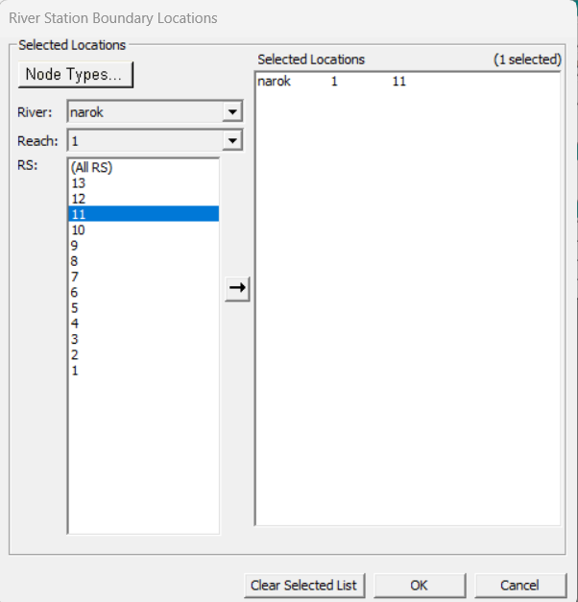Click on the **Add RS** button. This will enable you to add a discharge to the main river to account for tributaries. The following window will show:
2. Double-click on the River Station where a tributary enters or leaves the main river.
3. 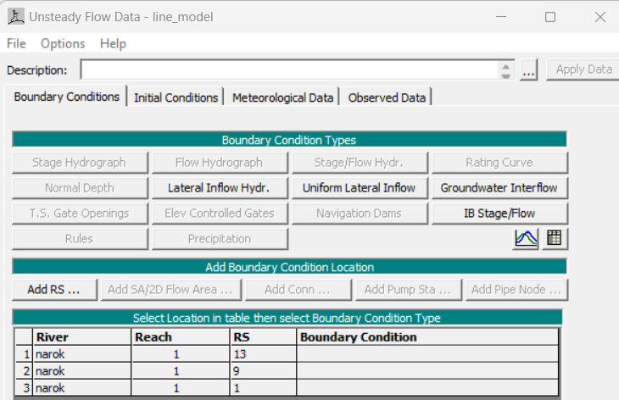Click on **OK**. The following screen will appear:

1. Select the empty cell, click on the boundary condition **Lateral Inflow Hydro** and enter the discharge that either enters or exits the main river due to the tributary.
2. Click on **File | Save Flow Data AS** and save the data in the folder you are working in.
3. 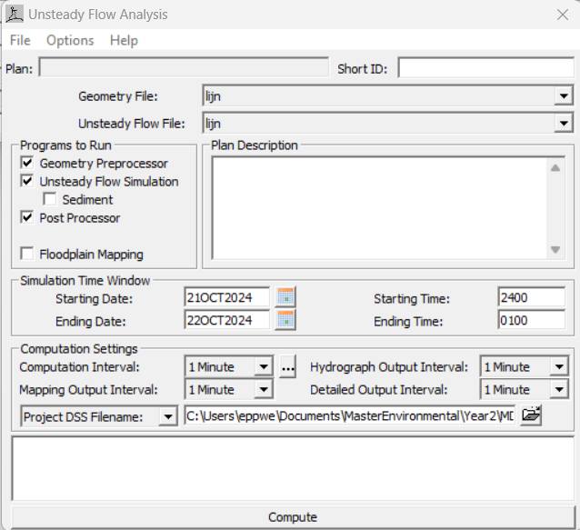Click on **Unsteady Flow Analysis ** to run the unsteady flow model. The following screen will appear:
4. Select the following programs to run: Geometry Preprocessor, Unsteady Flow Simulation and Post Processor.
5. Select the correct starting date and time and ending date and time, these should correspond to the simulation time specified in the flow hydrograph boundary condition.
6. Set all the computation settings to 1 minute.
7. Click on **Compute** and all the calculations will be performed.
8. Click **View | Detailed Output Tables** to display the results.

## 9. Minor loss coefficients

1. Click on the **View/Edit geometric data** button.
2. Click on the **Tables** menu in the Geometric Data – Geometry Editor.
3. 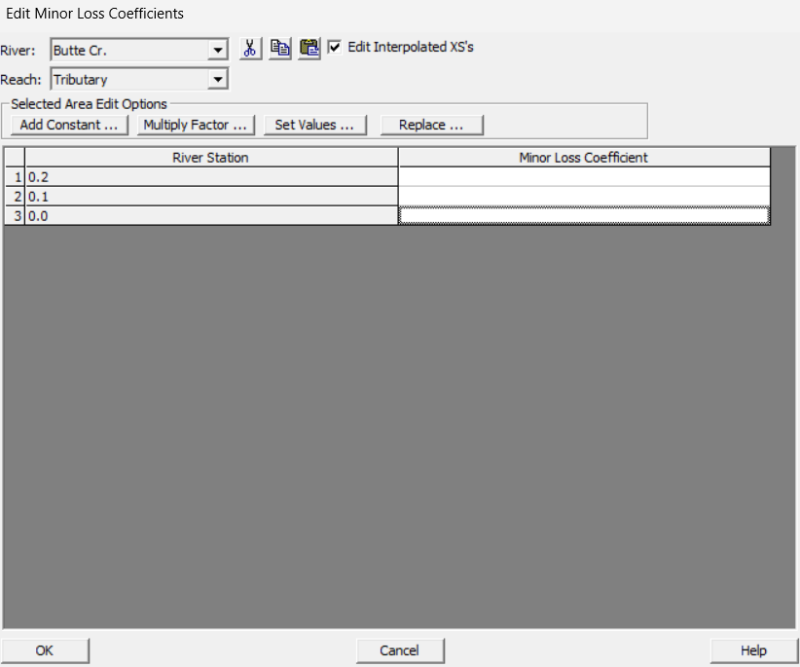Click on Minor Losses. The following window will show:
4. Enter the correct minor loss coefficients to the corresponding river stations.

***Minor Loss Coefficients***

*Minor loss coefficients can be used to account for energy losses, such as those occurring at bends. HEC-RAS calculates the energy loss by multiplying the minor loss coefficient with the flow velocity head. As an approximation, minor loss coefficients for flow in pipes can be used, which can be found in literature.*

Appendix H. Theoretical background HEC-RAS

# Introduction

This appendix provides the theoretical background for HEC-RAS. General information is covered in Chapter 5, while this section includes additional insights on three specific topics. These details serve as a reference document for those looking for more understanding of the program.

First, an outline of all project files in a HEC-RAS project are given. This outline provides background information on the working of the program, which might be valuable if expansion on the model is needed, or other changes are wanted. The information is not necessary to be familiar with, before following the instructions of Chapter 5 and Appendix G.

Secondly, an overview of all possibilities regarding generation of output is given. HEC-RAS can provide results in many different formats. The needed output for the manual is included in the step-by-step instruction. This information serves as extra information if more or different output is requested.

Thirdly, the application of GIS data in HEC-RAS is elaborated upon. Only a brief overview is given of the possibilities, not including clear instructions or defined outcomes. The paragraph is meant to give insights in more options of HEC-RAS and RAS-Mapper, which could be valuable when other methods to model the river reach are investigated.

Information for this theoretical appendix is retrieved from the HEC-RAS 5.0 Users Manual. (US Army Corps of Engineers - Hydrological Engineering Center, 2016)

# Elements of a project

A project can include the following types of files, which can only be created through or by the user interface:

* Plan Files

Have extension .P01 to .P99, in order of creation. The file contains a description and short identifier for the plan, a list of files that are associated with the plan, and a description of all the simulation options that were set for the plan. Created by **New Plan** or **Save Plan As** from the simulation windows.

* Run Files

Have extension .R01 to .R99, number associated to plan files. The file contains all of the necessary data to perform the computations that are requested by the plan files. The run file contains the input to any of the computational engines available in the HEC-RAS system. Generated automatically when using the **Compute** button from the simulation window.

* Output Files

Have extension .O01 to .O99, number associated to plan files. The file contains all of the computed results from the requested computational engine. File can only be read in the user interface.

* Geometry Files

Have extension .G01 to .G99, in order of being saved for a particular project. The file contains all of the geometric data for the river system that is being analysed: cross-section information, hydraulic structure data, coefficients, modelling approach information. A file is created when using **New Geometry Data** or **Save Geomery Data As** from the Geometric Data window.

* Steady Flow Data Files

Have extension .F01 to .F99, in order of being save for a particular project. The file contains the number of profiles to be computed, flow data, and boundary conditions for each reach. A file is created when using **New Flow Data** or **Save Flow Data As** from the Steady Flow Data window.

* Unsteady Flow Data Files

Have extension .U01 to .U99, in order of being save for a particular project. The file contains flow hydrographs at the upstream boundaries, starting flow conditions, and downstream boundary conditions. A file is created when using **New Flow Data** or **Save Flow Data As** from the Unsteady Flow Data window.

* Hydraulic Design Data Files

Have extension .H01 to .H99, in order of being save for a particular project. The file contains information corresponding to the type of hydraulic design calculation that is requested. A file is created when using **New Hydraulic Design Data** or **Save Hydraulic Design Data As** from the **File** menu of the Hydraulic Design Functions window.

Not applicable to similar projects are:

* Quasi-Unsteady Flow Data Files
* Sediment Data Files
* Water Quality Data Files

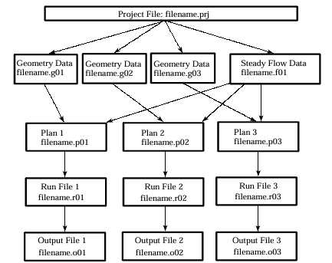An overview of the elements and their mutual relations is given in Figure 20 below.

Figure 24: Schematic of project data files (US Army Corps of Engineers - Hydrological Engineering Center, 2016)

# Generating output

All graphical and tabular output can be displayed on the screen, sent directly to a printer (or plotter), or passed through the Windows Clipboard to other software, such as a word-processor or spreadsheet.

## Summary of viewing and printing results

Several output features are available under the **View** option from the main window:

* Cross section plots
  + **Options** here include zoom in, zoom out, full plot, pan, animate, selecting which plans/profiles/variables to plot, profiles/variables to plot, velocity distribution, viewing interpolated cross-sections, control over the lines/symbols/labels/scaling/grid options.
* Water surface profile plots
* General profile plots
* Rating curve plots
* X-Y-Z perspective plots
* Hydrograph plots
* Hydraulic property tables (only for unsteady flow)
* Tabular output at specific locations (Detaild Output Tables)
* Tabular output for many locations (Profile Summary Tables)
* Summary of errors
* Warnings
* Notes

### Graphical output

Graphical plots can be extracted via the **File** menu on the plot windows:

* Send graphical plots directly to whichever printer/plotter you have defined under the Windows Print Manager.
* Send graphical plots to the Windows clipboard and paste them into other programs, such as a word-processor.

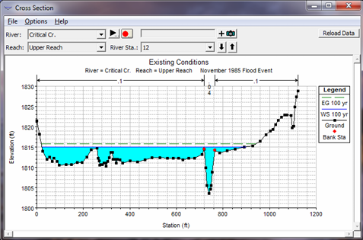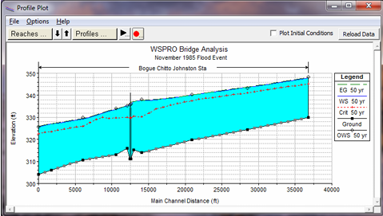

Figure 25: Example cross-section plot Figure 26: Example general profile plot

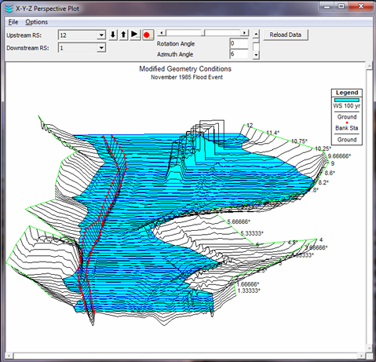

Figure 27: Example X-Y-Z perspective plot, of a river reach with a bridge. You are able to choose the starting and ending location of the plot and rotate left or right, up or down. The computed water surface profiles can be overlaid on top of the cross section

### Tabular output

Tabular output is available in two different formats:

* Detailed Output Table: detailed hydraulic results at a specific cross section location.
  + Elevation, velocity head, slope, discharge, top width, total velocity, maximal depth, flow area, n-value, average velocity, wetted perimeter, shear, hydraulic depth, *and more*.
* 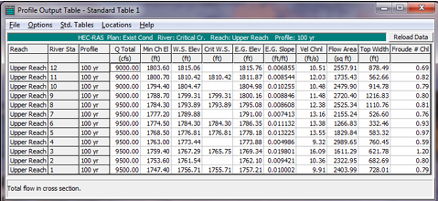Profile Summary Table: a limited number of hydraulic variables for several cross-sections and multiple profiles. There are several standard tables predefined under **Tables** menu. It is also possible to define your own table by specifying what variables you would like to have in a table. These specified tables can be saved and selected later as one of the standard tables available to the project.

Figure 29 Example profile output table

## Viewing Results

Chapter 9 of the HEC-RAS 5.0 Users Manual describes all possible results in more detail. This includes the graphical and tabular outputs as mentioned above, and all features within these options. Op pages 9-10 and 9-11 the steps on sending graphics to the printer or plotter and sending graphics to the windows clipboard are described. Page 9-22 includes the steps of sending tables to the printer of sending tables to the windows clipboard.

Some of the output possibilities are further described here.

### Plotting velocity distribution output

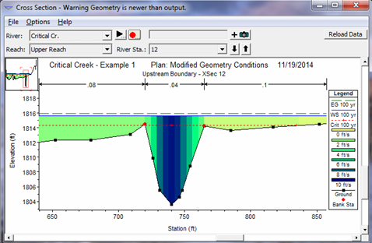Velocity distributions can only be plotted at locations where the user has specified that flow distribution output is calculated during the computations. To view, first go to a specific cross-section plot and then select **Velocity Distribution** from the **Options** menu. First, you need to set the minimum velocity, maximum velocity and velocity increment for plotting. It is better to let the program use the maximum velocity range for plotting. Select **Plot Velocity Distribution** and press “OK”. Details on the computation can be found in chapter 7 and 8 of the HEC-RAS 5.0 Users Manual, or chapter 4 of the Hydraulic Reference Manual.

Figure 30 Example velocity distribution plot

### Plotting other variables in profile

Any variable can be selected for a plot from the **General Profile Plot** option and then using **Plot Variables** under the **Options** menu. Multiple variables can be plot at the same time, however, be careful with scaling. When certain variables are selected, this can be saved as User Defined Plot by **Save Plot** from the **Options** menu. There are several predefined plots available under the **Standard Plots** menu at the top of the graphic window.

### Plotting one variable versus another

The rating curve plotting window has the ability to plot other variables, by choice. Select the **X Axis Variable** and **Y Axis Variable** from the **Options** menu of the rating curve plotting window.

### Detailed Output Tables

Any cross section can be displayed in a detailed output table by selecting the appropriate river, reach and river station from the list boxes at the top of the table. You can also view detailed hydraulic information for other types of nodes, by selecting from the **Type** menu, like culverts, bridges, multiple openings, inline structures, lateral structures, storage areas, storage area connections, pump stations, and flow distribution in cross sections.

The table can describe its output on either English or Metric units, no matter the format of the input data. Use the **Units System for Viewing** button.

### Profile Summary Tables

Examples of possible variables to show in a summary table are: discharge, slope, flow area, top width, Froude number, and more. The different standard tables are described on page 9-18 and 9-19 of the HEC-RAS 5.0 Users Manual. To view one of the types of tables, use the **Std. Tables** menu on the profiles summary table. You can also specify which plans, profiles and reaches to include in the table.

Interpolated cross-sections can be turned on or off in the table, with the **Include Interpolated XS’s** button from the **Options** menu. Default is to view all cross-sections, including the interpolated ones.

Additional to the standard tables, it is possible to create user defined tables, with the **Define Table** option from the **Options** menu. These are limited to 15 variables. Instructions are described on page 9-20 and 9-21 of the HEC-RAS 5.0 Users Manual.

# Using GIS data in a HEC-RAS model

During 1D hydraulic computations, only two-dimensional data is utilized. 3D data can be imported in HEC-RAS for display purposes. Also, GIS data can be imported for flood inundation maps, via HEC-RAS Mapper. Appendix B of the HEC-RAS 5.0 Users Manual describes the file formats used for importing and exporting GIS or CADD data.

Within HEC-RAS, uploading GIS data can also replace the need of having to draw a river reach by hand. The program can determine the riverbed based on elevation data and calculate the lengths between cross-sections and the difference in length between left and right banks in turns. A set-up for this method is included at the end of this Appendix.

More detailed information on using GIS data can be read in Chapter 14 and Appendix B of the HEC-RAS 5.0 Users Manual.

### ArcGIS extension

HEC-GeoRAS, allows a user to write geometric data to a file in the required format for HEC-RAS. Results from HEC-RAS can be read in HEC-GeoRAS to perform flood inundation mapping. HEC-GeoRAS is not part of the program, but software needs to be downloaded separately and used with ArcGIS.

## General procedure for utilizing GIS/CADD data with HEC-RAS

1. Start a New Project form the **File** menu of the main window.
2. Go to the Geometric Data editor and import the GIS/CADD data. By selecting **Importing Geometric Data** and then **GIS Format** from the **File** menu of the geometric data window.
   1. For this step, the GIS/CADD data needs to have been transformed to a text file as according to the required format. See Appendix B of the HEC-RAS 5.0 Users Manual.
3. Add any additional geometric data that is needed to represent the physical system.
4. Perform the water surface profile calculations for the desired flow rates.
5. View the results as a text file using the **Export GIS Data** option from the **File** menu of the main window.
6. Import the results file into your GIS/CADD system and develop the floodplain maps for each of the profiles.

Once you are utilizing GIS data in your project, any additional data can be imported directly into an existing HEC-RAS geometry file without starting a new project. For example, additional cross sections can be placed into the appropriate River and Reach sections of the model as needed.

### Graphical Cross Section Editor

This is a tool to visualize a cross section and allows to add, delete and modify cross section properties. The editor is accessed by the **Tools | Graphical Cross Sectional Edit** menu.

Manning’s n value data can be entered using the **Tables | Manning n or k values** menu.

## Utilizing a Digital Elevation Model

A Digital Elevation Model (DEM) can be loaded in RAS-Mapper, together with a projection file. HEC-RAS is capable of defining the riverbed, based on this elevation data.[6] One of the major advantages of basing the river profile on elevation data, is the ability of HEC-RAS to calculate the reach lengths of the two banks itself. This enables the possibility to include the impact of bends and turns in the river flow.

Challenges in this method are mostly related to the grid size of the elevation data, and its ratio compared to the size of the river. SRTM data for example, provides 30 by 30 meter elevation data for almost the whole world, but an average river is often smaller than 30 meters. There are tricks to deal with this challenge. For example, the grid size of a certain DEM can be made smaller, to 1 by 1 meter. The elevation data with this new grid, can be adjusted manually based on measurements. Alternatively, a river can be burned in a DEM, with a fixed width and relative depth.[7] First adjust the elevation data in a program like QGIS, then upload it in HEC-RAS.

Appendix I. Alternative manual computations

# Introduction

This appendix expands upon manual calculations, based on Manning’s equation and the Leopold & Haddock method, which can give valuable insights in the flow in a natural open channel, with limited required data. The methodology is explained, and results for the case study in the Enkare Narok river, Narok Town, Kenya, are given. The results, given in the other document, were not conclusive unfortunately, therefore the methodology is not further implemented in this manual. It is appended because we think it is a promising method with which you can make valuable estimates of a river flow, without the need of an elaborate model. The instructions could serve as a starting point for further elaborations on this subject.

# Goal of this step

The input for this step is the measured cross-sections, water levels, flow velocity profiles, and slopes per measurement point. Firstly, a Manning roughness coefficient will be determined. This is based on measured average flow velocities, with corresponding hydraulic radii and slopes. With the determined Manning roughness coefficient, discharges for bank full states of the various cross-sections can be determined.

With these bank full state discharges, the relation between geometry characteristics and discharge are studied using the Leopold & Haddock method. The objective is to determine non-linear between width and discharge, depth and discharge, and velocity and discharge.

# Required hardware

A computer is recommended to execute the computations. However, they could also be done manually.

# Required software

Software to execute the computations can be Microsoft Excel, or any programme working with Python, like Anaconda. The manual comes with a python package, named the *“Alternative Manual Computations package”*, which is the suggested software to use. This package serves as a set up to this alternative method and can be used as a guideline for the needed calculations. The package involves two python scripts, which use an Excel file as input. For further information, the reader is referred to the package itself, which includes a *“README.txt”* file with a brief instruction.

# Step by step instruction

The steps are distinguished in two main parts, firstly the application of Manning’s equation, determining an adequate Manning’s coefficient for the river, and secondly the application of the Leopold & Haddock method. The methodology is not written in a step-by-step way, but in a more theoretical manner.

## Manning equation

The Mannings equation is an empirical equation that applies to steady uniform flow in open channels, and describes the relation between discharge, flow velocity and channel slope. It was introduced by Robert Manning in 1889, as an alternative for the Chézy equation and is now one of the most commonly used equations for open channel flow.

$$Q=\left(\frac{1}{n}\right)*A*R^{\frac{2}{3}}*\sqrt{S}$$

Where $n [\frac{s}{m^{\left(\frac{1}{3}\right)}}]$ is the Manning roughness coefficient, $A [m^{2}]$ is the flow area of a cross section, $R \left[m\right]$ is the hydraulic radius and $S [\frac{m}{m}]$ is the slope of the channel bed. [8]

The cross section of the river flow is determined as described in Chapter 3, by measuring elevation and coordination points with a GPS system. The hydraulic radius can be calculated based on the cross section combined with the measured water level. The hydraulic radius is based on the wetted cross section and the wetted perimeter; the surface of the channel that is covered by water. The channel slope is determined based on the difference of elevation over a certain length at the cross-section. All required measurements and the processing of the data is described in Chapters 3 and 4.

Since $Q=v*A$, the Manning equation can be rewritten to:

$$v=\frac{1}{n}{*R}^{\frac{2}{3}}*\sqrt{S}$$

Where $v [\frac{m}{s}]$ is average flow velocity. At cross sections where the water level and the average velocity are measured, the Manning roughness coefficient $n$ is the only unknown parameter. It is recommended to only use cross-sections that had a natural and undisturbed flow. Calculate $n$ for these cross-sections and take the average value as a constant roughness coefficient over the entire river.

To verify and improve this method, the Manning coefficient should be compared to Manning coefficients in literature based on the river bed material. [9] The Manning coefficient ranges approximately between 0.01 and 0.07 [s/m1/3], and describes the roughness of the river bed. This depends on the material and coarseness of the river bed material. The coefficient reduces for smoother riverbeds, such as concrete.

### Bank full discharge

The determined Manning roughness coefficient $n$ is used as input for the original Manning equation in order to determine the bank full discharge at the different cross sections. This is the input for the Leopold & Maddock method. The bank full state of a river refers to the water level in a river that stays just between the natural levees of the river bank, just not overtopping and flooding the adjacent floodplains. It is in general expected that a natural levee of a river is only overtopped between twice per year and once per two years. [10] The bank full states for all cross-sections can be determined, by looking at signs in the landscape that indicate the natural levee and the bank full water level. Examples of indications can be: [11]

* A change in vegetation at a clear horizontal line
* A river bank turning flat
* A change in colour of soil and/or stone, at a clear horizontal line
* An excavation in the river bank, often with loose hanging roots

Keep in mind that the bank full water level should be approximately equal at both river banks. Water inlets or outlets, or human interference, can distort the natural levees.

## Leopold & Maddock method

Research of Leopold & Maddock in 1953 developed a set of exponential relations between some features of the geometry of a natural open surface flow, and the discharge. [12] The geometry is described by the total width of the channel $w$, in $[m]$, the average depth of the channel $d$, in $[m]$, and the average flow velocity over the entire cross section $v$, in $[\frac{m}{s}]$. The method consists of a set of equations:

$$w=a*Q^{b}$$

$$d=c*Q^{f}$$

$$v=k*Q^{m}$$

The relation of the parameters $a, b, c, f,k, m$ to the values for width, depth and velocity is described by the following set of conditions:

$$w*d*v=Q$$

$$b+f+m=1$$

$$a*c*k=1$$

By solving the equations above by taking measured values of the geometry and the discharge as input, the Leopold parameters can be solved. The $w, d, v, and Q$ of all measured cross sections together give average Leopold parameters. The parameters $b, f, and m$ are given by the slope of the relation of a fitted line between $w, d, or v$ and $Q$ on a logarithmic scale. If these parameters are known, the values for $a, c, and k$ can be derived from the set of equations. This method is proposed in the original report of Leopold and Maddock. However, it is easier to fit a line for the two unknown parameters per relation in one go. This is the method that is executed in the corresponding python script. The set of conditions are used as a check on whether the available data was suitable for the method. The initial study of Leopold & Maddock, gave average values for the parameters $b, f, and m$ that were found in studying a large variety of rivers in a semiarid area: $b=0.26, f=0.40, m=0.34$. (Luna B. Leopold, 1953) In the master thesis of Dorius Le Poole, Leopold parameters were determined as well, for the Enkare Narok river. These were based on the same method as described in this report, with 5 measured cross sections as input, and a fitted trendline through his data points. The found values were: $a=6.16, c=0.28, k=0.60,b=0.32,f=0.39 and m=0.27$. (Poole, 2024)

The discharge that serves as an input, will be calculated using the Manning equation, as described above. This will be done based on the bank full capacity that is measured at the different cross sections of the Enkare Narok river. When the Leopold parameters are known, the set of equations above can use as a way to calculate discharge at any point in the river, based on the geometry of a cross section.

On the use of the Leopold & Maddock method, lots of successive and elaborating studies have been done. In different ways, the method is assumed to be able to give reasonably accurate predictions of discharge and is mostly applied in data scarce areas. In cases where the maximum discharge is regarded, such as in this report, the hydraulic radius can be used instead of average depth. This is also done in this report. [13]

1. The Manning roughness coefficient is determined for different channel types by Ven Te Chow, in his textbook Open Channel Hydraulics, published in 1959. A table can be retrieved on <https://www.fsl.orst.edu/geowater/FX3/help/8_Hydraulic_Reference/Mannings_n_Tables.htm>
2. QGIS (2024, October). *Spatial without compromise: Spatial visualization and decision-making tools for everyone.* Retrieved from QGIS: <https://www.qgis.org/>
3. For all videos, go to <https://www.youtube.com/c/hansvanderkwast>
4. USGS (2018, July). *Digital Elevation – Shuttle Radar Topography Mission (SRTM) 1 Arc-Second Global.* Retrieved from USGS science for a changing world: <https://www.usgs.gov/centers/eros/science/usgs-eros-archive-digital-elevation-shuttle-radar-topography-mission-srtm-1>
5. There are also sample layouts available online, see <https://layout-hub.github.io/>
6. A clear instruction on how to utilize a Digital Elevation Model as the base of your model is given in the following YouTube series: <https://www.youtube.com/watch?v=BUjF_MGcxYQ&list=PLk_n8Ox5nf3G3SXucyn8XQNtwnByMXrvP>
7. A video of Hans van der Kwast (IHE Delft) explains the method of burning a river in DEM, in: <https://www.youtube.com/watch?v=ZyM1jnxFamU>
8. Venutelli (2005). *A Constitutive Explanation of Manning’s Formula.* Meccanica, Springer. Retrieved from: <https://link.springer.com/article/10.1007/s11012-005-6529-5>
9. The Manning roughness coefficient is determined for different channel types by Ven Te Chow, in his textbook Open Channel Hydraulics, published in 1959. A table can be retrieved from <https://www.fsl.orst.edu/geowater/FX3/help/8_Hydraulic_Reference/Mannings_n_Tables.htm>
10. Williams (1978). *Bank-full discharge of rivers*. Water Resources Research, Volume 14, Issue 6. Retrieved from: <https://doi.org/10.1029/WR014i006p01141>
11. More examples and explanations on how to locate the bank full states can be retrieved from: <https://www.waterboards.ca.gov/water_issues/programs/swamp/docs/cwt/guidance/413.pdf>
12. Leopold, Maddock (1953). *The Hydraulic Geometry of Stream Channels and Some Physiographic Implications*. Geological Survey Professional Paper 252. United States Government Printing Office, Washington. Retrieved from: <https://pubs.usgs.gov/publication/pp252>
13. S. Lawrence Dingman (2006). *Analytical derivation of at-a-station hydraulic-geometry relations.* Journal of Hydrology, Volume 334. Retrieved from: <https://www.sciencedirect.com/science/article/abs/pii/S0022169406005063?via%3Dihub>